A PROGRESSIVE WEB APPLICATION (PWA)-BASED HIGH-PRIORITY NOTIFICATION AND EVENT MANAGEMENT SYSTEM FOR PEÑARANDA BAND 1870



A CAPSTONE AND RESEARCH PROJECT

BY:
SIMON CHRISTIAN L. DE GUZMAN
JAKE MOISES A. MORALES
MARK PIOLO A. MORENTE
JOHN CHRISTOPHER G. PORTUGAL

OCTOBER 2026
A PROGRESSIVE WEB APPLICATION (PWA)-BASED HIGH-PRIORITY NOTIFICATION AND EVENT MANAGEMENT SYSTEM FOR PEÑARANDA BAND 1870

A Capstone and Research Project
Presented to the Faculty of
College of Information and Communications Technology
Cabanatuan City, Nueva Ecija

In Partial Fulfillment of the Requirements for the Degree
Bachelor of Science in Information Technology
With Specialization in Web Systems Technology

By:
Simon Christian L. De Guzman
Jake Moises A. Morales
Mark Piolo A. Morente
John Christopher G. Portugal

OCTOBER 2026


Republic of the Philippines
Nueva Ecija University of Science and Technology
College of Information and Communications Technology

E N D O R S E M E N T

This is to formally endorse the capstone and research project entitled “A Progressive Web Application (PWA)-Based High-Priority Notification and Event Management System for Peñaranda Band 1870,” prepared and submitted by Simon Christian L. De Guzman, Jake Moises A. Morales, Mark Piolo A. Morente, and John Christopher G. Portugal in partial fulfillment of the requirements for the degree of Bachelor of Science in Information Technology, with a specialization in Web Systems Technology. The undersigned hereby certifies that the project has been reviewed and is recommended for Capstone Oral Defense.

System and Manuscript Readiness:

ROSE ANNE G. COCHANCO, MSIT
Capstone Adviser

Manuscript Review and Editing:

CRIS NORMAN P. OLIPAS, Ed.D.
Research Editor

Completeness of Deliverables:

CRIS NORMAN P. OLIPAS, Ed.D.
Faculty-in-Charge, ITCAP02-4F

TABLE OF CONTENTS
 | Page No.
TITLE PAGE | i
ENDORSEMENT | ii
TABLE OF CONTENTS | iii
LIST OF TABLES | viii
LIST OF FIGURES | xii
CHAPTER 1: THE PROBLEM AND ITS BACKGROUND | 1
Introduction | 1
Review of Related Literature | 1
Synthesis | 1
Conceptual Framework | 1
Statement of the Problem | 1
Scope and Delimitations | 1
Significance of the Study | 1
Definition of Terms | 1
CHAPTER 2: METHODOLOGY | 1
Research Design | 1
Research Locale | 1
Respondents of the Study | 1
Research Instrument | 1
Data Gathering Procedure | 1
Data Analysis and Techniques | 1
Ethical Considerations | 1
CHAPTER 3: RESULTS AND DISCUSSION | 1
1. Design and Development of SmartBand Progressive Web Application (Addressing Research Problem 1) | 1
1.1 Plan | 1
1.2 Design | 1
Use Case Diagram | 1
Data Flow Diagrams (DFDs) | 1
Context Diagram (Level 0 DFD) | 1
Level 1 Data Flow Diagram | 1
Level 2 Data Flow Diagrams | 1
Class Diagram of the SmartBand System | 1
Entity Relationship Diagram (ERD) | 1
Database Normalization | 1
Unnormalized Form (UNF) | 1
First Normal Form (1NF) | 1
Second Normal Form (2NF) | 1
Third Normal Form (3NF) | 1
1.3 Development | 1
1.4 Testing | 1
1.5 Deploy | 1
1.5.1 Cloud Infrastructure and Hosting Architecture | 1
1.5.2 Database Provisioning and Row-Level Security (RLS) Deployment | 1
1.5.3 PWA Installation and Device Rollout Protocol | 1
1.5.4 Organizational Cutover and User Onboarding | 1
1.6 Agile Scrum Sprint Execution Logs and Process Documentation | 1
2. Assessment of Communication and Coordination Challenges in the Existing Setup (Addressing Research Problem 2) | 1
2.1. Timeliness of Notification | 1
2.2. Clarity and Prioritization | 1
2.3. Event Scheduling | 1
2.4. Message Acknowledgment | 1
2.5. Composite Summary of Communication and Coordination Challenges | 1
3. Technical Quality Evaluation by IT Experts (Addressing Research Problem 3: ISO/IEC 25010:2023) | 1
3.1. Functional Suitability | 1
3.2. Performance Efficiency | 1
3.3. Compatibility | 1
3.4. Interaction Capability | 1
3.5. Reliability | 1
3.6. Security | 1
3.7. Maintainability | 1
3.8. Flexibility | 1
3.9. Safety | 1
3.10. Composite Summary of Overall Technical Assessment as Rated by IT Experts | 1
4. System Evaluation by End-Users (Addressing Research Problem 4: Selected ISO/IEC 25010:2023 Characteristics) | 1
4.1. Functional Suitability | 1
4.2. Interaction Capability | 1
4.3. Reliability | 1
4.4. Performance Efficiency | 1
4.5. Security | 1
4.6. Composite Summary of End-Users’ System Evaluation | 1
5. Web Accessibility Evaluation (Addressing Research Problem 5: WCAG 2.1 Principles) | 1
5.1. Perceivable Principle | 1
5.2. Operable Principle | 1
5.3. Understandable Principle | 1
5.4. Robust Principle | 1
5.5. Comparative Summary of Web Accessibility Evaluation | 1
6. Qualitative Feedback and Thematic Analysis | 1
7. Discussion and Synthesis of Findings | 1
7.1. Alignment with Theoretical Frameworks | 1
7.2. Technical and Practical Superiority of Progressive Web Applications | 1
7.3. Contribution to Sustainable Development Goals (SDGs) | 1
CHAPTER 4: SUMMARY, CONCLUSIONS, AND RECOMMENDATIONS | 1
Summary of Findings | 236
Conclusions | 239
Recommendations | 240
REFERENCES | 242
APPENDICES | 247
Appendix A: Application Letter | 248
Appendix B-1: System Evaluation Questionnaire (ISO/IEC 25010 and Software Quality) | 249
Appendix B-2: Survey Questionnaire for Band Officers and Members | 267
Appendix C: User Manual | 277

LIST OF TABLES
Table No. | Table Title | Page No.
1 | Comparison of Existing Related Systems and the Developed SmartBand System | 1
2 | Distribution of Respondents | 1
3 | Scoring Rubric for Functional Suitability | 1
4 | Scoring Rubric for Performance Efficiency | 1
5 | Scoring Rubric for Compatibility | 1
6 | Scoring Rubric for Interaction Capability | 1
7 | Scoring Rubric for Reliability | 1
8 | Scoring Rubric for Security | 1
9 | Scoring Rubric for Maintainability | 1
10 | Scoring Rubric for Flexibility | 1
11 | Scoring Rubric for Safety | 1
12 | Scoring Rubric for Web Accessibility (WCAG 2.1) | 1
13 | User Stories and System Requirements Mapping | 1
14 | Data Dictionary for Table tbl_users | 1
15 | Data Dictionary for Table tbl_availability_grids | 1
16 | Data Dictionary for Table tbl_events | 1
17 | Data Dictionary for Table tbl_announcements | 1
18 | Data Dictionary for Table tbl_post_acknowledgments | 1
19 | Data Dictionary for Table tbl_event_rsvps | 1
20 | Data Dictionary for Table tbl_notification_logs | 1
21 | Data Dictionary for Table tbl_reliability_records | 1
22 | Data Dictionary for Table tbl_messages | 1
23 | Data Dictionary for Table tbl_push_subscriptions | 1
24 | Data Dictionary for Table tbl_instruments | 1
25 | Data Dictionary for Table tbl_audit_logs | 1
26 | Programming Languages Used in SmartBand Progressive Web Application | 1
27 | Back-End Framework Used in SmartBand Progressive Web Application | 1
28 | Front-End Frameworks and Interface Technologies Used in SmartBand | 1
29 | Database and Storage Technologies Used in SmartBand | 1
30 | Libraries, APIs, and Supporting Services Used in SmartBand | 1
31 | Analytical Components Used in SmartBand | 1
32 | Security and Privacy Components Implemented | 1
33 | Major Functional Outputs Produced During the Develop Phase | 1
34 | System Test Cases and Execution Results | 1
35 | Google Lighthouse Production Audit and Web Quality Benchmarks | 1
36 | High-Priority Web Push Delivery Latency and Siren Trigger Times Across Network Environments | 1
37 | Sprint Defect Tracking and Remediation Log | 1
38 | Post-Deployment Operational Maintenance Protocol | 1
39 | Production Hosting and Infrastructure Cost Specification Matrix | 1
40 | Assessment of Communication Challenges in Terms of Timeliness of Notification | 1
41 | Assessment of Communication Challenges in Terms of Clarity and Prioritization | 1
42 | Assessment of Communication Challenges in Terms of Event Scheduling | 1
43 | Assessment of Communication Challenges in Terms of Message Acknowledgment | 1
44 | Composite Summary of Communication and Coordination Challenges Experienced by Peñaranda Band 1870 (N = 93) | 1
45 | IT Experts' Evaluation on Functional Suitability (N = 5) | 1
46 | IT Experts' Evaluation on Performance Efficiency (N = 5) | 1
47 | IT Experts' Evaluation on Compatibility (N = 5) | 1
48 | IT Experts' Evaluation on Interaction Capability (N = 5) | 1
49 | IT Experts' Evaluation on Reliability (N = 5) | 1
50 | IT Experts' Evaluation on Security (N = 5) | 1
51 | IT Experts' Evaluation on Maintainability (N = 5) | 1
52 | IT Experts' Evaluation on Flexibility (N = 5) | 1
53 | IT Experts' Evaluation on Safety (N = 5) | 1
54 | Composite Summary of Overall Technical Assessment as Rated by IT Experts (N = 5) | 1
55 | End-Users' Evaluation on Functional Suitability (N = 93) | 1
56 | End-Users' Evaluation on Interaction Capability (N = 93) | 1
57 | End-Users' Evaluation on Reliability (N = 93) | 1
58 | End-Users' Evaluation on Performance Efficiency (N = 93) | 1
59 | End-Users' Evaluation on Security (N = 93) | 1
60 | Composite Summary of End-Users' Evaluation on the SmartBand System (N = 93) | 1
61 | Accessibility Evaluation on Perceivable Principle (N = 93) | 1
62 | Accessibility Evaluation on Operable Principle (N = 93) | 1
63 | Accessibility Evaluation on Understandable Principle (N = 93) | 1
64 | Accessibility Evaluation on Robust Principle (N = 93) | 1
65 | Comparative Summary of Web Accessibility Evaluation (WCAG 2.1) (N = 93) | 1
66 | Thematic Analysis of User Feedback on Experienced Challenges and System Enhancements | 1

LIST OF FIGURES
Figure No. | Figure Title | Page No.
1 | Conceptual Framework of the SmartBand: A PWA-Based High-Priority Notification and Event Management System | 1
2 | Location of Peñaranda Band 1870 in Poblacion III, Peñaranda, Nueva Ecija | 1
3 | Flowchart of Data Gathering Procedure | 1
4 | SmartBand Public Landing Page and Historical Ensemble Showcase | 1
5 | Musician Member Home Dashboard with Confirmed RSVP Status and Reliability Score | 1
6 | Band Secretary Operations Hub and Event Schedule Management Dashboard | 1
7 | Use Case Diagram | 1
8 | Context Diagram (Level 0 DFD) | 1
9 | Level 1 Data Flow Diagram | 1
10 | Level 2 DFD, Process 1: Register and Verify Users | 1
11 | Level 2 DFD, Process 2: Authenticate Users | 1
12 | Class Diagram of the SmartBand System | 1
13 | Entity Relationship Diagram (ERD) | 1
14 | Unnormalized Form (UNF) | 1
15 | First Normal Form (1NF) | 1
16 | Second Normal Form (2NF) | 1
17 | Third Normal Form (3NF) | 1
18 | SmartBand Production Evaluation Environment Architecture | 1
19 | Vercel Production Domain, SSL/TLS 1.3, and Edge DNS Routing for SmartBand | 1
20 | SmartBand Global Edge Network, Push Notification Gateway, and Service Worker Topology | 1
21 | Public Evaluation Deployment of SmartBand at https://band1870.vercel.app/ | 1
22 | SmartBand PWA Mobile Interface and Emergency Alert Accessed Over Cellular Network | 1

Chapter 1
THE PROBLEM AND ITS BACKGROUND

Introduction
Peñaranda Band 1870, a community brass band situated in Peñaranda, Nueva Ecija, relies heavily on synchronized participation and coordination for its rehearsals and civic performances. However, the organization currently encounters significant communication challenges due to its primary reliance on informal group chat applications. In this unstructured setup, urgent announcements are frequently mixed with non-essential casual conversations, making it difficult for users to identify priority information. As a result, members sometimes miss rehearsals and scheduled activities. Compounding this issue is the absence of an acknowledgment mechanism; band officers have no reliable way to confirm whether members have actually received, read, or understood important announcements, which heavily disrupts overall coordination.
These local challenges reflect broader inefficiencies observed in unstructured digital communication. While messaging applications are highly accessible, they do not inherently ensure communication effectiveness. Information overload occurs when users receive excessive messages, causing them to overlook critical updates. Eppler and Mengis (2004) further explain that when messages are not properly prioritized, vital information becomes indistinguishable from routine communication. For organizations that depend on coordinated activities, Media Synchronicity Theory suggests that tasks demand communication systems capable of delivering timely and clear information. Moreover, Grudin (1994) highlights that formal acknowledgment mechanisms are necessary to ensure that messages are successfully received and understood by the intended participants.
Addressing these communication gaps not only improves organizational efficiency but also aligns with the United Nations Sustainable Development Goals (SDGs). Specifically, modernizing the band's communication infrastructure supports SDG 9 (Industry, Innovation, and Infrastructure) by fostering technological innovation and integrating resilient digital infrastructure at the community level. Additionally, it contributes to SDG 16 (Peace, Justice, and Strong Institutions) by promoting effective, accountable, and transparent organizational practices, ensuring that the band's leadership can disseminate information and track member participation reliably.
To resolve the persistent issues of missed notifications, information overload, and a lack of accountability, there is a clear need to transition from informal group chats to a dedicated, centralized platform capable of prioritizing announcements and tracking user acknowledgment. Therefore, this study developed and evaluated SmartBand, a Progressive Web Application (PWA)-based high-priority notification and event management system tailored specifically for Peñaranda Band 1870. The PWA approach was selected as the most appropriate technological solution because it offers seamless cross-platform accessibility, allowing band members to use the system on smartphones, tablets, or desktop computers without the friction of downloading and installing a native application. Furthermore, PWAs support app-like features such as push notifications and responsive design, ensuring that urgent rehearsal schedules and performance updates are immediately delivered and acknowledged, thereby establishing a structured and highly efficient communication ecosystem for the organization.

Review of Related Literature
The following review presents an extensive discussion of the related literature and studies that provide theoretical, conceptual, and practical foundations for developing a Progressive Web Application (PWA)-based high-priority notification and event management system. The literature includes scholarly books, empirical studies, and existing systems relevant to organizational communication, information systems, notification mechanisms, and digital accessibility.

Organizational Infrastructure and Information Systems. The integration of information systems into organizational operations has become a fundamental component in improving communication, coordination, and overall efficiency. Modern organizations increasingly rely on structured digital systems to facilitate the accurate and timely flow of information among members. According to Laudon and Laudon (2020), Management Information Systems (MIS) enable organizations to collect, process, store, and distribute information systematically, ensuring consistency and reliability. Furthermore, enterprise systems provide centralized platforms that unify communication and operational processes, eliminating fragmented information sources and ensuring that all members access the same data (Turban et al., 2021).
While large-scale enterprise systems are well-documented, the need for structured information systems in small, community-based organizations is equally critical. In community and volunteer settings, organizations that adopt structured web-based systems are better equipped to manage information flow and reduce operational inefficiencies. Transitioning to centralized web-based management platforms has been shown to significantly improve communication efficiency and reduce miscommunication among users compared to informal methods. For instance, the implementation of centralized event and notification platforms in local institutions streamlines scheduling and provides real-time access to information, allowing members to stay updated and participate more actively in organizational activities (Reyes et al., 2022). Empirical studies, such as the deployment of digital governance and coordination systems in the Philippines, further demonstrate that adopting centralized platforms improves efficiency, reduces delays, and enhances information consistency across user groups (Aspa et al., 2024).
Despite these advantages, organizations that rely solely on informal communication methods often experience inefficiencies, such as delayed information dissemination, misinterpretation of messages, and poor coordination (Bawden & Robinson, 2009). Without structured systems, communication becomes fragmented and unreliable. As Dennis et al. (2008) explain through Media Synchronicity Theory, effective communication systems must support both the transmission and the understanding of information; systems lacking structure and synchronization fail to deliver messages effectively, resulting in coordination issues.
For community-based groups like Peñaranda Band 1870, these principles highlight a significant operational gap. The organization's current reliance on informal communication channels, specifically group chats, lacks the synchronization and structure necessary for effective coordination. Because many existing enterprise systems are designed for large corporations and are often too complex or costly for smaller groups (Turban et al., 2021), there is a distinct need for a localized, user-friendly alternative. The development of a centralized web-based information system tailored to Peñaranda Band 1870 is expected to resolve these inefficiencies by organizing communication, prioritizing accessibility, and ultimately enhancing the coordination and participation of its members.

Challenges of Mobile Instant Messaging and Information Overload. The widespread adoption of mobile instant messaging applications has transformed communication in both personal and organizational contexts. Platforms such as WhatsApp, Facebook Messenger, and Telegram have become primary tools for information exchange due to their accessibility, real-time messaging capabilities, and ease of use. However, despite these advantages, numerous studies have identified significant limitations in their effectiveness for structured organizational communication.
One of the primary issues associated with mobile messaging platforms is the mixing of formal and informal communication. According to Joseph et al. (2025), group chat environments often lack clear boundaries between official announcements and casual conversations, making it difficult for users to distinguish important information from non-essential messages. This blending of communication types reduces message visibility and increases the likelihood that critical information will be overlooked.
A major challenge arising from this communication structure is information overload. Bawden and Robinson (2009) define information overload as a condition in which individuals are exposed to excessive amounts of information, thereby reducing their ability to process and understand relevant content. This issue is particularly prevalent in messaging platforms where multiple conversations occur simultaneously. Supporting this, Eppler and Mengis (2004) explain that unstructured communication environments contribute to cognitive overload, leading to confusion, reduced productivity, and poor decision-making.
In addition, Iqbal and Horvitz (2010) found that poorly timed or excessive notifications can interrupt users and reduce productivity. When users experience constant interruptions, they tend to ignore or delay processing messages, which increases the risk of missing important updates. This behavior is further reinforced by notification fatigue, where users become desensitized to frequent alerts and begin to disregard them entirely. By implementing priority-based notifications, systems can effectively mitigate this fatigue by clearly differentiating message urgency, ensuring that only critical announcements capture immediate attention while non-essential alerts are minimized.
Another related concept is message flooding, the continuous influx of messages on communication platforms. Tang and Hew (2022) describe message flooding as a situation in which users receive an overwhelming number of notifications, leading to selective attention and reduced responsiveness. In organizational contexts, this leads to missed schedules, delayed responses, and poor coordination among members. Furthermore, frequent interruptions caused by messaging applications can disrupt concentration and reduce task efficiency (Guan & Plötz, 2017). This suggests that not only the quantity but also the timing and relevance of notifications play a critical role in communication effectiveness.
Another critical limitation of messaging platforms is the absence of structured prioritization mechanisms. Most messaging applications treat all messages equally, regardless of their importance. According to Sharp et al. (2007), effective communication systems must prioritize important messages to ensure they capture user attention. Without prioritization, urgent announcements may become buried under less important messages, reducing their visibility and effectiveness.
In addition to prioritization issues, messaging platforms also lack accountability mechanisms. Salazar (2022) emphasizes that most messaging systems do not provide reliable methods to verify whether users have received or acknowledged messages. While some platforms offer “read receipts,” these features are often inconsistent and do not guarantee that users have understood the message. Grudin (1994) further supports this by stating that communication is only effective when there is confirmation of message receipt. Without acknowledgment mechanisms, organizations cannot ensure that important information has been successfully communicated to all members.
Real-world applications further illustrate these challenges. It is a widely reported observation that platforms such as WhatsApp and Facebook Messenger, while heavily used for group communication, are primarily designed for social interaction rather than structured organizational communication. Consequently, users commonly report that these systems lack features such as message categorization, prioritization, and tracking, which are essential for effective coordination.
Moreover, while platforms like Microsoft Teams and Slack offer better organization through channels and threads, it is widely observed that even these platforms can suffer from information overload when multiple conversations occur simultaneously, as unstructured communication environments contribute heavily to cognitive overload (Eppler & Mengis, 2004). Users may still miss important messages if they are not properly highlighted or prioritized.
In a case study of organizational communication in small businesses, reliance on messaging platforms led to inconsistent information dissemination and reduced coordination efficiency (Norman, 2013). The study concluded that structured communication systems are necessary to address these limitations. This pattern is particularly relevant to community-based organizations such as Peñaranda Band 1870.
In the context of Peñaranda Band 1870, the reliance on group chat platforms presents similar challenges. Important announcements are often mixed with casual conversations, leading to missed rehearsals and poor coordination. The absence of acknowledgment mechanisms further exacerbates the problem, as there is no way to confirm whether members have received critical information. Therefore, there is a clear need for a system that addresses these limitations by providing structured communication, prioritizing important messages, and ensuring message acknowledgment.

Effectiveness of Centralized Notification and Event Management Systems. Centralized notification and event management systems have been widely recognized as effective tools for improving communication, coordination, and operational efficiency within organizations. These systems provide a unified platform for organizing, prioritizing, and making information accessible to all users. According to Laudon and Laudon (2020), centralized systems function as a structured backbone, ensuring that members access consistent, up-to-date information, thereby reducing miscommunication and coordination issues.
Similarly, Turban et al. (2021) emphasize that centralized information systems integrate communication processes within organizations, enabling seamless interaction among users. By consolidating data into a single platform, these systems eliminate fragmented communication channels and improve decision-making. This structured approach is particularly important in organizations that rely on coordinating and scheduling activities. Event management systems, in particular, enhance organizational efficiency by integrating scheduling, notification, and tracking features. According to O’Brien and Marakas (2011), these systems streamline planning processes by providing real-time updates and centralized scheduling tools, ensuring participants are informed in a timely manner.
Several empirical studies support the effectiveness of centralized event management systems. For instance, a study by Reyes et al. (2022) focused on an Event Management System with SMS notification, which significantly improved communication efficiency and reduced delays in information dissemination. The system enabled users to receive timely updates and improved coordination among participants. In another study, the implementation of a Campus Activities Management System with SMS reminders demonstrated that automated notification systems increased attendance rates and improved participant engagement (Aspa et al., 2024). The study found that users were more likely to attend events when they received structured, timely reminders. Furthermore, Pieloor et al. (2025) noted that centralized event management platforms improve coordination by integrating scheduling, notifications, and user tracking into a single platform, effectively reducing inefficiencies.
In educational institutions, platforms such as Google Classroom and Moodle are widely utilized to manage communication and distribute information. These platforms provide structured channels for announcements, schedules, and updates, theoretically enhancing communication by providing a centralized space for interaction. Real-world applications further demonstrate this concept; Google Calendar and Microsoft Outlook are widely used to manage events, send invitations, and receive reminders.
While project management tools such as Trello, Asana, and Monday.com also incorporate tracking features, they present limitations for community groups. While they provide excellent visibility into tasks and deadlines, they are not strictly designed for the high-priority communication needs of a community band, often lacking advanced notification prioritization specifically tied to event attendance and immediate acknowledgment.
Despite the broad effectiveness of centralized systems, significant limitations remain regarding message triage. Most existing platforms do not provide mechanisms for prioritizing messages based on urgency. According to Sharp et al. (2007), prioritization is essential in communication systems to ensure that critical messages capture user attention; without it, important notifications may be overlooked. Additionally, while some systems provide basic notification features, they do not verify whether users have understood the information. Grudin (1994) emphasizes that communication systems must include mechanisms for acknowledging messages to ensure effective information exchange.
Theoretically, while centralized platforms significantly improve communication efficiency, systems lacking acknowledgment tracking and prioritization will still face ongoing coordination issues. Existing applications often allow users to access schedules and receive notifications but lack the advanced priority-based messaging necessary to guarantee message receipt.
Furthermore, advancements in web technologies have enabled the development of more accessible and scalable solutions. According to Biørn-Hansen et al. (2017), modern web-based systems provide flexibility, scalability, and ease of access, making them suitable for organizations of various sizes. For Peñaranda Band 1870, the absence of a centralized system results in reliance on group chat platforms, leading to severe inefficiencies. The implementation of a centralized, web-based notification and event management system is expected to address these issues by organizing communication, prioritizing important messages, and providing a structured platform for event management.
Overall, the literature indicates that centralized systems are effective in improving communication and coordination. However, existing systems lack the integration of key features such as priority-based notification paired with acknowledgment tracking. This gap highlights the need for a specialized system that combines these features into a single, accessible platform.

Notification Systems and Acknowledgment Mechanisms. Notification systems are crucial in modern communication technologies, particularly in environments that require the timely dissemination of information and coordinated action among users. A notification system is a mechanism that delivers alerts, messages, or updates to users based on specific events or triggers. According to Sharp et al. (2007), effective notification systems must be designed to capture user attention while minimizing disruption. They emphasize that notifications should be relevant, timely, and prioritized to ensure that users respond appropriately.
In organizational settings, notification systems are essential for ensuring that important information reaches all members. Laudon and Laudon (2020) explain that communication systems must support both the delivery and visibility of information to ensure effective coordination. Without proper notification mechanisms, critical updates may be delayed or overlooked, leading to inefficiencies in organizational processes.
One of the key challenges in notification systems is ensuring that users do not ignore or overlook important messages. Iqbal and Horvitz (2010) found that poorly timed or excessive notifications can interrupt users and reduce productivity. Their study highlights the importance of designing notification systems that balance visibility and user control. Notifications must be delivered at appropriate times and must clearly indicate their level of importance.
Another important concept in notification system design is notification prioritization. According to Mehrotra and Musolesi (2017), intelligent notification systems that prioritize messages based on context and urgency are more effective than systems that treat all notifications equally. Prioritization ensures that critical messages receive immediate attention, while less important messages can be deferred.
Despite advancements in notification systems, many existing platforms lack effective prioritization mechanisms. For example, messaging applications such as WhatsApp and Facebook Messenger deliver notifications in real time but do not differentiate between urgent and non-urgent messages. As a result, important announcements may be buried under less relevant messages, reducing their visibility and impact.
In addition to prioritization, acknowledgment mechanisms are essential to ensuring effective communication. Grudin (1994) emphasizes that communication is only successful when the receiver confirms receipt of the message. Without acknowledgment, there is no guarantee that the message has been received, understood, or acted upon.
This concept is further supported by Dennis et al. (2008) through Media Synchronicity Theory, which states that effective communication requires both transmission and convergence. Transmission refers to the delivery of information, while convergence refers to the shared understanding among participants. Acknowledgment mechanisms facilitate convergence by confirming that messages have been received and understood.
In practical applications, acknowledgment mechanisms are implemented in various forms. For instance, read receipts in messaging platforms such as WhatsApp and Messenger indicate whether a message has been viewed. However, these features are limited and do not provide comprehensive tracking or verification of user understanding. According to Sharp et al. (2007), acknowledgment systems should go beyond simple read indicators and provide mechanisms for confirming user engagement and response.
Empirical evidence from modern management platforms demonstrates that integrating automated notifications with clear user engagement features significantly increases participation and attendance rates (Aspa et al., 2024). Furthermore, Iqbal and Horvitz (2010) suggest that users are more likely to engage with and process notifications when the system design clearly defines the expected response, preventing important messages from being ignored.
Another critical aspect of notification systems is user interface design. According to Norman (2013), effective design must clearly communicate the importance of notifications through visual cues such as color, size, and placement. High-priority notifications should be visually distinct to immediately capture user attention.
Modern systems have begun to incorporate advanced notification features. For example, Slack allows users to customize notification settings and prioritize messages through mentions and alerts. Similarly, Microsoft Teams provides notification management features that allow users to filter and prioritize messages. However, these systems still rely heavily on user configuration and may not fully address message prioritization automatically.
Another emerging trend is the use of push notification systems in web and mobile applications. As outlined in practitioner guidelines by Google Developers (2020), push notifications enable systems to deliver real-time updates even when the application is not actively in use. This technical capability is strongly supported by peer-reviewed research on Progressive Web Applications (PWAs); for instance, Biørn-Hansen et al. (2017) note that PWA technologies provide robust real-time communication features and offline functionality across devices, making them highly suitable for immediate, high-priority organizational communication.
However, push notification systems also present challenges. Boffi (2025) notes that excessive push notifications can lead to user fatigue and reduced engagement. Therefore, it is essential to design notification systems that balance frequency and relevance.
In the context of organizational communication, integrating notification and acknowledgment mechanisms is critical. Systems that combine these features provide a more reliable and effective communication framework. According to Sharp et al. (2007), effective systems must ensure not only that messages are delivered but also that users respond appropriately.
In the case of Peñaranda Band 1870, the absence of structured notification and acknowledgment mechanisms results in communication gaps. Important announcements may be overlooked, and there is no way to verify whether members have received or acknowledged messages. This leads to missed rehearsals, poor coordination, and reduced participation.
Therefore, there is a need for a system that integrates priority-based notification and acknowledgment tracking into a single platform. Such a system would ensure that important messages are clearly distinguished, delivered in real time, and confirmed by users. This would significantly improve communication efficiency and coordination within the organization.

Digital Accessibility and Progressive Web Applications. Digital accessibility has become an essential consideration in the development of modern information systems, particularly those intended for diverse user groups. Accessibility ensures that systems can be used effectively by individuals with varying abilities, devices, and levels of technological proficiency. According to the World Wide Web Consortium (W3C, 2025), accessibility refers to the design of web content that is perceivable, operable, understandable, and robust for all users. These principles are formalized in the Web Content Accessibility Guidelines (WCAG), which serve as the global standard for accessible web design.
The importance of accessibility is further emphasized by the Department of Information and Communications Technology (DICT, 2022), which highlights that digital systems must be inclusive and usable across different platforms and user conditions. In developing countries, accessibility is particularly critical due to variations in device capabilities, internet connectivity, and user experience levels. Mehrotra and Musolesi (2017) explain that accessible systems improve usability not only for individuals with disabilities but also for all users. They argue that designing for accessibility leads to better overall user experience, as systems become easier to navigate, understand, and operate.
One of the major challenges in system development is ensuring that applications are accessible across different devices and platforms. Traditional native applications often require installation and are limited to specific operating systems, which may restrict accessibility. In contrast, web-based systems offer greater flexibility but may lack advanced features such as offline access and push notifications.
To address these limitations, Progressive Web Applications (PWAs) have emerged as a hybrid solution that combines the advantages of web and mobile applications. According to Biørn-Hansen et al. (2017), PWAs offer features such as offline functionality, fast load times, and responsive design, making them highly accessible across devices. These applications can be accessed through web browsers without requiring installation, reducing barriers to entry for users. Google Developers (2020) further explains that PWAs support push notifications, enabling real-time communication even when the application is not actively open. This feature is particularly important for systems that rely on timely information dissemination, such as notification and event management systems.
In addition, Biørn-Hansen et al. (2017) note that PWAs offer significant advantages in terms of cost efficiency and cross-platform compatibility. Their research shows that PWAs reduce development and maintenance costs while maintaining performance comparable to native applications, making them highly suitable for organizations with limited resources. PWAs also support responsive design, ensuring applications adapt to different screen sizes and devices. According to Iqbal and Horvitz (2010), responsive design is essential for creating flexible, user-friendly interfaces that provide a consistent experience across devices.
Several well-documented industry case studies demonstrate the effectiveness of PWAs in real-world applications. According to verified industry reports by Google Developers (2020), Twitter Lite, a PWA version of Twitter, was developed to improve accessibility and performance in areas with limited connectivity, successfully reducing data usage and improving user engagement. Similarly, Google Developers (2020) highlights that Alibaba implemented a PWA that resulted in increased user engagement and improved performance compared to its native application, leading to a significant increase in conversion rates. Another case study cited is Pinterest, which adopted PWA technology to enhance the user experience; the implementation resulted in faster loading times and increased user interaction, proving the effectiveness of PWAs in improving overall accessibility and engagement.
In addition to accessibility, PWAs support push notification systems, which are essential for real-time communication. According to Sharp et al. (2007), push notifications enable systems to deliver timely updates and alerts, ensuring that users receive important information immediately. However, the effectiveness of push notifications depends on proper design and implementation. Mehrotra and Musolesi (2017) emphasize that excessive notifications can lead to user fatigue, reducing engagement and responsiveness. Therefore, systems must balance notification frequency and relevance to maintain effectiveness.
Accessibility is also closely linked to usability. According to the ISO/IEC 25010:2023 Software Quality Standards, usability refers to the extent to which a system can be used effectively, efficiently, and satisfactorily by users. Accessible systems enhance usability by enabling users to interact with the system without difficulty. The integration of WCAG principles into system design ensures that applications are inclusive and user-friendly. For example, ensuring that text is readable, interfaces are navigable, and content is understandable improves the overall user experience.
In organizational systems, accessibility is crucial to ensuring that all members can effectively use the system. This is particularly important in community-based organizations where users may have varying levels of technological proficiency. For Peñaranda Band 1870, adopting a PWA-based system offers several advantages. First, it ensures accessibility across devices, allowing members to use the system on smartphones, tablets, or computers. Second, it eliminates the need for installation, making it easier for users to adopt the system. Third, it supports push notifications, enabling real-time communication of important announcements.
Furthermore, integrating WCAG principles into the system design ensures that the application is user-friendly and accessible to all members. This includes designing clear interfaces, ensuring readability, and providing intuitive navigation. Despite the advantages of PWAs, challenges remain in ensuring optimal performance and user engagement. According to Biørn-Hansen et al. (2017), developers must carefully design PWAs to ensure compatibility and reliability across different devices.
Nevertheless, the benefits of PWAs outweigh their limitations, particularly in applications that require accessibility, real-time communication, and cross-platform compatibility. In summary, the literature highlights that accessibility and PWA technology play a critical role in the development of modern communication systems. By combining accessibility principles with advanced web technologies, organizations can develop systems that are inclusive, efficient, and effective.
In the context of this study, the use of a PWA-based system ensures that SmartBand is accessible, responsive, and capable of delivering real-time notifications. This aligns perfectly with the objective of improving communication and coordination within Peñaranda Band 1870.

Synthesis
The reviewed literature presents a comprehensive understanding of the role of information systems, communication platforms, notification mechanisms, and web technologies in improving organizational coordination and communication efficiency. Across the different studies, several consistent themes emerge, highlighting both the strengths and limitations of existing systems.
First, the literature strongly supports the importance of structured information systems in organizational environments. Studies by Laudon and Laudon (2020), O’Brien and Marakas (2011), and Turban et al. (2021) consistently emphasize that centralized systems improve communication by organizing information, reducing fragmentation, and ensuring that all members have access to consistent and reliable data. These systems enhance coordination and decision-making by providing a unified platform for communication.
However, despite the availability of digital communication tools, several studies highlight the limitations of informal messaging platforms. Research by Salazar (2022), Bawden and Robinson (2009), and Iqbal and Horvitz (2010) reveals that messaging applications often lead to information overload, message flooding, and reduced communication effectiveness. These platforms lack structure, making it difficult for users to distinguish important messages from routine communication. As a result, critical information is often overlooked, leading to missed schedules and poor coordination.
Furthermore, studies on centralized notification and event management systems demonstrate their effectiveness in addressing communication challenges. Systems such as Google Calendar, Moodle, and Trello provide structured platforms that improve coordination by integrating scheduling and notification features. Empirical studies (Reyes et al., 2022; Pieloor et al., 2025) confirmed that centralized systems enhance communication efficiency, increase participation, and reduce delays in information dissemination.
Despite these advantages, existing systems still exhibit several limitations. Most platforms lack prioritization mechanisms, which are essential for distinguishing urgent messages from routine communication. According to Sharp et al. (2007), prioritization is critical in ensuring that important messages capture user attention. Without this feature, even centralized systems may fail to deliver critical information effectively.
In addition, the absence of acknowledgment mechanisms remains a significant gap in existing systems. Grudin (1994) and Dennis et al. (2008) emphasize that communication is only effective when message receipt is confirmed. While some messaging platforms provide basic read receipts, these features are limited and do not guarantee user understanding or engagement. Empirical evidence, such as the deployment of automated notification systems by Aspa et al. (2024), demonstrates that integrating structured engagement tracking improves accountability and coordination.
Moreover, the literature highlights the importance of accessibility and usability in system adoption. The integration of the World Wide Web Consortium (W3C, 2025) guidelines ensures that systems are usable by individuals with diverse abilities. At the same time, Progressive Web Applications (PWAs) offer a practical solution to improve accessibility and performance. Studies by Biørn-Hansen et al. (2017) show that PWAs offer cross-platform compatibility, offline functionality, and real-time notification capabilities, making them highly suitable for community-based organizations.
Although numerous studies have explored communication systems, a specific literature gap exists regarding the synthesis of these distinct features into a singular tool. For instance, while Reyes et al. (2022) and Aspa et al. (2024) successfully developed centralized event management platforms, their studies revealed systems that lack priority-based message triage. Existing solutions are highly fragmented: they function strictly as unprioritized scheduling calendars (e.g., Google Calendar), unstructured messaging hubs (e.g., Messenger), or enterprise-grade task managers that are too complex and costly for community groups.
Table 1 summarizes how the existing related systems compare against the developed SmartBand system across the key features this study identifies as critical gaps.

Table 1
Comparison of Existing Related Systems and the Developed SmartBand System
System / Study | Key Features (per this study's RRL) | Priority-Based Message Triage | Acknowledgment / Receipt Tracking | Identified Gap
Event Management System with SMS Notification (Reyes et al., 2022) | Sends SMS-based event updates; improved communication efficiency and reduced delays in information dissemination for a community foundation | Not reported | Not reported | Notifies users but does not distinguish urgent vs. routine messages, and does not confirm whether members actually received or understood them
Campus Activities Management System with SMS Reminders (Aspa et al., 2024) | Automated SMS reminders for campus events; shown to increase attendance rates and participant engagement | Not reported | Not reported | Improves attendance through reminders alone, but has no mechanism to flag high-priority announcements or verify acknowledgment
Centralized Event Management Platform for Continuing Education (Pieloor et al., 2025) | Integrates scheduling, notifications, and user tracking into a single platform for institutional coordination | Not reported | Partial — general “user tracking” mentioned, not specific receipt confirmation | Centralizes logistics but does not implement urgency-based prioritization of messages
Development of Events Management System (Joseph et al., 2025) | Cited in this study for its finding that group chats blur official announcements with casual conversation, reducing message visibility | Not specified in available literature | Not specified in available literature | Feature set not detailed in this study's review; verify directly with the source before citing feature-level comparisons
SmartBand (Developed System) | PWA-based platform combining event scheduling, SMS/push notification, priority-based message triage, and acknowledgment tracking; installation-free and cross-platform via PWA architecture | Yes — core feature | Yes — core feature | Synthesizes scheduling, triage, and receipt verification into one accessible platform, addressing the gaps identified above

As shown in Table 1, none of the reviewed systems combine priority-based message triage with acknowledgment tracking in a single accessible platform—the specific gap SmartBand is designed to address.
This fragmentation highlights the unique value of the developed system. Unlike existing event management tools, SmartBand uniquely synthesizes three critical components—event scheduling, message triage, and receipt verification—into a single, highly accessible Progressive Web Application (PWA). Specifically, the gap in message triage is addressed by SmartBand’s priority-based notification feature, which visually and functionally distinguishes urgent updates from routine chatter. The gap in communication convergence (Dennis et al., 2008) is addressed by the explicit acknowledgment tracking mechanism, allowing band officers to monitor exactly who has received and confirmed the schedule. Finally, the gap in inclusive deployment is addressed by the PWA architecture and WCAG compliance, ensuring cross-platform accessibility without the friction of app installation. Through this synthesis, SmartBand provides a targeted, comprehensive, and unique solution tailored to the specific communication and coordination challenges of Peñaranda Band 1870.

Conceptual Framework
The conceptual framework of this study models both the theoretical variables and the systematic methodological execution required to address the communication and coordination challenges of Peñaranda Band 1870. Grounded in system development principles and supported by relevant literature, the framework outlines the direct relationships between the existing organizational problems, the required system features, the iterative development process, and the expected outcomes.
To satisfy the academic modeling of these variables, an Input-Process-Output (IPO) model is utilized to define the boundaries of the study, while a comprehensive process framework illustrates the exact developmental and evaluative lifecycle of the developed web-based application.

Figure 1
Conceptual Framework of the SmartBand: A PWA-Based High-Priority Notification and Event Management System
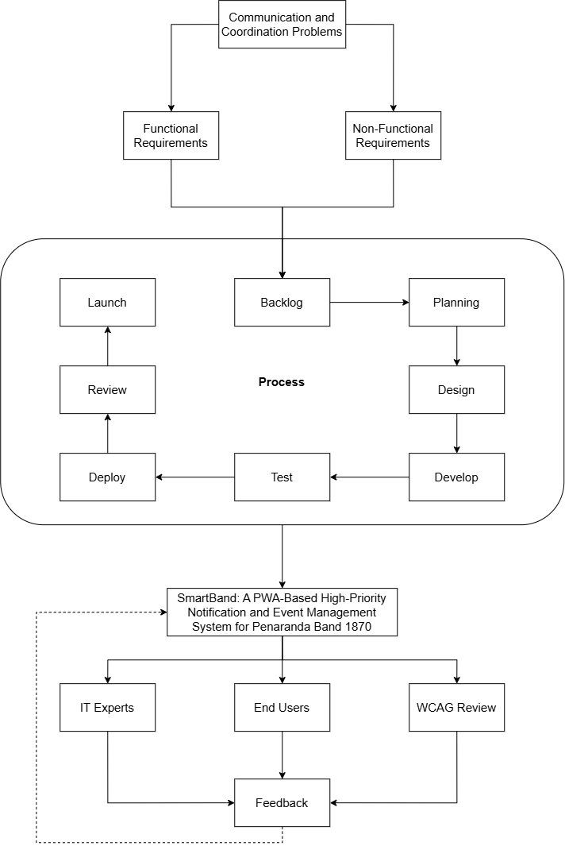
As illustrated in Figure 1, the systematic process initiates with the identification of existing Communication and Coordination Problems within the organization, specifically missed announcements, delayed notifications, message overload in group chats, lack of acknowledgment tracking, and poor event coordination. The synthesis of these operational deficiencies establishes the System Requirements. These are formally categorized into Functional Requirements (high-priority notifications, push notifications, event scheduling, acknowledgment tracking, and user role management) and Non-Functional Requirements (accessibility, reliability, security, performance efficiency, and compatibility).
To construct the solution, the framework employs the Agile Scrum Development Process. Rather than utilizing a rigid, linear methodology, this iterative approach begins with Backlog Grooming to prioritize the system requirements. The development then proceeds through continuous execution cycles comprising Sprint Planning, Design, Develop, Test, Deploy, and Review phases. Upon the successful completion of a sprint cycle, the phase concludes with the Launch of the application.
The culmination of this developmental phase is the SmartBand System, a fully functional Progressive Web Application (PWA)-Based High-Priority Notification and Event Management System. Following its deployment, the application undergoes a rigorous System Evaluation phase divided into three distinct domains. First, an IT Experts Evaluation is conducted to assess technical compliance based on the ISO/IEC 25010:2023 Software Quality Standards. Second, an End Users Evaluation is administered to measure the system's Functional Suitability, Performance Efficiency, Interaction Capability, Reliability, and Security based on the selected ISO/IEC 25010:2023 Software Quality Characteristics, capturing practical usability and overall user experience from the members' perspective. Third, a strict WCAG Accessibility Evaluation is performed to ensure the system is inclusive for all users, specifically assessing if the application's interface and information are Perceivable, Operable, Understandable, and Robust.
A critical component of this framework is the Feedback Synthesis mechanism. Evaluation results from the IT experts, end-users, and accessibility checks are systematically categorized into functional and non-functional deficiencies. These identified issues are subsequently logged as backlog items and prioritized in subsequent Agile sprints for continuous system refinement. This iterative feedback loop guarantees that the final deployment achieves the ultimate objectives of the study: improved communication, improved coordination, efficient notification delivery, and reliable acknowledgment tracking.

Statement of the Problem
This study aimed to design, develop, and evaluate a Progressive Web Application (PWA)-Based High-Priority Notification and Event Management System for Peñaranda Band 1870.
Specifically, this study sought to answer the following questions:
- How was the SmartBand Progressive Web Application designed and developed based on the stages of the Agile Scrum Methodology in terms of:
  - Plan;
  - Design;
  - Development;
  - Testing;
  - Deploy; and
  - Sprint Execution Logs and Documentation?
- How did the officers and members of Peñaranda Band 1870 assess the communication and coordination challenges in the existing group chat-based setup in terms of:
  - Timeliness of Notification;
  - Clarity and Prioritization;
  - Event Scheduling; and
  - Message Acknowledgment?
- How did IT experts assess the technical quality of the Progressive Web Application (PWA)-Based High-Priority Notification and Event Management System for Peñaranda Band 1870 based on the ISO/IEC 25010:2023 Software Quality Standards in terms of:
  - Functional Suitability;
  - Performance Efficiency;
  - Compatibility;
  - Interaction Capability;
  - Reliability;
  - Security;
  - Maintainability;
  - Flexibility; and
  - Safety?
- How did the end-users assess the Progressive Web Application (PWA)-Based High-Priority Notification and Event Management System for Peñaranda Band 1870 based on the selected ISO/IEC 25010:2023 Software Quality Characteristics in terms of:
  - Functional Suitability;
  - Performance Efficiency;
  - Interaction Capability;
  - Reliability; and
  - Security?
- How was the system’s accessibility evaluated by IT experts and end-users based on the Web Content Accessibility Guidelines (WCAG) 2.1 principles, in terms of:
  - Perceivable;
  - Operable;
  - Understandable; and
  - Robust?

Scope and Delimitations
This study focuses on the development and evaluation of a web-based high-priority notification and event management system for Peñaranda Band 1870 located in Peñaranda, Nueva Ecija. The system is designed to provide a centralized platform for sending announcements, delivering notifications, tracking message acknowledgment, and managing scheduled rehearsals and events.
The respondents in the study comprise a total of ninety-eight (98) individuals. This includes all ninety-three (93) registered members of the organization—employing complete enumeration sampling for the band—alongside five (5) selected IT experts, ensuring full representation and an accurate, multi-faceted evaluation of the developed system.
The study covers two major components: (1) identification of communication and coordination problems in the existing method, and (2) evaluation of the developed system based on the ISO/IEC 25010:2023 software quality standards, specifically in terms of functional suitability, performance efficiency, compatibility, interaction capability, reliability, security, maintainability, flexibility, and safety.
The evaluation of the system is based on user feedback gathered after system implementation and testing within the organization.
However, the study is limited to the functionality of the developed system and does not include financial management, instrument inventory monitoring, biometric attendance systems, or integration with external social media platforms. The study also does not measure musical performance, skill development, or behavioral changes of members beyond communication and coordination efficiency.
Furthermore, the system is developed specifically for Peñaranda Band 1870 and is not intended to be generalized for all organizations without further modification and testing. However, while developed explicitly for this group, the system's architecture and foundational features may serve as a replicable model for similar community-based organizations seeking to modernize their communication and coordination infrastructure.

Significance of the Study
The development of the SmartBand Progressive Web Application (PWA)-based high-priority notification and event management system is expected to benefit several specific groups by fundamentally improving communication efficiency and organizational coordination within Peñaranda Band 1870.
Band Members. The system helps members receive clear, timely announcements regarding rehearsals, performances, and schedule changes. Specifically, through the push notification and message prioritization features, members are immediately alerted to urgent updates, significantly reducing the likelihood of critical information being buried or missed. Furthermore, the centralized event calendar feature allows members to easily track upcoming activities, enabling them to prepare properly and participate more consistently.
Band Officers and Leaders. Officers benefit from a dedicated, reliable platform for disseminating official announcements. By utilizing the system's acknowledgment tracking feature, officers can explicitly verify message receipt and confirm member attendance, effectively eliminating the need to repeatedly send manual follow-up reminders in unstructured group chats. Additionally, the event management dashboard streamlines the scheduling process, making overall coordination significantly easier and reducing operational misunderstandings.
Peñaranda Band 1870 Organization. The organization as a whole gains a structured digital infrastructure. By consolidating event scheduling, prioritized announcements, and confirmation tracking into a single PWA platform, the system establishes a reliable "single source of truth." This technological integration minimizes miscommunication, improves attendance rates, and streamlines event preparation, thereby enhancing the band's overall operational efficiency and organizational reliability.
Academic and IT Communities. This study contributes significantly to the existing body of technical knowledge regarding the deployment of Progressive Web Applications (PWAs) in small, non-profit, or community-based organizations. By synthesizing priority-based notification routing with structured acknowledgment tracking in a highly accessible web environment, this project provides a replicable technical blueprint for resolving informal communication inefficiencies (such as group chat information overload) without requiring costly enterprise-level software or the friction of native application installations.
Future Researchers. This study will serve as a foundational reference for future researchers developing PWA-based notification mechanisms, organizational management platforms, or specialized communication tools for small community groups. The technical framework, system architecture, and empirical evaluation metrics documented in this research will provide baseline data for further improving structured coordination systems and digital accessibility features in similar grassroots institutions.

Definition of Terms
The following terms are defined both conceptually and operationally as used in this study:
Acknowledgment Tracking. A feature in communication systems that verifies and records whether a specific message has been successfully received and processed by intended users (Sharp et al., 2007; Grudin, 1994). In this study, it refers to the SmartBand system function that records and displays whether a band member has viewed and explicitly confirmed receipt of an announcement.
Administrator. A user who manages system operations, including user accounts and content control (Laudon & Laudon, 2020). In this study, the authorized band officer refers to the person who manages announcements, schedules, and system users.
Announcement. A formal communication used to inform members about organizational activities or updates (Robbins & Judge, 2017). In this study, it refers to official messages sent through the system regarding rehearsals, performances, and events.
Centralized Scheduling. A system that organizes and manages events within a single platform to improve coordination (Laudon & Laudon, 2020). In this study, the term refers to the calendar feature that displays and manages all band activities.
Coordination. The process of organizing group activities to achieve common goals efficiently (Robbins & Judge, 2017). In this study, it refers to band members' organized participation in rehearsals and events.
Event Management System. A system used to organize, schedule, and manage events within an organization (Laudon & Laudon, 2020). In this study, it refers to the feature that allows administrators to create and manage rehearsal and performance schedules.
High-Priority Notification. A notification that is marked as urgent and designed to capture immediate user attention (Preece et al., 2015). In this study, system alerts are visually and functionally distinguished to emphasize important announcements.
Information Dissemination. The process of distributing information to a group of people (Robbins & Judge, 2017). In this study, it refers to how announcements are delivered to band members.
Interaction Capability. The degree to which a system provides user interfaces that enable users to interact effectively, efficiently, and with satisfaction (ISO/IEC 25010:2023). In this study, this term replaces the traditional construct of 'usability' and refers to how intuitively members and officers can learn, navigate, and operate the SmartBand system functions.
Member. An individual who belongs to an organization and participates in its activities (Robbins & Judge, 2017). In this study, it refers to registered members of Peñaranda Band 1870 who receive notifications and interact with the system.
Notification System. A system that delivers messages or alerts to users to inform them of updates or events (Preece et al., 2015). In this study, it refers to the feature that sends announcements and alerts to band members through the web application.
Progressive Web Application (PWA). A web application that provides app-like features such as offline access and push notifications (DICT, 2022). In this study, the SmartBand system is designed to function across devices without installation.
Push Notification. A message sent from a system to a user’s device to provide real-time updates (Preece et al., 2015). In this study, it refers to alerts sent by the SmartBand system to notify members of announcements.
Software Quality. The degree to which a system meets specified requirements and user expectations (ISO/IEC 25010:2023). In this study, the term refers to the evaluation of the system against ISO 25010 criteria.
System Acceptability. The overall assessment of whether a system is practically and socially acceptable to satisfy the needs and requirements of its stakeholders (Nielsen, 1993). In this study, it refers to the respondents’ collective approval and validation of the SmartBand system based on their evaluation of its software quality characteristics, rather than just the evaluation process itself.
System User. An individual who interacts with a system to perform tasks (Laudon & Laudon, 2020). In this study, it refers to both administrators and members who use the system.
Web-Based System. A system that operates through a web browser without requiring installation on a device (Laudon & Laudon, 2020). In this study, it refers to the SmartBand system accessed via internet browsers.

Chapter 2
METHODOLOGY
This chapter presents the research design, locale, respondents, instruments, data gathering procedures, data analysis techniques, and ethical considerations of the study.

Research Design
This study employed a descriptive-developmental research design. The descriptive method was utilized to identify and analyze the existing communication and coordination problems experienced by the organization. Specifically, it examined operational issues such as missed announcements, delayed information dissemination, lack of acknowledgment, and difficulty in tracking schedules. To achieve this, primary data regarding communication inefficiencies and user needs were collected directly from the ninety-three (93) active band members and officers, alongside five (5) IT experts, comprising a total of ninety-eight (98) respondents through structured assessment instruments.
The descriptive phase identified existing communication challenges, which directly informed the functional and non-functional requirements addressed in the developmental phase. For instance, the identified prevalence of missed messages directly dictated the requirement for push notifications and acknowledgment tracking in the developed solution. The developmental method was subsequently applied in the actual design, creation, and evaluation of the web-based high-priority notification and event management system. According to Richey and Klein (2014), developmental research focuses on the systematic process of designing, developing, and evaluating technological solutions to accurately address real-world problems.
This combined research design is highly appropriate for the study because it not only investigates the current organizational challenges but also provides a systematic framework to build, refine, and validate a practical technological solution. It seamlessly links the problem identification to system creation by following a structured Agile Scrum development process, which encompasses requirement gathering, iterative system design, development, testing, and deployment of the SmartBand Progressive Web Application (PWA).
Furthermore, to fully justify the developmental design, the process culminated in a rigorous evaluation phase. The developed system was evaluated by IT experts and end-users using the updated ISO/IEC 25010:2023 software quality standards. This ensured the system's technical and practical acceptability was comprehensively assessed in terms of functional suitability, performance efficiency, compatibility, interaction capability, reliability, security, maintainability, flexibility, and safety.

Research Locale
The study was conducted in Poblacion III, Peñaranda, Nueva Ecija, which serves as the primary operational base for Peñaranda Band 1870. As illustrated in Figure 2, this specific locality is where the organization regularly convenes for rehearsals, meetings, and civic performances. The band operates within a concentrated community setting, with members residing within or near the area to enable regular participation. This locale was purposefully selected because it encapsulates the exact organizational environment where the previously discussed communication and coordination inefficiencies occur. Implementing the SmartBand system directly within this specific setting ensured that the developed solution was designed to address the actual logistical realities of the community group.

Figure 2
Location of Peñaranda Band 1870 in Poblacion III, Peñaranda, Nueva Ecija
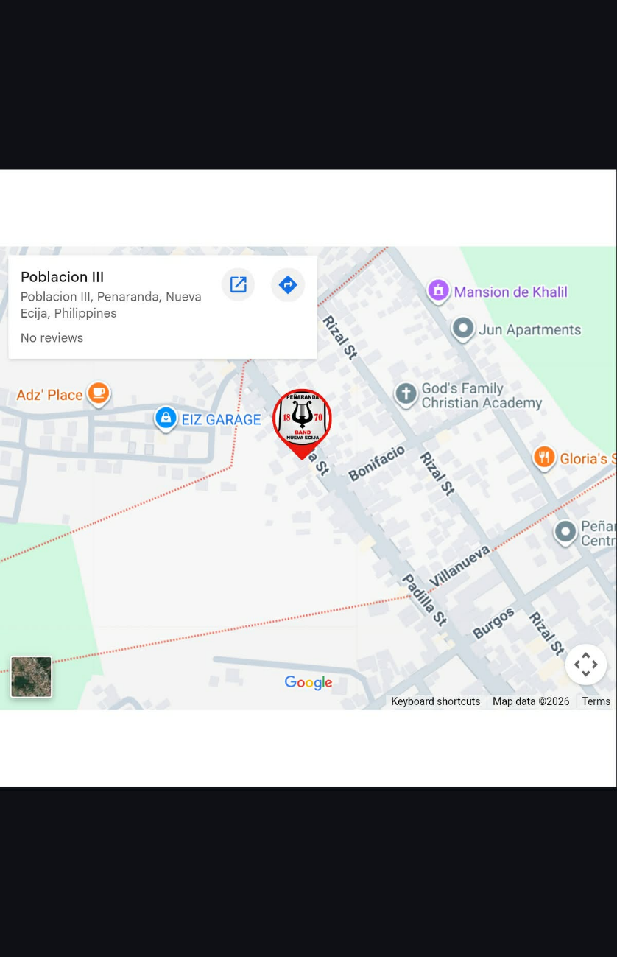
As shown in Figure 2, Peñaranda Band 1870 is situated in Poblacion III, Peñaranda, Nueva Ecija, Philippines. The area is characterized by a community-based environment, with members residing within or near the locality, enabling regular participation in organizational activities. The location's accessibility makes it a practical setting for implementing and testing the developed system.
The selection of this locale was based on the communication and coordination challenges the organization currently faces. The reliance on group chat platforms may lead to information overload, with important announcements often mixed with non-essential conversations. In addition, the absence of a centralized communication system and acknowledgment mechanism may lead to missed notifications, delayed responses, and inconsistencies in attendance during rehearsals and events. These conditions make the locale appropriate for examining the potential effectiveness of a high-priority notification and event management system.
Furthermore, conducting the study within this locale was expected to provide practical advantages for system deployment and evaluation. Since all respondents were members of Peñaranda Band 1870 and were located within this area, the researchers were able to facilitate efficient data collection and system testing. The organization's localized nature was also expected to support accurate feedback based on actual system usage. By implementing the SmartBand system in this setting, the study aimed to determine its effectiveness in improving communication efficiency, enhancing coordination, and supporting member participation within a community-based organization.

Respondents of the Study
The respondents of the study consisted of a total of ninety-eight (98) individuals. This population was composed of ninety-three (93) registered members of Peñaranda Band 1870, including both the officers and regular members, alongside five (5) selected IT experts.
To appropriately select these respondents, the study employed a dual sampling approach: complete enumeration sampling for the organizational members and purposive sampling for the technical evaluators. Combining these two sampling methods within the same study is highly appropriate because evaluating a web-based system requires both the practical, everyday perspective of the end-users and the specialized, technical assessment of software professionals.
For the band organization, complete enumeration sampling was utilized, wherein all ninety-three (93) active members were included as respondents. This method was justified because the total population was highly manageable in size, which allowed the researchers to eliminate sampling error. By surveying the entire population, the study ensured comprehensive data collection that captured the diverse digital literacy levels, communication habits, and logistical perspectives of every individual within the organization. This guaranteed a highly accurate evaluation of the SmartBand system's practical effectiveness in improving their specific coordination challenges.
Conversely, purposive sampling was utilized to select the five (5) IT experts. Because evaluating the system's software architecture requires specialized knowledge, these experts were selected based on strict criteria: they had to have a minimum of three (3) years of professional or academic experience in web systems development, possess a strong understanding of Progressive Web Applications (PWAs), and be highly familiar with the ISO/IEC 25010:2023 Software Quality Standards and Web Content Accessibility Guidelines (WCAG). This targeted selection ensured the technical evaluation was conducted by highly qualified professionals capable of accurately assessing complex metrics such as performance efficiency, security, and maintainability.
The distribution of respondents is presented in Table 2.

Table 2
Distribution of Respondents
Category | Frequency (n) | Percentage (%)
IT Experts | 5 | 5.10%
Officers | 10 | 10.20%
Members | 83 | 84.70%
Total | 98 | 100

As presented in Table 2, the study involved a total of ninety-eight (98) respondents, composed of IT experts, officers, and members of Peñaranda Band 1870. The majority of the respondents were the members, with a frequency of 83 or 84.70% of the total population. This indicates that the evaluation primarily focused on the actual end-users of the developed system, since the members are the primary recipients of notifications, announcements, and scheduled event updates. Their responses are essential in determining the usability, functionality, and reliability of the system from the user’s perspective.
The officers, with a frequency of 10 or 10.20%, were also included as respondents because they serve as the administrators and coordinators of the organization’s activities. As users responsible for posting announcements, managing schedules, and monitoring member participation, their evaluation provides valuable insights into the effectiveness of the system’s management and notification features.
In addition, 5 IT experts representing 5.10% of the total respondents were purposively selected to assess the technical quality of the developed application. Their inclusion is important in evaluating the system based on the ISO/IEC 25010:2023 software quality standards and accessibility principles. Their professional assessment strengthens the credibility of the study by providing an expert perspective on the system’s technical performance, security, maintainability, and overall compliance with software quality requirements.
The inclusion of these respondent groups ensured a balanced and comprehensive evaluation of the developed system from both the technical perspective of experts and the practical experience of actual users, thereby supporting the validity and reliability of the study’s findings.

Research Instrument
The primary instruments used in this study are researcher-adapted survey questionnaires designed to gather data for the evaluation of the developed Progressive Web Application (PWA)-Based High-Priority Notification and Event Management System for Peñaranda Band 1870. The instruments were developed in accordance with the study’s objectives and aligned with the Statement of the Problem to ensure that all relevant system aspects are adequately assessed. The research instrument is composed of four (4) main evaluation tools, supplemented by an open-ended feedback section. To eliminate ambiguity regarding their distribution, the administration of these tools is strictly categorized by respondent group.
The first instrument is based on the updated ISO/IEC 25010:2023 Software Product Quality Model, which is utilized for the technical assessment of the system. This instrument is administered exclusively to the IT experts and evaluates the system in terms of core software quality characteristics, including functional suitability, performance efficiency, compatibility, reliability, security, maintainability, and other relevant technical attributes. This ensures that the system is evaluated from a professional and technical standpoint.
The second instrument is based on selected criteria from the ISO/IEC 25010:2023 Software Quality Model, tailored specifically for usability and user experience assessment. This instrument is administered exclusively to the end-users (band officers and members) and focuses on evaluating the system in terms of functional suitability, performance efficiency, interaction capability, reliability, and security. This emphasizes the practical usability of the system, particularly in relation to how effectively and efficiently end-users can interact with the application in real-world usage scenarios.
The third instrument is a Web Content Accessibility Guidelines (WCAG)-based questionnaire, which is used to assess the digital accessibility of the system. To ensure a comprehensive evaluation, this specific instrument is administered to both the IT experts and the end-users to determine whether the system is perceivable, operable, understandable, and robust. It evaluates the system’s accessibility compliance across different devices, user capabilities, and usage environments, ensuring inclusivity.
The fourth instrument is a researcher-made baseline survey on communication and coordination challenges (Part II of Appendix B-2), which is administered to the officers and members before they use the system. It contains twelve (12) statements grouped into four categories, namely Timeliness of Notification, Clarity and Prioritization, Event Scheduling, and Message Acknowledgment, which are rated on a 5-point Likert scale (5 = Strongly Agree to 1 = Strongly Disagree).
In addition, the questionnaire includes open-ended questions administered to both respondent groups that allow them to provide qualitative feedback regarding their experiences, concerns, and suggestions. To ensure these responses are rigorously evaluated, the qualitative data gathered from this section were analyzed using Thematic Analysis. The researchers systematically coded the open-ended responses to identify recurring patterns, themes, and user sentiments. This qualitative component supports the quantitative findings by providing deeper, contextual insights into user perception and system performance.
Prior to data collection, all instruments were subjected to a strict validation process to ensure clarity, relevance, and alignment with the study objectives. The instruments were validated by a panel consisting of the research adviser and three (3) external IT professionals holding master's degrees and extensive industry experience in software engineering and web development. Based on their expert feedback, several revisions were incorporated prior to final administration; specifically, highly technical jargon in the end-user questionnaire was simplified to ensure comprehensibility for respondents with varying digital literacy levels, and the WCAG metrics were realigned to specifically target mobile-browser accessibility.

Data Gathering Procedure
This section presents the data-gathering procedure that was followed in conducting the study. The process was carefully designed to ensure that the data collected were accurate, reliable, and relevant to the objectives of the research. It outlined the systematic steps the researchers undertook, from preparing and validating the research instrument to analyzing and interpreting the collected data.
The procedure also ensured that ethical considerations were strictly observed throughout the study, including voluntary participation, confidentiality of responses, and proper coordination with the organization. Each step in the process was intended to establish a structured approach to data collection, allowing the researchers to effectively identify the communication challenges experienced by the members of Peñaranda Band 1870 and to evaluate the developed SmartBand system.
Furthermore, the procedure integrated both the descriptive and developmental components of the study. It included identifying existing communication problems and evaluating the developed system against ISO/IEC 25010:2023 software quality characteristics and the Web Content Accessibility Guidelines (WCAG). This ensured that the data gathered supported both problem analysis and system assessment.
Figure 3 illustrates the flowchart of the data gathering procedure followed in the study.

Figure 3
Flowchart of Data Gathering Procedure
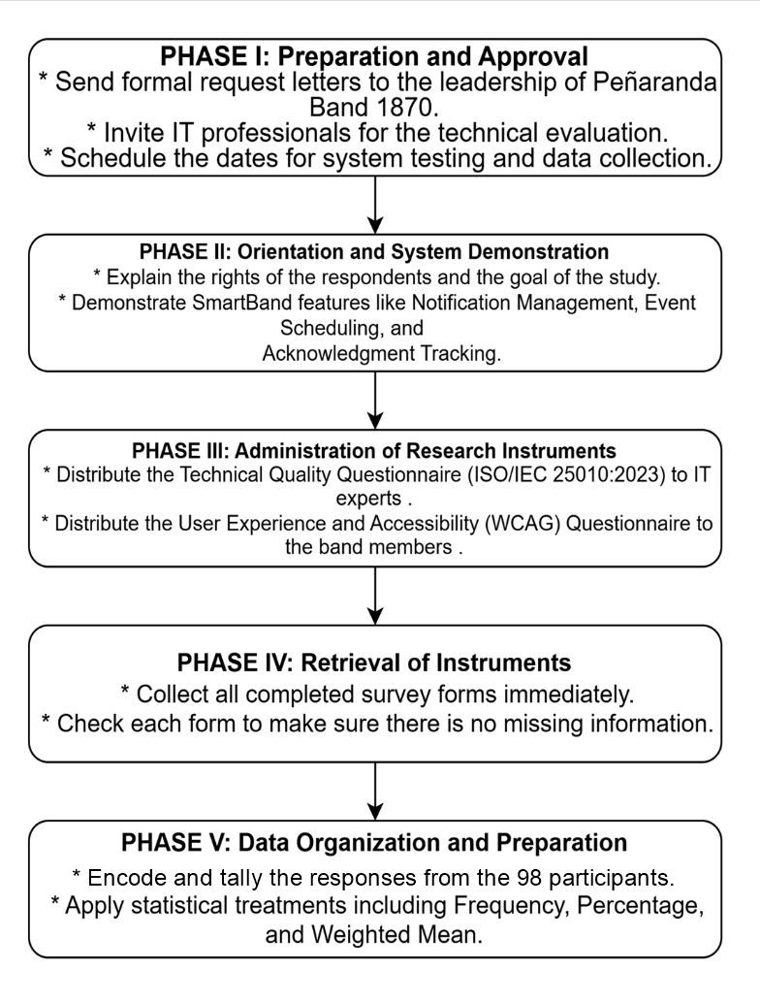
The first phase was the preparation and approval stage. The researchers prepared a formal letter of request addressed to the leadership of Peñaranda Band 1870, seeking permission to conduct the study within the organization and to involve the band officers and members as respondents. A separate request was also sent to selected IT professionals, inviting them to participate as technical evaluators of the system. These letters clearly stated the study's purpose, the procedures involved, and the expected participation of the respondents. Upon approval, the researchers coordinated with the band leadership to schedule data collection at a convenient time that did not disrupt regular rehearsals or band activities.
The second phase involved orientation and system demonstration. Before administering the research instruments, the researchers conducted a brief orientation session for all respondents. During this session, the study's purpose was explained, and respondents were informed of their rights, including the option to participate voluntarily, confidentiality, and the right to withdraw at any time. Following the orientation, the researchers demonstrated the developed SmartBand Progressive Web Application. This included showcasing key system features such as the High-Priority Notification Management, Centralized Event Scheduling, and the Message Acknowledgment Tracking mechanism. This step ensured that respondents had sufficient understanding of the system’s functionalities before providing their evaluation.
The third phase was the administration of the research instruments. The appropriate questionnaire was distributed to each group of respondents based on their role. The Technical Quality Questionnaire, based on ISO/IEC 25010:2023, and the WCAG Accessibility Questionnaire were given to IT professionals, while the User Experience and WCAG Accessibility Questionnaire was administered to the band officers and members. The communication challenges survey (Part II of Appendix B-2) was answered by the officers and members based on their experience with the Messenger group chats before they used SmartBand. The researchers were present during the evaluation to clarify any questions and ensure that the respondents completed the questionnaire independently, without external influence.
The fourth phase was the retrieval of the instruments. To ensure a high retrieval rate and data completeness, the researchers collected completed questionnaires immediately upon respondents' completion. Each questionnaire was checked for completeness to avoid missing data. Incomplete responses, if there were any, were politely verified with the respondents before final collection.
The fifth phase was the data organization and preparation for analysis. The data collected from the 98 respondents were systematically encoded, tallied, and organized into tabular form. The responses were then subjected to appropriate statistical treatment, such as the computation of weighted means, to facilitate analysis and interpretation. All collected data were handled with strict confidentiality and were used solely for academic purposes.

Data Analysis and Techniques
This study employed a quantitative research approach, using descriptive statistical methods to analyze and interpret data collected from the respondents. The quantitative approach was appropriate for this study because it involved the systematic collection of numerical data through a structured survey questionnaire and the measurement of respondents’ perceptions using a Likert scale. Through this approach, the researchers quantified the organization's communication challenges and evaluated the developed SmartBand system against established criteria.
Specifically, the study employed a quantitative descriptive method, focusing on summarizing, organizing, and interpreting numerical data to describe the current conditions and evaluate system performance. This method was suitable because the study did not aim to establish cause-and-effect relationships, but rather to assess and describe the level of communication challenges, system requirements, system acceptability, and accessibility compliance based on participants' responses.
The primary statistical tools used in this study were frequency, percentage, weighted mean, and rank, which are commonly applied to analyzing Likert-scale data. The weighted mean allowed the researchers to determine the average response for each variable by assigning numerical values to participants' responses. To ensure methodological transparency, the weighted mean was computed using the following formula:
WM = (Σfx) / N

Where:
- WM = Weighted Mean
- Σ = Summation symbol
- f = Frequency of responses
- x = Assigned weight or numerical value of the scale
- N = Total number of respondents

Each research problem was analyzed according to the nature of its data. For Research Problem 1, which concerns the design and development of the SmartBand Progressive Web Application, the researchers narrated and documented the tasks performed in each stage of the Agile Scrum methodology (Plan, Design, Development, Testing, Deploy, and Sprint Execution Logs and Documentation). The outputs of these stages were presented through descriptive tables, system models, and figures, and no statistical treatment was applied.
For Research Problem 2, which concerns the communication and coordination challenges in the existing setup, the responses of the ninety-three (93) officers and members to Part II of the survey questionnaire (Appendix B-2) were encoded, and the weighted mean was computed for each indicator, for each category (Timeliness of Notification, Clarity and Prioritization, Event Scheduling, and Message Acknowledgment), and for all categories combined. The categories were ranked from the highest to the lowest weighted mean and interpreted using the following scale: 4.21 – 5.00 (Strongly Agree / Very High Extent of Challenge), 3.41 – 4.20 (Agree / High Extent of Challenge), 2.61 – 3.40 (Neutral / Moderate Extent of Challenge), 1.81 – 2.60 (Disagree / Low Extent of Challenge), and 1.00 – 1.80 (Strongly Disagree / Very Low Extent of Challenge).
For Research Problem 3, the ratings of the five (5) IT experts on the nine (9) ISO/IEC 25010:2023 software quality characteristics were treated using the weighted mean for each indicator, for each characteristic, and for all characteristics combined, and the characteristics were ranked from the highest to the lowest. The means were interpreted using the scoring rubrics in Tables 3 to 11, in which the 5-point agreement scale corresponds to the qualitative remarks of each characteristic (4.21 – 5.00 = Strongly Agree; 3.41 – 4.20 = Agree; 2.61 – 3.40 = Neutral; 1.81 – 2.60 = Disagree; and 1.00 – 1.80 = Strongly Disagree). A weighted mean of 3.41 or higher was considered the acceptability threshold.
For Research Problem 4, the ratings of the ninety-three (93) end-users, composed of ten (10) officers and eighty-three (83) members, on Functional Suitability, Interaction Capability, Reliability, Performance Efficiency, and Security were treated using the weighted mean for each group of respondents, for all end-users combined, and for all characteristics combined, and the characteristics were ranked from the highest to the lowest. The means were interpreted using the same 5-point scale and the scoring rubrics in Tables 3, 4, 6, 7, and 8.
For Research Problem 5, the accessibility ratings on the four WCAG 2.1 principles (Perceivable, Operable, Understandable, and Robust) were treated using the weighted mean and rank, and were interpreted using the scoring rubric in Table 12 (4.21 – 5.00 = Highly Accessible; 3.41 – 4.20 = Accessible; 2.61 – 3.40 = Moderately Accessible; 1.81 – 2.60 = Slightly Accessible; and 1.00 – 1.80 = Not Accessible).
The open-ended responses of the respondents were analyzed using thematic analysis (Braun & Clarke, 2006) to support and explain the quantitative findings.
Tables 3 to 12 present the scoring rubrics used to interpret the results for Research Problems 3 to 5.

Table 3
Scoring Rubric for Functional Suitability
Range | Qualitative Remarks | Verbal Description
4.21 – 5.00 | Highly Suitable | The SmartBand meets or exceeds all functional requirements with a high accuracy, completeness, and efficiency.
3.41 – 4.20 | Suitable | The SmartBand meets most functional requirements with a satisfactory level of accuracy, completeness, and efficiency.
2.61 – 3.40 | Somewhat Suitable | The SmartBand meets some functional requirements but demonstrates low levels of accuracy, completeness, or efficiency.
1.81 – 2.60 | Unsuitable | The SmartBand meets very few functional requirements, with low accuracy, completeness, and efficiency.
1.00 – 1.80 | Highly Unsuitable | The SmartBand fails to meet most or all functional requirements, with very low accuracy, completeness, and efficiency.

As presented in Table 3, the scoring rubric was used to evaluate the system’s functional suitability, particularly its ability to provide the required features, deliver accurate results, and support intended operations under specified conditions.

Table 4
Scoring Rubric for Performance Efficiency
Range | Qualitative Remarks | Verbal Description
4.21 – 5.00 | Highly Efficient | The SmartBand’s performance is exceptional, meeting or exceeding all efficiency requirements. Users experience no delays or errors, and the system performs consistently well under all operating conditions.
3.41 – 4.20 | Efficient | The SmartBand’s performance is above average and meets most efficiency requirements. Users experience minimal delays or errors, and the system performs well under normal operating conditions.
2.61 – 3.40 | Less Efficient | The SmartBand’s performance is average, with room for improvement. Users may experience occasional delays or errors, but overall, the system functions adequately.
1.81 – 2.60 | Inefficient | The SmartBand’s performance is below average and fails to fully meet efficiency requirements. Users may experience delays or errors that affect productivity.
1.00 – 1.80 | Highly Inefficient | The SmartBand’s performance is significantly below expectations, frequently causing delays, errors, or failures that disrupt normal operation.

As presented in Table 4, the scoring rubric was utilized to assess the system’s performance efficiency. This evaluation focuses on how well the SmartBand performs under various operating conditions, specifically looking for the absence of delays or errors and its consistency during normal operation.
Table 5
Scoring Rubric for Compatibility
Range | Qualitative Remarks | Verbal Description
4.21 – 5.00 | Highly Compatible | The SmartBand is fully compatible with other hardware or software and can seamlessly integrate without any issues or modifications.
3.41 – 4.20 | Compatible | The SmartBand can work with other hardware or software with minor adjustments or configurations.
2.61 – 3.40 | Somewhat Compatible | The SmartBand can work with other hardware or software but requires significant adjustments or configurations.
1.81 – 2.60 | Less Compatible | The SmartBand struggles to work with other hardware or software and needs major adjustments.
1.00 – 1.80 | Not Compatible | The SmartBand cannot work with other hardware or software and requires complete redesign or replacement.

As presented in Table 5, the scoring rubric was used to measure the system's compatibility. This focuses on the SmartBand's ability to seamlessly integrate and function with other hardware or software components without requiring major modifications or redesigns.

Table 6
Scoring Rubric for Interaction Capability
Range | Qualitative Remarks | Verbal Description
4.21 – 5.00 | Highly Interactive | Users can perform tasks intuitively and efficiently, with smooth system responses and clear, immediate feedback.
3.41 – 4.20 | Interactive | Users can perform tasks with some guidance or minor delays; system feedback is generally adequate.
2.61 – 3.40 | Less Interactive | Users face difficulties interacting with the system, with delays or unclear feedback reducing task efficiency.
1.81 – 2.60 | Poorly Interactive | Users experience significant difficulties, with delayed responses and confusing feedback.
1.00 – 1.80 | Non-Interactive | Users cannot effectively interact with the system due to poor responsiveness, unclear instructions, or system errors.

As presented in Table 6, the scoring rubric was used to evaluate the interaction capability of the system. This assessment determines how intuitively users can perform tasks and whether the system provides immediate, clear feedback and smooth responses during user engagement.

Table 7
Scoring Rubric for Reliability
Range | Qualitative Remarks | Verbal Description
4.21 – 5.00 | Highly Reliable | The SmartBand performs consistently without failures, providing accurate and dependable outcomes under all conditions.
3.41 – 4.20 | Reliable | The SmartBand generally operates as expected, with only minor or occasional errors.
2.61 – 3.40 | Slightly Reliable | The SmartBand is prone to errors or interruptions, affecting performance and dependability.
1.81 – 2.60 | Unreliable | The SmartBand frequently experiences errors or interruptions, reducing overall dependability.
1.00 – 1.80 | Non-Reliable | The SmartBand frequently fails or produces inaccurate results, making it unreliable for intended use.

As presented in Table 7, the scoring rubric was used to determine the reliability of the system. This involves evaluating the SmartBand’s ability to perform consistently and produce accurate, dependable outcomes without frequent interruptions or failures.

Table 8
Scoring Rubric for Security
Range | Qualitative Remarks | Verbal Description
4.21 – 5.00 | Strong Security | The SmartBand has multiple layers of security measures that provide comprehensive protection against unauthorized access, data breaches, and other threats. Security features are regularly updated and tested to ensure effectiveness.
3.41 – 4.20 | Adequate Security | The SmartBand has basic security measures that prevent most common threats; however, some vulnerabilities may exist and require improvement.
2.61 – 3.40 | Weak Security | The SmartBand has significant security vulnerabilities, with gaps that may allow unauthorized access, data breaches, or other threats. Immediate improvements are needed.
1.81 – 2.60 | Very Weak Security | The SmartBand’s security measures are largely ineffective, leaving it vulnerable to breaches or data loss.
1.00 – 1.80 | No Security | The SmartBand has no effective security measures and is highly vulnerable to breaches and data loss. Urgent action is required.

As presented in Table 8, the scoring rubric was used to assess the system’s security. The evaluation focuses on the effectiveness of the system’s multi-layered security measures in protecting against data breaches and unauthorized access, ensuring that user data remains confidential and secure.

Table 9
Scoring Rubric for Maintainability
Range | Qualitative Remarks | Verbal Description
4.21 – 5.00 | Highly Maintainable | The SmartBand can be easily modified, updated, or corrected with minimal effort due to well-structured and organized design.
3.41 – 4.20 | Maintainable | The SmartBand can be modified or updated with minor effort, maintaining acceptable performance and structure.
2.61 – 3.40 | Less Maintainable | The SmartBand requires considerable effort to modify or update due to complexity or lack of structure
1.81 – 2.60 | Hardly Maintainable | The SmartBand is difficult to modify or fix, requiring significant time and effort for maintenance.
1.00 – 1.80 | Not Maintainable | The SmartBand cannot be effectively modified or maintained due to poor design or extreme complexity.

As presented in Table 9, the scoring rubric was used to evaluate the maintainability of the system. This measures how easily the SmartBand can be modified, updated, or corrected based on its organizational structure and design complexity.

Table 10
Scoring Rubric for Flexibility
Range | Qualitative Remarks | Verbal Description
4.21 – 5.00 | Highly Flexible | The SmartBand easily adapts to various user needs, environments, or configurations without requiring major changes.
3.41 – 4.20 | Flexible | The SmartBand can adapt to most user needs or environments with minor adjustments or configuration changes.
2.61 – 3.40 | Less Flexible | The SmartBand has limited adaptability and requires significant changes to support different needs or environments
1.81 – 2.60 | Hardly Flexible | The SmartBand struggles to adapt to new user requirements or environments without major redesign.
1.00 – 1.80 | Not Flexible | The SmartBand cannot adapt to different user needs or environments, limiting its usability

As presented in Table 10, the scoring rubric was used to assess the flexibility of the system. This evaluation determines how well the application adapts to various user requirements, environments, or configurations without necessitating major structural changes.

Table 11
Scoring Rubric for Safety
Range | Qualitative Remarks | Verbal Description
4.21 – 5.00 | Highly Safe | The SmartBand effectively prevents hazards, protects users and data, and functions securely under all conditions.
3.41 – 4.20 | Safe | The SmartBand is generally safe, with only minor risks that do not significantly affect users or data
2.61 – 3.40 | Slightly Unsafe | The SmartBand presents noticeable safety risks that may potentially affect users or data.
1.81 – 2.60 | Unsafe | The SmartBand exposes users or data to significant hazards or risks, affecting reliability and functionality.
1.00 – 1.80 | Highly Unsafe | The SmartBand is unsafe, posing serious hazards to users or data. Urgent corrective actions are required.

As presented in Table 11, the scoring rubric was used to evaluate the safety of the system. This focuses on the system's ability to prevent hazards and function securely to protect both the users and the integrity of the data under all conditions.

Table 12
Scoring Rubric for Web Accessibility (WCAG 2.1)
Range | Qualitative Remarks | Verbal Description
4.21 – 5.00 | Highly Accessible | The SmartBand is considered fully compliant with web accessibility standards.
3.41 – 4.20 | Accessible | The SmartBand is perceived to have minor issues, but is generally accessible.
2.61 – 3.40 | Moderately Accessible | The SmartBand is perceived to have accessibility barriers.
1.81 – 2.60 | Slightly Accessible | The SmartBand is perceived to have major accessibility issues.
1.00 – 1.80 | Not Accessible | The SmartBand is perceived as unusable for users with disabilities.
As presented in Table 12, the scoring rubric was used to evaluate the system’s compliance with the Web Content Accessibility Guidelines (WCAG 2.1). This assessment ensures that the SmartBand is inclusive and usable for individuals with diverse needs and abilities, ranging from fully compliant to unusable.

Ethical Considerations
This study strictly adhered to ethical standards in the conduct of research to ensure the protection, rights, and welfare of all participants involved. Ethical considerations were observed throughout the entire research process, including data collection, system testing, analysis, and reporting of results. Furthermore, prior to the study’s execution, the research protocol underwent an institutional ethics review and was approved by the college’s research committee, ensuring full compliance with institutional ethical guidelines and standards.
Prior to data collection, the researchers sought permission from the appropriate authorities of Peñaranda Band 1870. A formal request letter was submitted to inform the organization about the purpose, scope, and procedures of the study. Data collection only proceeded upon the formal approval of this request.
Participation in this study was entirely voluntary. All respondents were informed about the nature and purpose of the study before they were asked to participate. A consent statement was included in the questionnaire to ensure that participants willingly agreed to be part of the research. Respondents also had the right to withdraw from the study at any time without any penalty or consequence.
The researchers ensured the confidentiality and anonymity of all respondents. Personal information was not disclosed, and responses were treated with strict confidentiality. Data collected were used solely for academic purposes and were not shared with any unauthorized individuals or organizations.
In compliance with the Data Privacy Act of 2012 (Republic Act No. 10173), all collected data were securely stored and protected from unauthorized access. Only the researchers had access to the data, and appropriate measures were taken to safeguard both digital and physical records. To enforce proper data retention and disposal, a strict data lifecycle was implemented; all collected data were scheduled to be retained in secure storage for a maximum period of one (1) year following the project's conclusion. Upon the expiration of this retention period, all physical records were to be securely shredded, and digital files were to be permanently wiped from all drives to ensure they could not be recovered or reconstructed.
The study also ensured that there was no harm or risk to the participants. The questionnaire was designed to avoid sensitive or intrusive questions, and the system evaluation focused solely on user experience and system performance. Respondents were not subjected to any form of physical, psychological, or social harm during the conduct of the study.
Furthermore, the researchers observed honesty and integrity in reporting the findings. All data were presented accurately without manipulation, fabrication, or misrepresentation. Proper acknowledgment of sources and references was also strictly observed to avoid plagiarism.
Overall, these ethical principles were implemented to ensure that the study was conducted responsibly, respectfully, and in accordance with accepted academic research standards.

Chapter 3
RESULTS AND DISCUSSION
This chapter presents, analyzes, and interprets the data gathered from the development, implementation, and evaluation of the SmartBand Progressive Web Application. Grounded in the descriptive-developmental research design, the discussion begins by presenting the systematic development of the system to address the communication and coordination inefficiencies of Peñaranda Band 1870 identified in the preceding chapters. The organization's reliance on unstructured group chats was translated into specific technical requirements, which guided the development of a centralized, priority-based platform for announcements, notifications, event scheduling, and acknowledgment tracking.
Following the design and development section, which presents the developed user interfaces and system capabilities, the chapter systematically addresses the specific problems of the study. It first presents the communication challenges experienced by the members of Peñaranda Band 1870. It then presents the technical quality evaluation conducted by IT experts and the system acceptability assessment conducted by the end-users, using the ISO/IEC 25010:2023 software quality model. Finally, the chapter presents the accessibility compliance results based on the Web Content Accessibility Guidelines (WCAG), providing an assessment of the application's accessibility and usability for its intended users. The five research problems are addressed in the order in which they appear in the Statement of the Problem, followed by the qualitative feedback and the synthesis of the findings.

1. Design and Development of SmartBand Progressive Web Application (Addressing Research Problem 1)
The development of the SmartBand Progressive Web Application (PWA) followed a systematic approach to address the specific communication and coordination challenges of Peñaranda Band 1870. This phase was guided by the Agile Scrum methodology, which allowed for the iterative refinement of the system's functional requirements throughout the development process. The organization's previous reliance on unstructured group chats was translated into specific technical solutions, with the development focused on building a centralized, cross-platform platform designed to prioritize urgent announcements and efficiently track member participation.

1.1 Plan
During the initial planning phase, the researchers focused on identifying the core communication and coordination challenges experienced by Peñaranda Band 1870. The identified concerns included difficulties in managing announcements, scheduling activities, and coordinating events through existing communication channels. These findings served as the foundation for defining the objectives, scope, and functional requirements of the SmartBand Progressive Web Application (PWA).
Following the identification of the system requirements, the researchers established the project scope and development priorities to guide the systematic implementation of the developed solution. The planning process considered the functional and nonfunctional requirements of the system, including high-priority notifications, event scheduling, acknowledgment tracking, user role management, accessibility, reliability, security, performance efficiency, and compatibility. These requirements were organized to provide a clear direction for the succeeding design and development phases.
The planning stage was conducted within the Agile Scrum framework established for the project. The identified requirements served as the basis for the development backlog and subsequent sprint activities. Through this approach, the researchers established a structured roadmap for transforming the communication and coordination requirements of Peñaranda Band 1870 into a centralized web-based platform. The resulting plan guided the succeeding design, development, testing, deployment, and evaluation of the SmartBand Progressive Web Application.

Table 13
User Stories and System Requirements Mapping
User Stories | Actor(s) | Functional Requirement | Non-Functional Requirement | Needed UI | Scenario
[USER REGISTRATION & APPLICATION MGT] As a new musician, I want to register and specify my instrument so I can be verified on the master list. | Band Member | The system must capture user details and store the account with a "Pending" status. | Security: Secure password handling and strict data privacy compliance. | Landing Page / Registration Form | A new trombonist registers their details to request access to the band's digital portal.
[USER REGISTRATION & APPLICATION MGT] As an administrator, I want to review pending registrations so only verified musicians gain access. | IT Administrator | The system must display unverified users and allow the admin to execute "Approve & Verify" or "Decline". | Security: Strict enforcement of Role-Based Access Control (RBAC). | Admin Operations Dashboard | The admin logs in, sees a pending request from a new member, and approves their account.
[AUTH, PROFILE & ACCOUNT ACCESS] As a user, I want to install the system directly to my device home screen so I can access it quickly. | Band Member | The system must register a Service Worker and manifest file to enable PWA installation. | Compatibility: Must function seamlessly across Android, iOS, and desktop browsers. | App Settings & Alerts Modal | A member clicks "Install App" to add the SmartBand shortcut directly to their phone screen.
[AUTH, PROFILE & ACCOUNT ACCESS] As a user, I want to input my weekly availability in a grid layout so the management knows when I am free. | Band Member | The system must allow users to toggle specific time slots (Morning, Afternoon, Evening) and save to the database. | Interaction Capability: The grid must be highly responsive and intuitive for touch screens. | Member Profile / Availability Grid | A musician updates their schedule to indicate they are free on Wednesday afternoon.
[AUTH, PROFILE & ACCOUNT ACCESS] As a user, I want my attendance to update my Reliability Score so my participation is accurately recognized. | Band Member, IT Admin | The system must calculate a percentage score based on user acknowledgment logs and participation history. | Reliability: The scoring algorithm must calculate the metric consistently without errors. | Member Profile / Band Directory | A member consistently acknowledges notifications, maintaining a 100% Reliability Score.
[EVENT SCHEDULING & NOTIFICATION MGT] As a musician, I want to receive a call-time siren so I am immediately alerted to high-priority schedules. | Band Member | The system must integrate a Push API to trigger an audible 5-second brass alarm and visual banner. | Performance Efficiency: Notifications must be delivered in real-time without delay | Device Lock Screen / In-App Banner | An urgent procession is scheduled, and all members receive a loud alert on their devices.
[EVENT SCHEDULING & NOTIFICATION MGT] As a secretary, I want to filter member availability by day, time, and instrument so I can assemble a section. | Band Secretary | The system must query the availability database based on the selected dropdown parameters. | Performance Efficiency: The system must retrieve and display database queries quickly. | Secretary Management Hub | The secretary searches for available trumpet players for a Monday morning parade.
[EVENT SCHEDULING & NOTIFICATION MGT] As an officer, I want to trigger targeted RSVP re-notifications so I can secure an accurate headcount. | Band Secretary | The system must identify unconfirmed users and send automated reminders upon clicking "Alert Unconfirmed". | Reliability: The system must accurately target only users who have not yet responded. | Secretary Management Hub | The secretary notices 5 members have not RSVP'd and clicks a button to remind them.

1.2 Design
The design phase of the SmartBand Progressive Web Application prioritized user accessibility, mobile responsiveness, and high-performance offline capabilities. Recognizing that band members utilize various mobile devices under different network conditions, the researchers adopted a "mobile-first" design philosophy. The graphical user interface (GUI) was engineered with intuitive navigation, touch-friendly grid layouts, and high-contrast elements to accommodate the diverse digital literacy levels of the ninety-three active members. Furthermore, the Progressive Web App (PWA) architecture was designed to include a web manifest and service workers, enabling users to install the system directly to their device home screens for instant access without traditional app store prerequisites.
To establish a robust structural foundation prior to interface development, the system's logical flow and data architecture were modeled using standard software engineering diagrams. Unified Modeling Language (UML) tools, such as Use Case and Class Diagrams, were utilized to define strict user roles and relational database schemas. Concurrently, Data Flow Diagrams (DFDs) were designed to map the secure routing of information—from member registration and availability inputs to the broadcast of high-priority announcements and the automated calculation of Attendance Reliability Scores. This rigorous architectural planning ensured that the Role-Based Access Control (RBAC) securely separated the operations and data privileges of Band Members, Band Secretaries, and IT Administrators.
Following the structural mapping, the researchers developed high-fidelity user interface prototypes. These interfaces translated the conceptual designs into functional screens that directly address the organization's scheduling and communication inefficiencies. The figures below illustrate the primary user interfaces of the deployed SmartBand system.

Figure 4
SmartBand Public Landing Page and Historical Ensemble Showcase
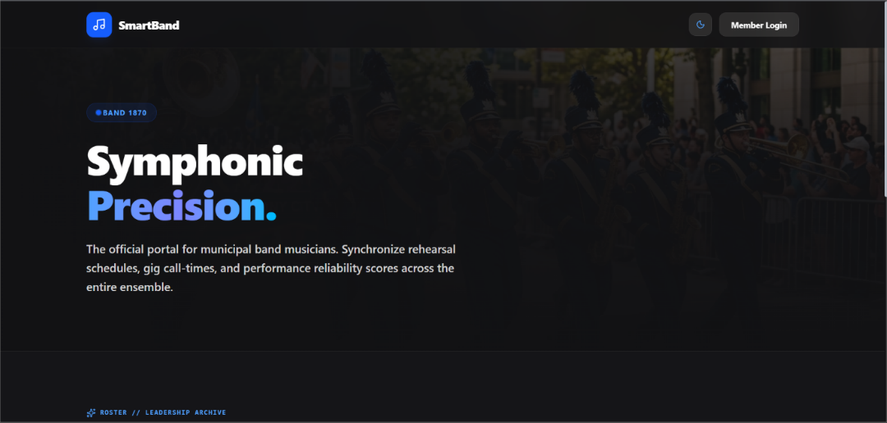

Figure 4 presents the public landing page of SmartBand, serving as the official digital gateway for Peñaranda Band 1870. The interface articulates the ensemble's civic heritage and core operating values, highlighting the system's capabilities in automating call-times, rehearsal rosters, and attendance reliability scoring. Direct call-to-action buttons allow active musicians to access the member login screen or inspect the official executive leadership council archive.

Figure 5
Musician Member Home Dashboard with Confirmed RSVP Status and Reliability Score
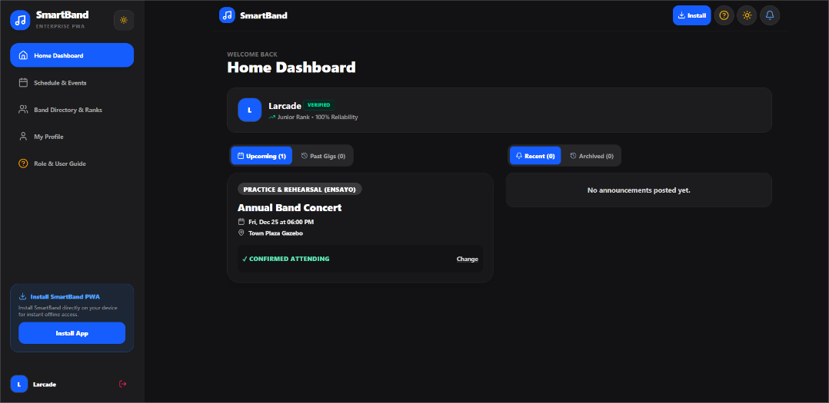

Figure 5 illustrates the authenticated Band Member Home Dashboard. The interface provides an immediate operational overview upon login, displaying the musician's instrument classification, verified standing, active Reliability Score (e.g., 100%), and upcoming band commitments. For scheduled rehearsals or gigs, members are presented with one-touch RSVP confirmation controls ('I will Attend', 'Cannot Attend') that instantly update the administrative roster in real time.

Figure 6
Band Secretary Operations Hub and Event Schedule Management Dashboard
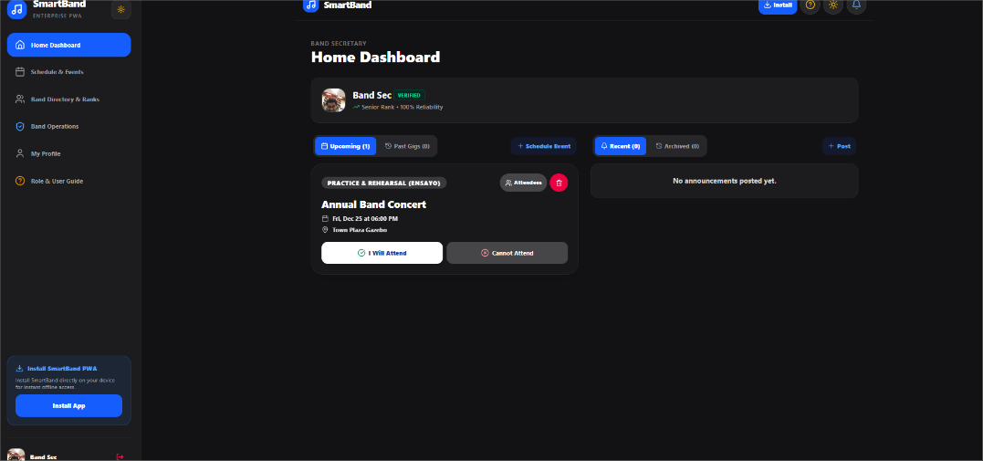
Figure 6 showcases the Band Secretary Home Dashboard, providing operational officers with comprehensive management tools. Officers can monitor overall event turnouts, dispatch high-priority broadcast announcements, execute quick event scheduling, review live attendance tallies, and access the member availability cross-referencing tool.

Use Case Diagram
Figure 7 illustrates the functional behavior and operational boundaries of the SmartBand Progressive Web Application tailored for the Peñaranda Band 1870. The system models interactions across three primary human actors—Band Member (Musician), Band Officer (Secretary / Leader), and IT Administrator—alongside two secondary external service actors: the Web Push API (Browser Service) and the Audio Subsystem (Hardware / Siren).
Musician actors engage with the platform by registering an account, authenticating credentials, and installing the application directly onto client devices via Progressive Web Application caching protocols. Within their profile space, members maintain their instrument profiles and weekly availability grids, view scheduled community performances, and track their personal attendance standing via the reliability score. When a musician confirms receipt of an alert or submits an event RSVP, the Confirm Receipt / RSVP process executes a mandatory <<include>> relationship to Calculate Reliability Index, ensuring continuous, automated updates to their participation metric.
Administrative operations are directed by the Band Officer, whose access requires credential authentication that strictly incorporates an <<include>> Verify Role Status dependency to validate officer privileges. Officers oversee event logistics through the Manage Event Schedules process, which can be conditionally augmented via an <<extend>> relationship with Filter Availability by Section to identify available personnel per instrument group. When releasing urgent directives, the Broadcast Announcements process triggers mandatory <<include>> behaviors to Dispatch Web Push Alert through the external Web Push API and Trigger Call-Time Siren via the client-side Audio Subsystem. Officers also monitor real-time mobilization through Track Attendance Roster, which provides an <<extend>> path to Send Targeted Reminders to unconfirmed musicians, and generate consolidated activity reports for organizational reviews.
System integrity and security oversight are maintained by the IT Administrator. This actor validates new registrants against the official roster through Verify Member Accounts, provisions administrative permissions via Manage Roles (RBAC), and inspects immutable operational records through the Audit System Ledger to guarantee platform accountability.

Figure 7
Use Case Diagram
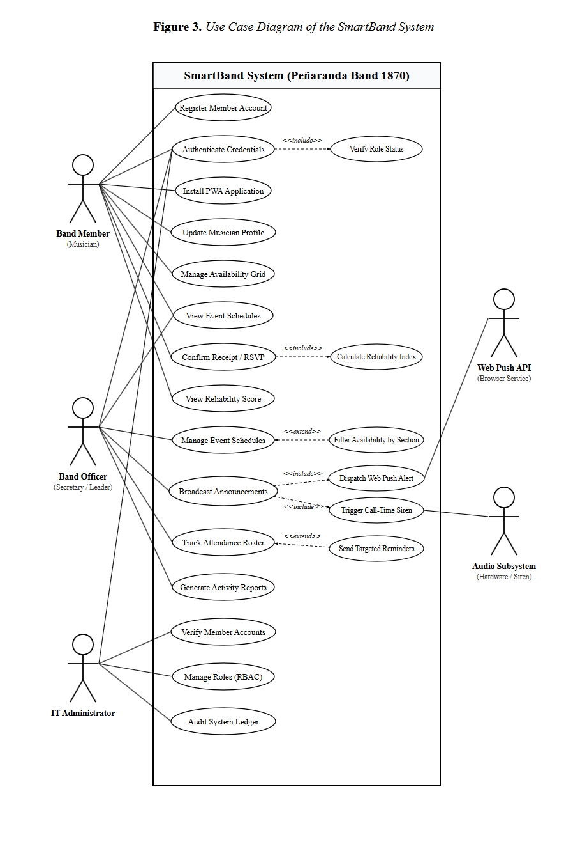

Data Flow Diagrams (DFDs)
Data Flow Diagrams (DFDs) were formulated to model the functional pathways through which information originates, transforms, persists, and distributes across the SmartBand Progressive Web Application. By abstracting operational workflows into structured processes, data stores, and external entities, the diagrams visualize boundary interactions between band members, officers, administrators, external push services, audio hardware subsystems, and the relational database.

Context Diagram (Level 0 DFD)
The Context Diagram (Level 0 DFD) models the SmartBand system as a singular central process (Process 0.0), delineating the macro-level operational boundaries of the platform. The system interfaces directly with three human external entities—the Band Member (Musician), the Band Officer (Secretary / Leader), and the Band IT Administrator—alongside two external peripheral services: the Web Push Notification Service (Push Gateway) and the Client Audio Subsystem (Device Hardware). The Band Member inputs registration credentials, profile details, weekly availability blocks, and event acknowledgment confirmations, receiving event schedules, high-priority notifications, attendance reliability scores, and section rosters. The Band Officer supplies announcement broadcasts, rehearsal call-times, schedule updates, and targeted reminder requests, receiving section availability tallies, live attendance rosters, and executive analytics. The Band IT Administrator submits verification approvals, role configurations, and master roster updates while inspecting audit logs. Externally, the system dispatches push payloads to the Web Push Service and call-time audio triggers to the device's Audio Subsystem.

Figure 8
Context Diagram (Level 0 DFD)
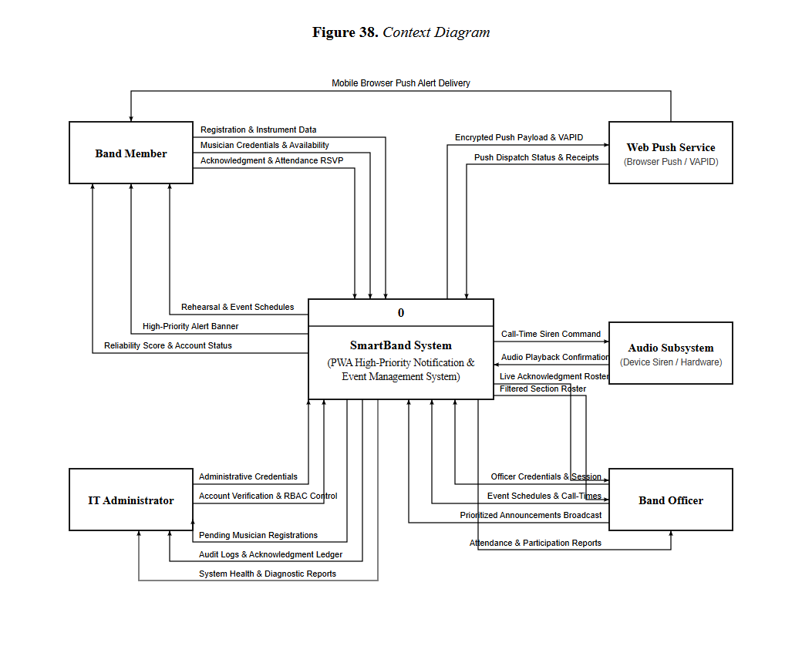Level 1 Data Flow Diagram
The Level 1 Data Flow Diagram decomposes the macro system into seven primary operational processes. Process 1.0 (Register and Verify Users) ingests musician applicant data, stores pending accounts in the database, and enables administrator verification against the official municipal roster. Process 2.0 (Authenticate Users) verifies credentials, enforces Role-Based Access Control (RBAC), and issues encrypted session tokens. Process 3.0 (Manage Member Availability & Profiles) captures recurring weekly availability matrices across morning, afternoon, and evening slots and maintains instrument specializations. Process 4.0 (Manage Event Schedules) enables officers to create, update, and categorize rehearsals, civic parades, and performances. Process 5.0 (Manage Announcements & Priority Triage) classifies directives by urgency (Low, Medium, High). Process 6.0 (Dispatch Push Notifications & Call-Time Siren) routes high-priority alerts through the Web Push API and triggers client-side audio alarms. Process 7.0 (Track Acknowledgments & Attendance Reliability) logs two-way receipt confirmations, computes individual Reliability Indexes, and generates section turnout rosters.

Figure 9
Level 1 Data Flow Diagram
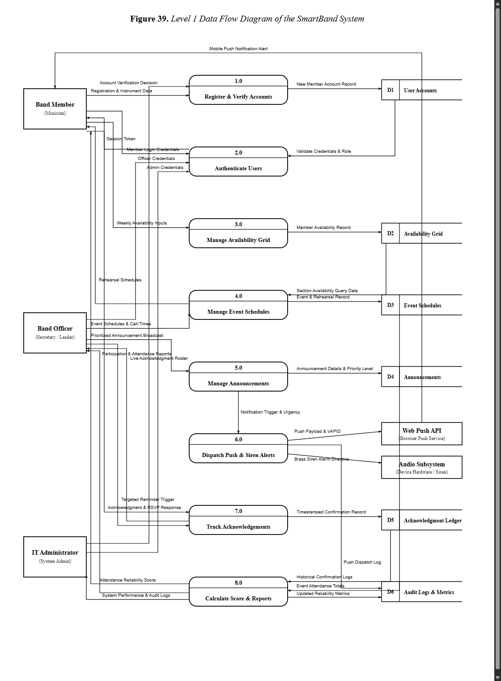

Level 2 Data Flow Diagrams
Level 2 Data Flow Diagrams specify the internal transformations governing key operational processes within the architecture:

Level 2 DFD for Process 1 (Register and Verify Users):
Decomposes member onboarding into three sub-processes. Sub-process 1.1 (Capture Musician Details) validates contact numbers and instrument choices, writing new records with a "Pending" status to the Users data store. Sub-process 1.2 (Inspect Pending Queue) retrieves unverified registrants for administrative review. Sub-process 1.3 (Verify Against Master List) matches submissions against the municipal band roster, updates verification flags, and assigns initial membership privileges.

Figure 10
Level 2 DFD, Process 1: Register and Verify Users
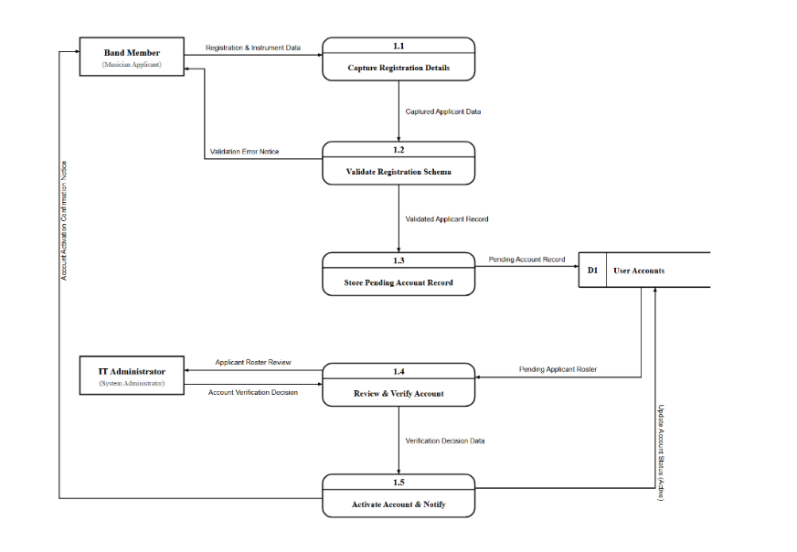

Level 2 DFD for Process 2 (Authenticate Users):
Models user access control. Sub-process 2.1 (Validate Credentials) verifies email and hashed password pairs. Sub-process 2.2 (Verify Role Permissions) queries assigned RBAC entitlements. Sub-process 2.3 (Issue Session Token) generates an encrypted session token and directs the user to their role-specific operational dashboard (Member, Secretary, or Admin).

Figure 11
Level 2 DFD, Process 2: Authenticate Users
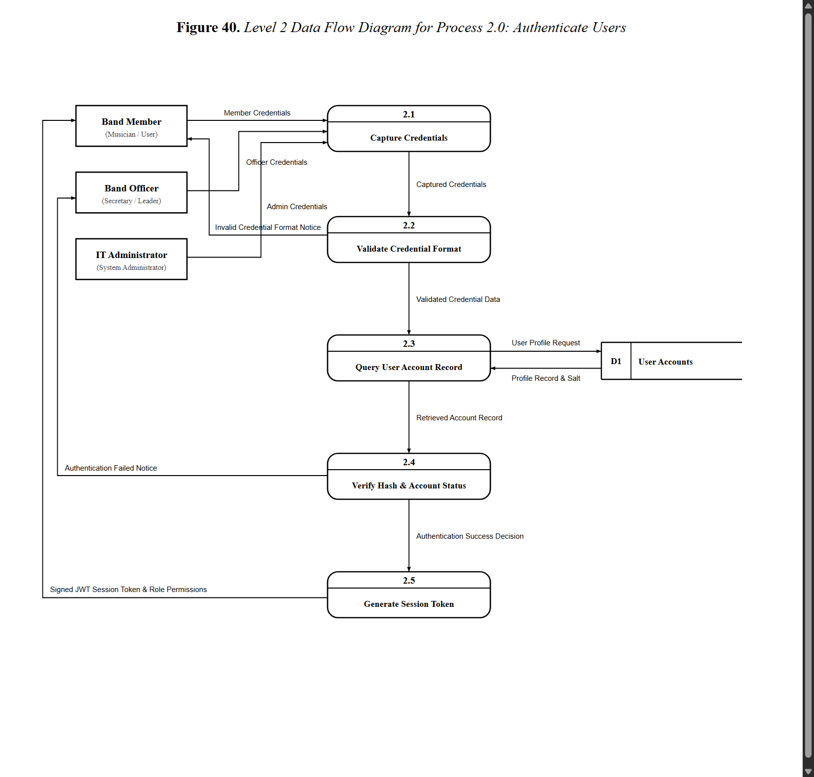

Class Diagram of the SmartBand System
The Class Diagram formalizes the object-oriented structure of the SmartBand web application, defining class attributes, methods, inheritance hierarchies, and operational associations across domain layers. The central abstract entity User encapsulates common credentials, contact details, and role specifications, from which Musician, BandOfficer, and ITAdministrator derive specialized behaviors. Domain model classes—including Instrument, WeeklyAvailability, EventSchedule, Announcement, AcknowledgmentLedger, AttendanceRecord, ReliabilityScore, and AuditLog—encapsulate business rules and database persistence. These domain entities interact with specialized service handlers, such as PushNotificationService for VAPID payload dispatching, AudioAlarmService for client-side call-time audio synthesis, AvailabilityFilterService for section querying, and ReliabilityCalculationEngine for automated turnout scoring.

Figure 12
Class Diagram of the SmartBand System
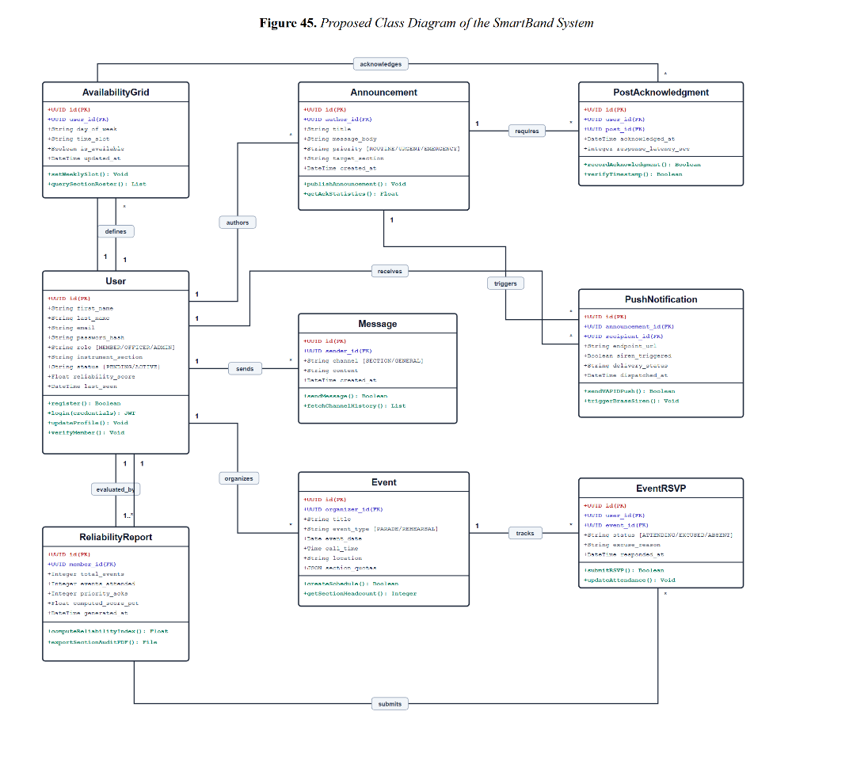

Entity Relationship Diagram (ERD)
To establish a robust relational data model supporting the multi-tier operational workflows of Peñaranda Band 1870, an Entity Relationship Diagram (ERD) was developed. The model defines the structural schema, primary keys, foreign referential constraints, and business cardinalities across twelve normalized operational entities.
The users entity serves as the primary authentication and identity root of the architecture, maintaining unique email credentials, password digests, user roles (member, secretary, admin), seniority ranks, and verification status. An associated profiles entity maintains personal biographies, telephone numbers, and emergency contact records. Musician instrument capabilities are modeled through a many-to-one relationship with instruments, which records section classifications (Woodwinds, Brass, Percussion). Routine availability is tracked via weekly_availabilities, which records member availability across day-of-week and time-slot blocks.
Event operations are governed through events, storing event titles, categories (Rehearsal, Parade, Vigil, Funeral), assembly locations, call-times, and required section quotas. Official directives are maintained in announcements, which features a priority level attribute (Low, Medium, High). Two-way communication convergence is preserved in acknowledgment_ledgers, which pairs announcements with individual members, recording response statuses (Confirmed, Unavailable, Excused) and cryptographic timestamps. Actual rehearsal attendance is logged in attendance_records, which feeds directly into reliability_scores to maintain historical participation metrics. Finally, administrative oversight is secured through immutable audit_logs.
Figure 13
Entity Relationship Diagram (ERD)
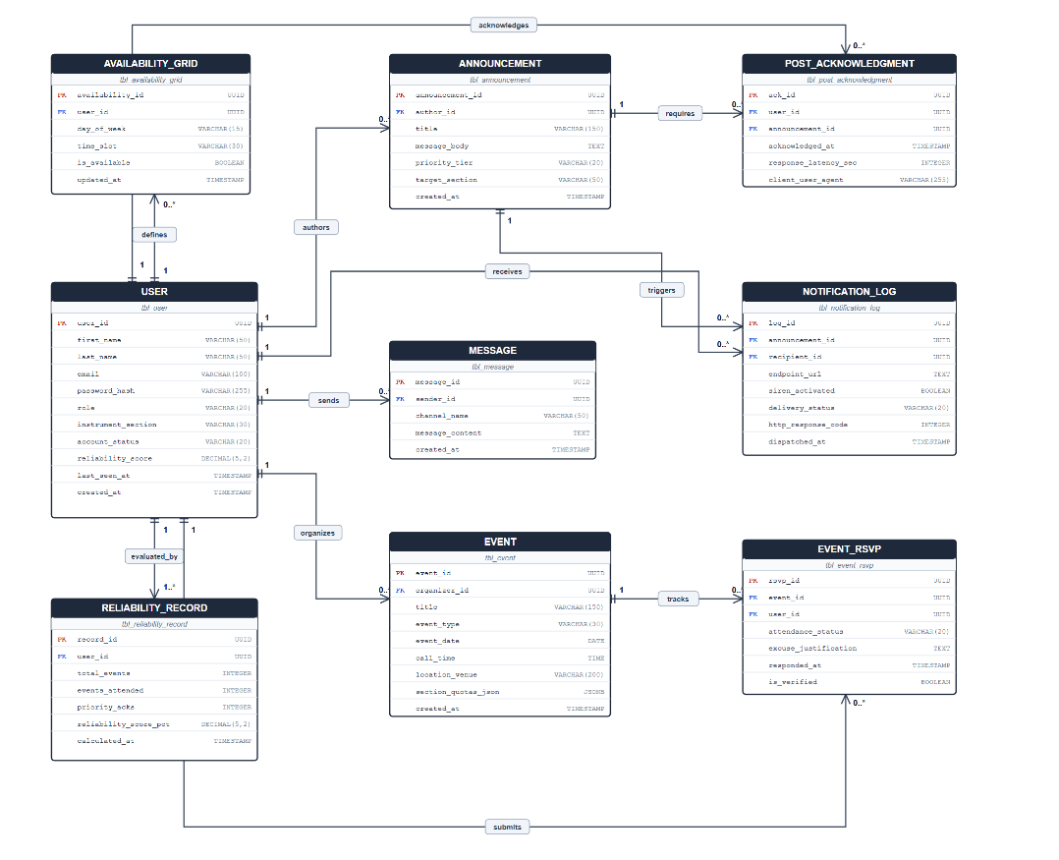
Database Normalization
Database normalization was systematically performed to structure the SmartBand data model into Third Normal Form (3NF). This engineering process eliminated data redundancy, resolved insertion, update, and deletion anomalies, and enforced strict referential integrity across all relational entities.

Unnormalized Form (UNF)
The unnormalized state represents raw, denormalized records containing multi-valued attributes, repeating groups, and combined transactional data. In this baseline form, user profiles, instrument specializations, recurring availability slots, event schedules, priority announcements, and attendance confirmations were consolidated into single flat table structures.

Figure 14
Unnormalized Form (UNF)
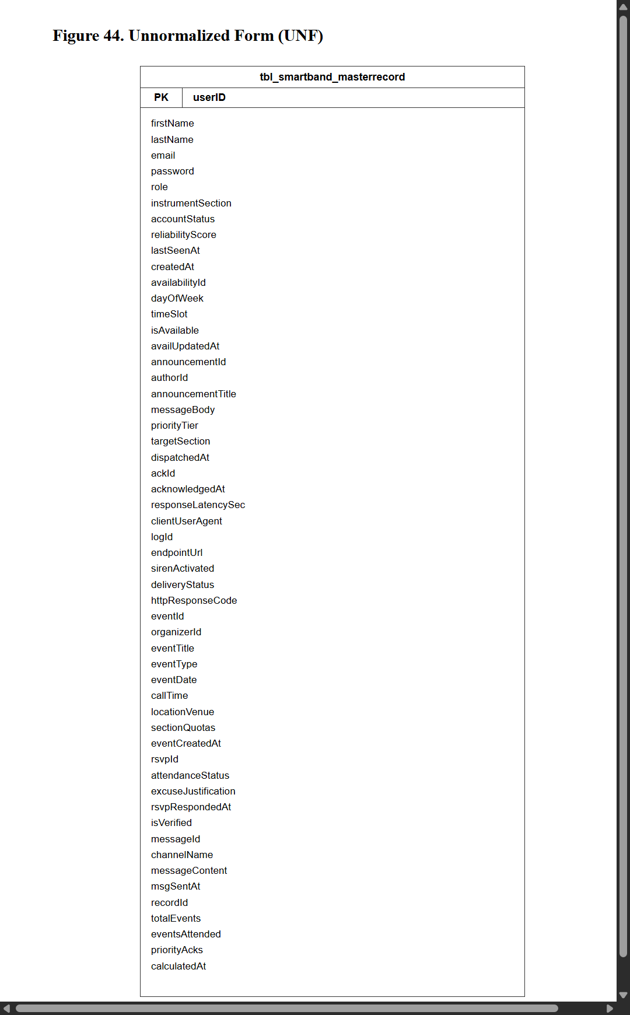
First Normal Form (1NF)
Conversion to First Normal Form (1NF) resolved repeating groups and ensured that every attribute contains only atomic, indivisible values. Multi-valued fields (such as multiple available time slots and secondary instruments) were separated into discrete rows, and a composite primary key structure was identified to uniquely distinguish every operational transaction record.

Figure 15
First Normal Form (1NF)
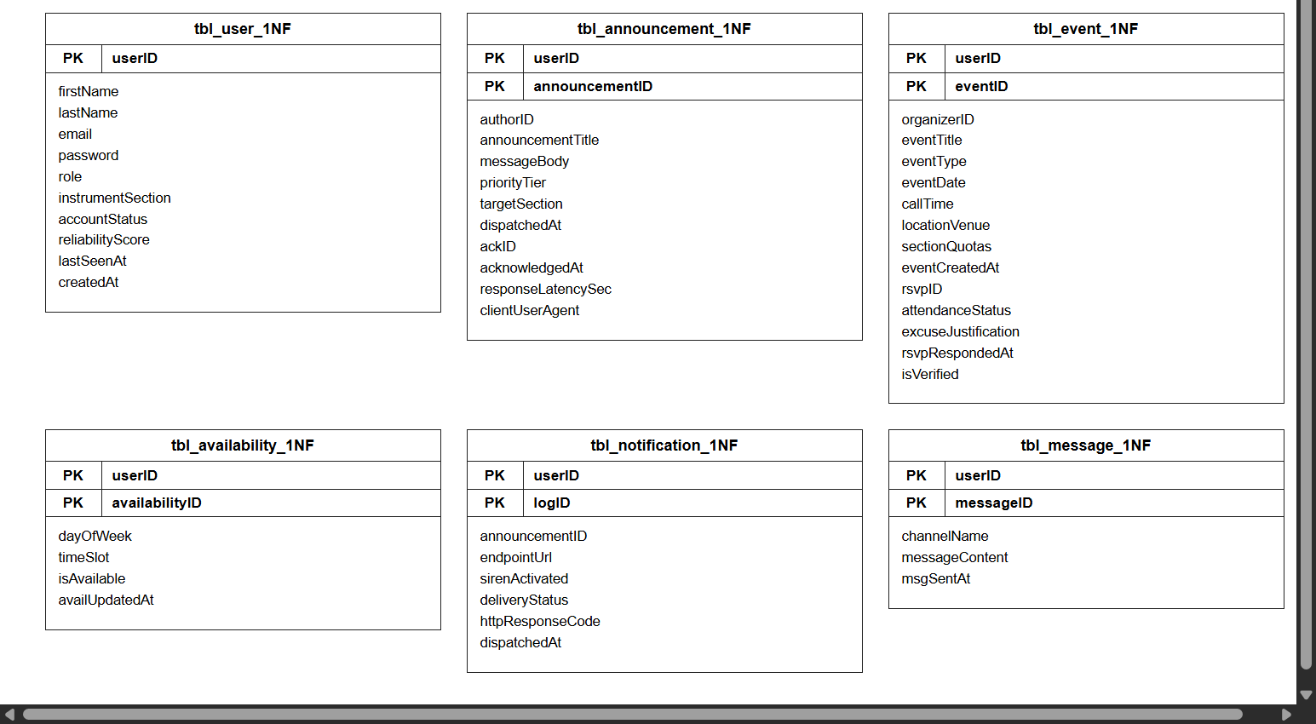

Second Normal Form (2NF)
Transition to Second Normal Form (2NF) eliminated partial functional dependencies. Attributes depending only on a subset of composite candidate keys were decomposed into independent relations. User profiles, instrument categories, event commitments, and announcement records were segregated into distinct entities, each governed by its own standalone primary key with foreign key Crow's Foot relationships.

Figure 16
Second Normal Form (2NF)
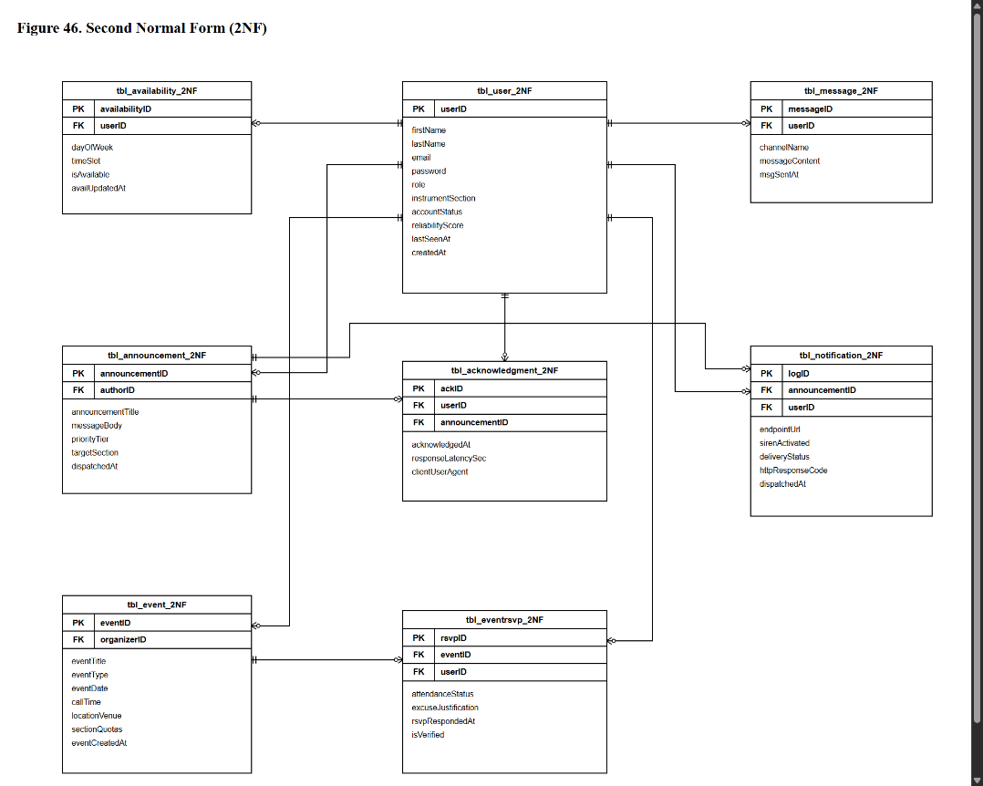

Third Normal Form (3NF)
Advancement to Third Normal Form (3NF) eliminated transitive functional dependencies, ensuring every non-key column depends solely on the primary key ("the key, the whole key, and nothing but the key"). Calculated turnout percentages, section headcount summaries, and reliability score aggregates were decoupled from base transactional tables and handled via application business logic. Consistent snake_case naming conventions and standard id primary/foreign key relationships were enforced across all twelve final database entities.

Figure 17
Third Normal Form (3NF)
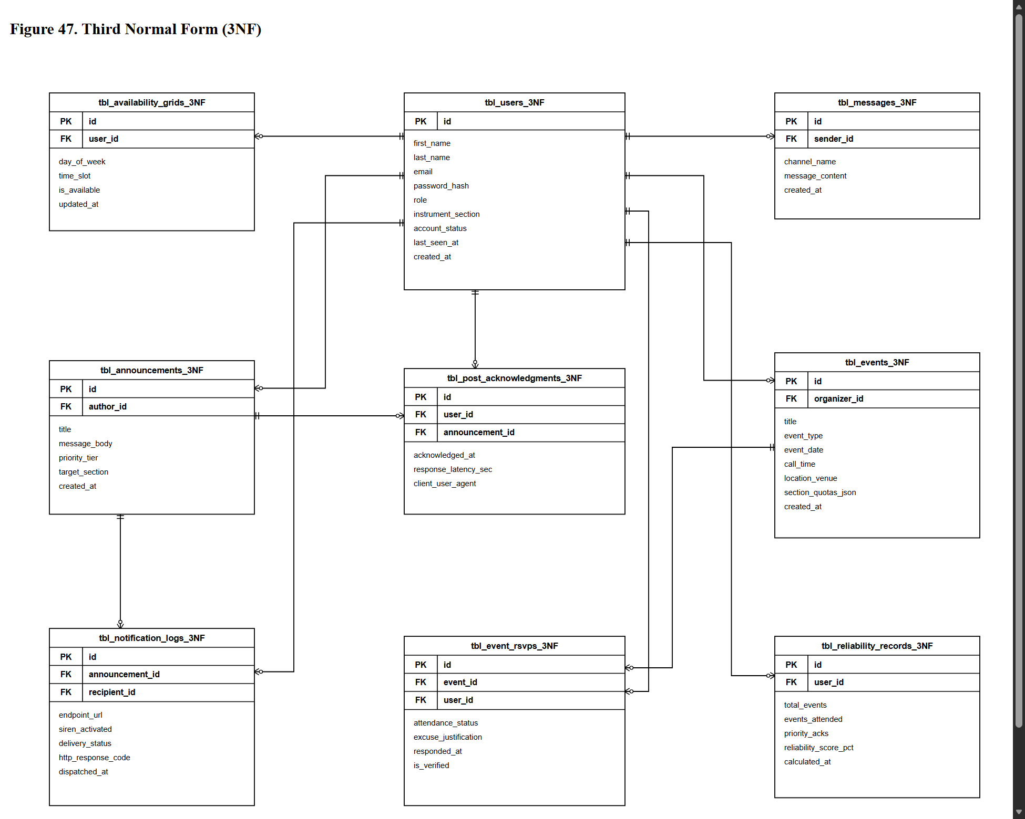

Data Dictionary
Table 14 serves as the central authentication, profile, and identity root of the SmartBand application. It stores demographic details, role-based access privileges, instrument assignments, cryptographic credential hashes, and operational account statuses for all active musicians, band officers, and system administrators.

Table 14
Data Dictionary for Table tbl_users
Field Name | Data Type | Length / Constraint | Key | Description
id | UUID | 36 / NOT NULL, DEFAULT gen_random_uuid() | PK | Universally unique identifier serving as the immutable primary key for each user account. (Example: 'a0eebc99-9c0b-4ef8-bb6d-6bb9bd380a11')
first_name | VARCHAR | 50 / NOT NULL | - | Legal first name of the band musician, officer, or system administrator. (Example: 'Juan')
last_name | VARCHAR | 50 / NOT NULL | - | Legal surname / family name of the user. (Example: 'Dela Cruz')
email | VARCHAR | 100 / NOT NULL, UNIQUE | - | Personal or organizational email address utilized as the unique username for system authentication. (Example: 'j.delacruz@penarandaband1870.ph')
password_hash | VARCHAR | 255 / NOT NULL | - | Cryptographically salted and stretched password digest generated via bcrypt algorithm (2a cost factor 12). (Example: '...3mQ9qZ7')
contact_number | VARCHAR | 15 / NULL | - | Primary mobile phone number in Philippine cellular format (09XXXXXXXXX) used for emergency communication. (Example: '09171234567')
role | VARCHAR | 20 / NOT NULL, DEFAULT 'member', CHECK (role IN ('member', 'secretary', 'president', 'admin')) | - | System authorization role enforcing Role-Based Access Control (RBAC) boundaries across application modules. (Example: 'member')
instrument_section | VARCHAR | 30 / NOT NULL, CHECK (instrument_section IN ('Woodwinds', 'Brass', 'Percussion', 'Administration')) | - | Primary musical instrument section grouping governing broadcast targeting and roster queries. (Example: 'Brass')
primary_instrument | VARCHAR | 50 / NOT NULL | - | Specific musical instrument designated to the musician within PeÃ±aranda Band 1870. (Example: 'Bb Trumpet 1st')
account_status | VARCHAR | 20 / NOT NULL, DEFAULT 'pending', CHECK (account_status IN ('pending', 'verified', 'declined', 'suspended')) | - | Administrative verification and lifecycle status governing login access permissions. (Example: 'verified')
reliability_score | DECIMAL | 5,2 / NOT NULL, DEFAULT 100.00, CHECK (reliability_score BETWEEN 0.00 AND 100.00) | - | Cached cumulative reliability percentage derived from event attendance and prompt notification acknowledgments. (Example: 96.50)
last_seen_at | TIMESTAMP | 8 bytes / NULL | - | System timestamp tracking the user's most recent active interaction or telemetry heartbeat. (Example: '2026-09-25 14:32:10')
created_at | TIMESTAMP | 8 bytes / NOT NULL, DEFAULT CURRENT_TIMESTAMP | - | System timestamp recording the exact chronological date and time the user account was registered. (Example: '2026-01-15 08:30:00')
updated_at | TIMESTAMP | 8 bytes / NOT NULL, DEFAULT CURRENT_TIMESTAMP | - | System timestamp tracking the most recent modification made to the user's profile attributes. (Example: '2026-09-20 10:15:22')

Table 15 manages individual musician weekly availability schedules across standard operational shifts. This table enables executive officers (Band Secretary and Conductor) to query real-time section rosters and assemble balanced instrumentation lineups for rehearsals and upcoming civic engagements.

Table 15
Data Dictionary for Table tbl_availability_grids
Field Name | Data Type | Length / Constraint | Key | Description
id | BIGINT | 8 bytes / NOT NULL, GENERATED ALWAYS AS IDENTITY | PK | Synthetic numeric primary key uniquely indexing each availability matrix timeslot record. (Example: 1001)
user_id | UUID | 36 / NOT NULL | FK | Foreign key referencing the authenticated musician to whom this availability slot belongs (tbl_users(id) ON DELETE CASCADE). (Example: 'a0eebc99-9c0b-4ef8-bb6d-6bb9bd380a11')
day_of_week | VARCHAR | 10 / NOT NULL, CHECK (day_of_week IN ('Monday', 'Tuesday', 'Wednesday', 'Thursday', 'Friday', 'Saturday', 'Sunday')) | - | Specific day of the recurring weekly schedule being configured by the musician. (Example: 'Wednesday')
time_slot | VARCHAR | 15 / NOT NULL, CHECK (time_slot IN ('Morning', 'Afternoon', 'Evening')) | - | Standard operational band shift interval (Morning: 8-12, Afternoon: 1-5, Evening: 6-10). (Example: 'Afternoon')
is_available | BOOLEAN | 1 byte / NOT NULL, DEFAULT true | - | Binary flag indicating whether the musician affirms availability (true) or unavailability (false). (Example: true)
updated_at | TIMESTAMP | 8 bytes / NOT NULL, DEFAULT CURRENT_TIMESTAMP | - | Chronological timestamp tracking when the member last updated this specific schedule cell. (Example: '2026-09-21 16:45:00')

Table 16 catalogs all official musical performances, civic processions, religious parades, church services (Misa/Bantay/Lamay/Libing), concerts, and rehearsals scheduled by band leadership. It maintains mandatory call-times, venues, assembly guidelines, and instrument section quotas.

Table 16
Data Dictionary for Table tbl_events
Field Name | Data Type | Length / Constraint | Key | Description
id | BIGINT | 8 bytes / NOT NULL, GENERATED ALWAYS AS IDENTITY | PK | Unique synthetic numeric primary key identifying the scheduled band event or service. (Example: 501)
organizer_id | UUID | 36 / NOT NULL | FK | Foreign key identifying the band officer (Secretary, President, or Conductor) who created the event (tbl_users(id) ON DELETE RESTRICT). (Example: 'b1ffcd88-8b1a-4fe7-aa5c-5aa8ac270b22')
title | VARCHAR | 150 / NOT NULL | - | Official public name or descriptive title of the performance or rehearsal engagement. (Example: 'PeÃ±aranda Town Fiesta Procession & Civic Parade')
event_type | VARCHAR | 30 / NOT NULL, CHECK (event_type IN ('Ensayo', 'Parade', 'Bantay/Lamay', 'Libing', 'Concert', 'Civic Service')) | - | Operational classification defining the formal protocol and liturgical nature of the gig. (Example: 'Parade')
event_date | DATE | 4 bytes / NOT NULL | - | Calendar date on which the engagement is scheduled to take place (YYYY-MM-DD format). (Example: '2026-10-12')
call_time | TIME | 8 bytes / NOT NULL | - | Mandatory assembly, uniform inspection, and instrument tuning time required prior to performance. (Example: '05:30:00')
start_time | TIME | 8 bytes / NOT NULL | - | Official step-off or musical presentation commencement time. (Example: '06:30:00')
location_venue | VARCHAR | 200 / NOT NULL | - | Physical venue address, parade route assembly point, or church landmark. (Example: 'PeÃ±aranda Municipal Plaza & Saint Francis Church')
section_quotas_json | JSONB | Variable / NOT NULL, DEFAULT '{woodwinds: 12, brass: 18, percussion: 4}' | - | Structured JSON document delineating required musician headcounts across instrument sections. (Ex: '{woodwinds: 15, brass: 20, percussion: 5}')
dress_code | VARCHAR | 100 / NULL, DEFAULT 'Type A Formal Uniform' | - | Required musical attire or marching uniform protocol for the engagement. (Example: 'Type A Marching Gala Uniform' or 'Casual Band Polo')
status | VARCHAR | 20 / NOT NULL, DEFAULT 'scheduled', CHECK (status IN ('scheduled', 'in_progress', 'completed', 'cancelled')) | - | Current operational lifecycle status of the scheduled event. (Example: 'scheduled')
created_at | TIMESTAMP | 8 bytes / NOT NULL, DEFAULT CURRENT_TIMESTAMP | - | System timestamp recording when the event record was committed to the database. (Example: '2026-09-22 09:00:00')
updated_at | TIMESTAMP | 8 bytes / NOT NULL, DEFAULT CURRENT_TIMESTAMP | - | System timestamp tracking the most recent modification made to the event specifications. (Example: '2026-09-24 11:20:00')

Table 17 manages official broadcast bulletins, urgent notices, call-time modifications, and musical directives published by band leadership. It features tiered priority classifications that govern automated dispatch mechanisms and emergency siren triggers.

Table 17
Data Dictionary for Table tbl_announcements
Field Name | Data Type | Length / Constraint | Key | Description
id | BIGINT | 8 bytes / NOT NULL, GENERATED ALWAYS AS IDENTITY | PK | Unique synthetic numeric primary key indexing each official announcement publication. (Example: 201)
author_id | UUID | 36 / NOT NULL | FK | Foreign key identifying the band officer or administrator who published the announcement (tbl_users(id) ON DELETE RESTRICT). (Example: 'b1ffcd88-8b1a-4fe7-aa5c-5aa8ac270b22')
title | VARCHAR | 150 / NOT NULL | - | Concise header summarizing the subject and core premise of the announcement bulletin. (Example: 'URGENT: Revised Call-Time for Saint Francis Fluvial Parade')
message_body | TEXT | Variable / NOT NULL | - | Full informational content including operational guidelines, uniform codes, and assembly rules. (Example: 'All brass and woodwinds assemble at church patio by 05:00 AM sharp in Gala White Uniform.')
priority_tier | VARCHAR | 15 / NOT NULL, DEFAULT 'Low', CHECK (priority_tier IN ('Low', 'Medium', 'High')) | - | Urgency classification governing dispatch speed and siren triggering (High initiates audible brass alert). (Example: 'High')
target_section | VARCHAR | 30 / NOT NULL, DEFAULT 'All', CHECK (target_section IN ('All', 'Woodwinds', 'Brass', 'Percussion')) | - | Instrument cohort filter restricting visibility to designated musical sections or the entire band. (Example: 'All')
requires_ack | BOOLEAN | 1 byte / NOT NULL, DEFAULT true | - | Boolean switch designating whether members are required to submit a two-way digital acknowledgment. (Example: true)
created_at | TIMESTAMP | 8 bytes / NOT NULL, DEFAULT CURRENT_TIMESTAMP | - | Exact system date and time when the announcement bulletin was committed and published. (Example: '2026-09-24 18:00:00')
expires_at | TIMESTAMP | 8 bytes / NULL | - | Optional calendar expiration timestamp after which the notice is archived from active alert boards. (Example: '2026-10-15 23:59:59')

Table 18 implements the two-way cryptographic acknowledgment ledger of the SmartBand platform. It captures auditable read receipts, response latency durations, and device signatures when musicians confirm receipt of high-priority directives, eliminating unilateral messaging ambiguity.

Table 18
Data Dictionary for Table tbl_post_acknowledgments
Field Name | Data Type | Length / Constraint | Key | Description
id | BIGINT | 8 bytes / NOT NULL, GENERATED ALWAYS AS IDENTITY | PK | Unique synthetic numeric primary key identifying each specific acknowledgment transaction. (Example: 8001)
announcement_id | BIGINT | 8 bytes / NOT NULL | FK | Foreign key identifying the parent announcement bulletin being acknowledged (tbl_announcements(id) ON DELETE CASCADE). (Example: 201)
user_id | UUID | 36 / NOT NULL | FK | Foreign key referencing the authenticated musician who submitted the verification receipt (tbl_users(id) ON DELETE CASCADE). (Example: 'a0eebc99-9c0b-4ef8-bb6d-6bb9bd380a11')
acknowledged_at | TIMESTAMP | 8 bytes / NOT NULL, DEFAULT CURRENT_TIMESTAMP | - | Precise system timestamp recording the second when the musician confirmed acknowledgment. (Example: '2026-09-24 18:03:14')
response_latency_sec | INTEGER | 4 bytes / NOT NULL, CHECK (response_latency_sec >= 0) | - | Computed duration in seconds elapsed between announcement dispatch and user acknowledgment submission. (Example: 194)
client_user_agent | VARCHAR | 255 / NULL | - | Browser environment and operating hardware header captured to substantiate acknowledgment authenticity. (Example: 'Mozilla/5.0 (Linux; Android 14; SM-S918B) Chrome/128.0.0.0 Mobile')

Table 19 manages member attendance commitments, pre-event availability confirmations, formal absence excuse justifications, and post-event on-site roll-call verifications conducted by band officers.

Table 19
Data Dictionary for Table tbl_event_rsvps
Field Name | Data Type | Length / Constraint | Key | Description
id | BIGINT | 8 bytes / NOT NULL, GENERATED ALWAYS AS IDENTITY | PK | Unique primary key identifying each specific event participation commitment record. (Example: 3001)
event_id | BIGINT | 8 bytes / NOT NULL | FK | Foreign key referencing the scheduled event or rehearsal being tracked (tbl_events(id) ON DELETE CASCADE). (Example: 501)
user_id | UUID | 36 / NOT NULL | FK | Foreign key referencing the musician submitting the RSVP or undergoing attendance audit (tbl_users(id) ON DELETE CASCADE). (Example: 'a0eebc99-9c0b-4ef8-bb6d-6bb9bd380a11')
attendance_status | VARCHAR | 20 / NOT NULL, CHECK (attendance_status IN ('attending', 'declined', 'absent', 'excused', 'present')) | - | Formal attendance standing indicating prospective commitment or verified physical attendance. (Example: 'attending')
excuse_justification | TEXT | Variable / NULL | - | Qualitative explanation submitted by the musician when declining an engagement or requesting an excused absence. (Example: 'Official university examination scheduled at NEUST PeÃ±aranda Campus.')
responded_at | TIMESTAMP | 8 bytes / NOT NULL, DEFAULT CURRENT_TIMESTAMP | - | System timestamp tracking when the member submitted their initial RSVP confirmation or decline. (Example: '2026-09-23 14:12:00')
is_verified | BOOLEAN | 1 byte / NOT NULL, DEFAULT false | - | Administrative verification flag affirmed by the Secretary during physical roll-call at assembly. (Example: true)
verified_by | UUID | 36 / NULL | FK | Foreign key identifying the band officer who validated the musician's physical presence at the venue (tbl_users(id) ON DELETE SET NULL). (Example: 'b1ffcd88-8b1a-4fe7-aa5c-5aa8ac270b22')

Table 20 captures low-level delivery telemetry, HTTP gateway response codes, endpoint transmission statuses, and acoustic siren activation commands dispatched via the Web Push protocol to recipient client devices.

Table 20
Data Dictionary for Table tbl_notification_logs
Field Name | Data Type | Length / Constraint | Key | Description
id | BIGINT | 8 bytes / NOT NULL, GENERATED ALWAYS AS IDENTITY | PK | Synthetic primary key uniquely identifying each outbound push notification transmission log. (Example: 12001)
announcement_id | BIGINT | 8 bytes / NOT NULL | FK | Foreign key referencing the parent announcement payload that triggered this transmission (tbl_announcements(id) ON DELETE CASCADE). (Example: 201)
recipient_id | UUID | 36 / NOT NULL | FK | Foreign key designating the targeted band musician receiving the notification dispatch (tbl_users(id) ON DELETE CASCADE). (Example: 'a0eebc99-9c0b-4ef8-bb6d-6bb9bd380a11')
endpoint_url | TEXT | Variable / NOT NULL | - | W3C Web Push subscription endpoint URL registered by the client device's browser service. (Example: 'https://fcm.googleapis.com/fcm/send/eR5k90xP_...89x')
siren_activated | BOOLEAN | 1 byte / NOT NULL, DEFAULT false | - | Boolean indicator confirming whether the 5-second acoustic brass call-time siren command was dispatched. (Example: true)
delivery_status | VARCHAR | 20 / NOT NULL, DEFAULT 'pending', CHECK (delivery_status IN ('pending', 'delivered', 'failed', 'expired')) | - | Network delivery resolution status reported back by the browser push service provider. (Example: 'delivered')
http_response_code | INTEGER | 4 bytes / NULL | - | Standard HTTP status code returned by the push gateway (e.g., 201 Created, 404 Not Found, 410 Gone). (Example: 201)
dispatched_at | TIMESTAMP | 8 bytes / NOT NULL, DEFAULT CURRENT_TIMESTAMP | - | Exact system timestamp when the backend application server dispatched the notification packet. (Example: '2026-09-24 18:00:02')

Table 21 stores mathematical snapshot evaluations of musician reliability and participation metrics. It aggregates event attendance history, timely priority acknowledgments, and calculated compliance scores to support objective administrative decision-making and gig roster selection.

Table 21
Data Dictionary for Table tbl_reliability_records
Field Name | Data Type | Length / Constraint | Key | Description
id | BIGINT | 8 bytes / NOT NULL, GENERATED ALWAYS AS IDENTITY | PK | Unique synthetic primary key identifying each specific reliability audit evaluation record. (Example: 401)
user_id | UUID | 36 / NOT NULL | FK | Foreign key referencing the band musician whose cumulative performance metrics are evaluated (tbl_users(id) ON DELETE CASCADE). (Example: 'a0eebc99-9c0b-4ef8-bb6d-6bb9bd380a11')
total_events | INTEGER | 4 bytes / NOT NULL, DEFAULT 0, CHECK (total_events >= 0) | - | Cumulative count of mandatory events and rehearsals scheduled for the musician's section. (Example: 24)
events_attended | INTEGER | 4 bytes / NOT NULL, DEFAULT 0, CHECK (events_attended >= 0) | - | Verified count of scheduled events physically attended and validated during roll-call. (Example: 23)
priority_acks | INTEGER | 4 bytes / NOT NULL, DEFAULT 0, CHECK (priority_acks >= 0) | - | Count of High-Priority announcements acknowledged within the prescribed 30-minute threshold. (Example: 18)
reliability_score_pct | DECIMAL | 5,2 / NOT NULL, CHECK (reliability_score_pct BETWEEN 0.00 AND 100.00) | - | Formally computed composite score percentage representing attendance integrity and acknowledgment punctuality. (Example: 95.83)
calculated_at | TIMESTAMP | 8 bytes / NOT NULL, DEFAULT CURRENT_TIMESTAMP | - | System timestamp recording when this performance evaluation snapshot was executed and stored. (Example: '2026-09-25 00:00:00')

Table 22 stores real-time sectional communications, logistical inquiries, and peer coordination messages dispatched within designated SmartBand in-app messaging channels, maintaining section-level discourse records.

Table 22
Data Dictionary for Table tbl_messages
Field Name | Data Type | Length / Constraint | Key | Description
id | BIGINT | 8 bytes / NOT NULL, GENERATED ALWAYS AS IDENTITY | PK | Synthetic primary key uniquely identifying each posted sectional chat communication. (Example: 6001)
sender_id | UUID | 36 / NOT NULL | FK | Foreign key referencing the authenticated member or officer transmitting the message (tbl_users(id) ON DELETE CASCADE). (Example: 'a0eebc99-9c0b-4ef8-bb6d-6bb9bd380a11')
channel_name | VARCHAR | 50 / NOT NULL, CHECK (channel_name IN ('general', 'woodwinds', 'brass', 'percussion', 'officers', 'announcements')) | - | Dedicated communication channel or section stream wherein the message was submitted. (Example: 'brass')
message_content | TEXT | Variable / NOT NULL | - | Textual payload of the communication dispatched between ensemble members. (Example: 'Please prepare the march sheet for San Antonio de Padua tomorrow.')
created_at | TIMESTAMP | 8 bytes / NOT NULL, DEFAULT CURRENT_TIMESTAMP | - | Chronological timestamp when the message was received and committed by the application server. (Example: '2026-09-24 19:15:30')

Table 23 manages W3C Push API client device registrations, storing cryptographic subscription endpoints, elliptic curve public keys, and authentication tokens required to deliver offline web push notifications and call-time sirens.

Table 23
Data Dictionary for Table tbl_push_subscriptions
Field Name | Data Type | Length / Constraint | Key | Description
id | BIGINT | 8 bytes / NOT NULL, GENERATED ALWAYS AS IDENTITY | PK | Unique synthetic numeric primary key identifying each device push subscription profile. (Example: 901)
user_id | UUID | 36 / NOT NULL | FK | Foreign key referencing the authenticated user owning the subscribing mobile or desktop device (tbl_users(id) ON DELETE CASCADE). (Example: 'a0eebc99-9c0b-4ef8-bb6d-6bb9bd380a11')
endpoint | TEXT | Variable / NOT NULL, UNIQUE | - | Full HTTPS endpoint URI provided by the push vendor (e.g., Firebase Cloud Messaging, Mozilla autopush). (Example: 'https://fcm.googleapis.com/fcm/send/cx98_K12...99')
p256dh_key | VARCHAR | 255 / NOT NULL | - | Base64-encoded P-256 elliptic curve Diffie-Hellman public key used for end-to-end push payload encryption. (Example: 'BNcRdreALRF88qV345...km19=')
auth_token | VARCHAR | 255 / NOT NULL | - | Cryptographic authentication secret shared between client browser and push dispatcher server. (Example: 'tB_87vFf990k_Qx1')
user_agent | VARCHAR | 255 / NULL | - | Client browser and operating platform identification string used for multi-device management. (Example: 'Mozilla/5.0 (Windows NT 10.0; Win64; x64) Chrome/128.0.0.0')
created_at | TIMESTAMP | 8 bytes / NOT NULL, DEFAULT CURRENT_TIMESTAMP | - | System timestamp recording when the device subscription was successfully registered. (Example: '2026-09-18 10:20:00')

Table 24 contains the master reference catalog of musical instruments utilized across Peñaranda Band 1870, enforcing standardized nomenclature, notation clef associations, and section categorizations across the system.

Table 24
Data Dictionary for Table tbl_instruments
Field Name | Data Type | Length / Constraint | Key | Description
id | INTEGER | 4 bytes / NOT NULL, GENERATED ALWAYS AS IDENTITY | PK | Synthetic numeric primary key uniquely identifying each instrument master record. (Example: 14)
instrument_name | VARCHAR | 50 / NOT NULL, UNIQUE | - | Standardized musical name and voicing of the instrument. (Example: 'Bb Cornet')
section | VARCHAR | 30 / NOT NULL, CHECK (section IN ('Woodwinds', 'Brass', 'Percussion')) | - | Musical instrument family classification determining operational sectioning. (Example: 'Brass')
clef | VARCHAR | 20 / NOT NULL, CHECK (clef IN ('Treble', 'Bass', 'Alto', 'Percussion')) | - | Standard musical notation clef read by the musician for rehearsal repertoire allocation. (Example: 'Treble')
is_active | BOOLEAN | 1 byte / NOT NULL, DEFAULT true | - | Boolean flag indicating whether this instrument is actively deployed in the current band roster. (Example: true)

Table 25 maintains an immutable historical ledger of administrative transactions, security actions, account verifications, role modifications, and event deletions, satisfying institutional governance and system auditability.

Table 25
Data Dictionary for Table tbl_audit_logs
Field Name | Data Type | Length / Constraint | Key | Description
id | BIGINT | 8 bytes / NOT NULL, GENERATED ALWAYS AS IDENTITY | PK | Unique synthetic numeric primary key identifying each security audit log record. (Example: 15001)
user_id | UUID | 36 / NULL | FK | Foreign key referencing the authenticated administrator or officer executing the logged operation (tbl_users(id) ON DELETE SET NULL). (Example: 'b1ffcd88-8b1a-4fe7-aa5c-5aa8ac270b22')
action_type | VARCHAR | 50 / NOT NULL | - | Standardized action category code (USER_VERIFIED, USER_SUSPENDED, EVENT_DELETED, ROLE_CHANGED). (Example: 'USER_VERIFIED')
table_affected | VARCHAR | 50 / NOT NULL | - | Physical database table targeted by the mutating administrative transaction. (Example: 'tbl_users')
record_id | VARCHAR | 50 / NULL | - | Primary key identifier of the specific target entity modified during the action. (Example: 'a0eebc99-9c0b-4ef8-bb6d-6bb9bd380a11')
details_json | JSONB | Variable / NULL | - | Structured JSON document recording previous attributes, modified values, and operational metadata. (Example: '{previous_status: pending, new_status: verified}')
ip_address | VARCHAR | 45 / NULL | - | Client IP address (IPv4 or IPv6 format) originating the administrative transaction request. (Example: '112.198.102.45')
created_at | TIMESTAMP | 8 bytes / NOT NULL, DEFAULT CURRENT_TIMESTAMP | - | Immutable chronological timestamp recording the exact moment the audit entry was written. (Example: '2026-09-24 10:14:05')

1.3 Development
Following the completion of system modeling and wireframing, the researchers initiated the development phase to construct the operational software artifacts of the SmartBand: A Progressive Web Application (PWA)-Based High-Priority Notification and Event Management System for Peñaranda Band 1870. Development execution adhered to Agile Scrum iterations, converting functional user stories into modular, role-governed software services tailored for band musicians, operational officers (Band Secretary and President), and system administrators. The engineering architecture was structured around a decoupled yet unified cloud-native Progressive Web Application ecosystem, providing sub-second reactive interface rendering, W3C Web Push notification delivery with automated 5-second acoustic brass call-time siren synthesis, a two-way cryptographic read receipt ledger, interactive weekly availability matrix querying, and automated attendance reliability score calculation.
Programming Languages
The technologies used in SmartBand were chosen to make the system fast, secure, easy to use on mobile devices, and simple to maintain. Modern JavaScript (ES2022+) was used to handle user interactions, background offline tasks, and sound notifications. The application was built using Vue.js 3 Single File Components to keep the page structure, design, and logic well organized. PostgreSQL was used to store and manage database records, HTML5 provided the semantic page layout, and CSS3 delivered clean, responsive styling across smartphones, tablets, and computers.
Table 26
Programming Languages Used in SmartBand Progressive Web Application
Programming Language | Description / Role in the System
JavaScript (ES2022+) | Powers asynchronous client-side DOM manipulation, Service Worker lifecycle event interceptors (install, activate, push, notificationclick), client-side Web Audio API oscillator synthesis, and non-blocking asynchronous Fetch API communications.
TypeScript (v5.x) | Implements strict static typing across client component interfaces, serverless API route handlers, and database relational entity mappings; eliminates common runtime TypeError and undefined exceptions during high-concurrency event broadcast operations.
SQL (PostgreSQL Dialect) | Used for relational data definition, manipulation, querying, and indexing within the PostgreSQL database engine, ensuring strict referential integrity across member availability grids, event schedules, urgent announcements, and attendance audit trails.
HTML5 | Defines the semantic structure, form validation boundaries, layout hierarchy of user-facing views, and Web App Manifest links (manifest.webmanifest) essential for mobile browser PWA installation triggers.
CSS3 | Provides modern responsive presentation, visual layout constraints, interactive UI state transitions, and responsive flexbox/grid containers across diverse desktop, tablet, and smartphone display viewports compliant with WCAG 2.1 Level AAA visual contrast standards.

These core technologies operate in tight synchrony across the deployment stack. TypeScript and SQL govern persistent transactional integrity and API contracts, while ECMAScript ES2022+ and modern CSS3 drive the high-velocity, responsive user interfaces and background worker threads on musician mobile devices.

Integrated Development Environment
Visual Studio Code (VS Code) was used as the primary development environment for writing the system code. It provided an efficient workspace for editing Vue.js components, writing JavaScript logic, designing responsive layouts with Tailwind CSS, testing Service Workers, and running database migrations.
The IDE environment was augmented with specialized development extensions, including ESLint for static syntax analysis and unhandled promise detection, Prettier for deterministic code formatting, Tailwind CSS IntelliSense for real-time utility class validation and autocomplete, TypeScript and JavaScript Language Features for real-time compiler diagnostics, GitLens for commit tracking and collaborative feature-branch merges, and PostgreSQL tools for direct query execution and schema inspection. The integrated terminal within VS Code facilitated the continuous execution of local Node.js development servers, automated compilation pipelines, and Git version control operations.

Back-End Framework
The backend for SmartBand was designed to easily handle moments when many musicians use the system at the same time—such as when an urgent call-time is announced. Instead of managing and paying for a traditional server, the researchers used Supabase, a cloud Backend-as-a-Service platform powered by PostgreSQL. This provides automated APIs, live data updates, and secure user authentication without requiring complex server maintenance.

Table 27
Back-End Framework Used in SmartBand Progressive Web Application
Framework / Tool | Description / Role in the System
Supabase Cloud (BaaS) | Serves as the cloud backend for the system. It hosts the database, user authentication, automated APIs, and real-time features without needing a separate physical server.
Supabase Authentication | Handles member login, account creation, and password security. Newly registered members are put on hold automatically until an administrator approves their account.
Supabase Realtime Engine | Keeps data synchronized live across all devices. When an officer posts an announcement or records attendance, members see the updates instantly without refreshing the page.

Using Supabase allows the app to fetch information quickly and receive live updates over WebSockets. This ensures that attendance confirmations and urgent announcements appear immediately on all devices without needing to refresh the page.

Front-End Frameworks and Interface Technologies
The user interface was built to be simple and easy to use for all musicians, from veteran senior players to young students. To make the system fast and easy to install without an app store, the researchers used the Progressive Web Application (PWA) standard combined with Vue.js 3, Vite, Vue Router, Pinia, Tailwind CSS, and Lucide icons.

Table 28
Front-End Frameworks and Interface Technologies Used in SmartBand
Framework / Tool | Description / Role in the System
Progressive Web App (PWA) | Allows band members to install the system directly to their phone or desktop home screen like a mobile app, without needing an app store.
Vue.js 3 (Composition API) | The main frontend framework used to build interactive, fast-loading user interfaces like the attendance tracker, event calendar, and availability schedule.
Vite 8 | The build tool used to compile and bundle the web application. It makes development fast and keeps the app file size small so it loads quickly on mobile data.
Vue Router 4 | Handles navigation between different pages in the app (such as Home, Schedule, Members, Profile, and Admin) and prevents unauthorized users from opening protected pages.
Pinia 2 | Manages shared app data in memory, such as the logged-in user's role, account profile, offline status alerts, and notification sounds.
Tailwind CSS 3 | Used for styling the entire user interface. It provides clean responsive layouts, light and dark themes, and large, accessible touch buttons for smartphones.
Lucide Vue Next | Provides lightweight, clean icons for musical instruments, navigation menus, and status alerts across the application.

Combining the PWA standard with Vue.js 3 and Tailwind CSS creates a clean, lightweight app that installs directly to the home screen, loads in under a second, and works smoothly on any smartphone.

Database and Storage Technologies
SmartBand uses a hybrid storage setup: a centralized cloud database for official band records, combined with local device storage so musicians can still view their schedules offline. The system uses a Supabase PostgreSQL database protected by Row-Level Security rules, Supabase Storage for profile photos, and the browser's Cache Storage and LocalStorage for offline access.

Table 29
Database and Storage Technologies Used in SmartBand
Technology / Storage Engine | Description / Role in the System
Supabase PostgreSQL 15 | The main cloud database used to store member profiles, scheduled events, announcements, attendance records, and weekly availability.
Row-Level Security (RLS) | Security rules set inside the database. It protects privacy by allowing regular members to only see general member lists, while reserving personal contact details, reliability scores, and management controls for band officers.
Supabase Storage | Cloud storage buckets used to store member profile pictures and official band images, like the Peñaranda Band 1870 crest logo.
Cache Storage (Workbox) | Saves the app's core design and scripts in the phone's browser cache so the app can open quickly and work even when the device is offline.
LocalStorage & IndexedDB | Saves upcoming schedules, announcements, and user settings on the member's device so musicians can still check gig call-times during rural parades without internet access.

This multi-tiered storage model ensures that centralized institutional records maintain strict relational integrity in cloud storage, while client devices cache necessary operational schedules to remain functional during rural marching processions without cellular connectivity.

Libraries, APIs, and Supporting Services Used
Several software libraries and web APIs were added to support key features. These include the Supabase JavaScript library to connect to the cloud database, jsPDF to create clean printable attendance sheets with the official band crest logo, the Web Audio API for call-time alarm sounds, and the Push API for phone notifications.

Table 30
Libraries, APIs, and Supporting Services Used in SmartBand
Library / API / Service | Description / Role in the System
@supabase/supabase-js | The software library that connects the Vue.js frontend to the Supabase cloud backend to load data, save changes, and listen for live updates.
jsPDF & jspdf-autotable | Creates printable PDF reports directly in the browser, such as official event roll-call sheets, past gig history, and band directories with the official crest logo.
Web Audio API | Plays an instant 5-second acoustic brass fanfare siren on the phone to alert members of urgent call-times without needing to download sound files.
Push & Notifications API | Delivers push notification alerts to musicians' phone lock screens for urgent rehearsals, schedule changes, and attendance reminders.
Service Worker API | Runs in the background of the browser to manage offline caching and receive push notifications when the web app is closed.
HTML5 Canvas API | Prepares and renders the official band logo image so it can be cleanly embedded at the top of PDF attendance reports.
Vercel Cloud Platform | Hosts the live web application on the cloud with secure HTTPS, fast worldwide loading speeds, and automatic updates.

Integrating the W3C Web Audio API, Push API, and VAPID cryptographic standards empowers the web application to replicate native mobile capabilities, ensuring urgent notices break through passive device silences.

Analytical Components
Operational decision support was implemented through dedicated analytical calculation and prediction modules within the SmartBand platform. To eliminate subjective attendance evaluations, the researchers formulated mathematical scoring algorithms that evaluate member responsiveness, compute instrument section headcount quotas, and verify turnout reliability.

Table 31
Analytical Components Used in SmartBand
Component / Analytical Model | Description / Role in the System
Attendance Reliability Index Engine | Executes the weighted composite scoring formula: R_i = ((w_a * A_c + w_r * P_a) / (w_a * A_t + w_r * P_t)) * 100, where w_a = 0.40 and w_r = 0.60, generating an objective reliability percentage (0.00% to 100.00%) displayed transparently on member profiles and rosters.
Response Latency Tracking Engine | Calculates chronological response elapsed time: Delta_T = T_acknowledged - T_dispatched in seconds and minutes, flagging non-responsive personnel on the Band Secretary operations dashboard for automated follow-up reminders.
Section Quota & Turnout Analyzer | Evaluates real-time section deficits: Deficit_s = Quota_s - Sum(VerifiedRSVP_s) across Woodwinds, Brass, and Percussion to warn officers when critical instrumental sections fall below parade marching thresholds.
Evaluation Statistical Aggregator | Computes automated descriptive statistics (Mean) over 5-point Likert survey responses for ISO/IEC 25010 software product quality and WCAG 2.1 accessibility compliance assessments.

These analytical engines deliver continuous operational intelligence to band officers, identifying non-responsive members and streamlining section assembly for civic parades.
Security and Privacy Components Implemented
Given that the system stores personal demographic details, contact numbers, instrument section assignments, and attendance records, comprehensive security and privacy safeguards were engineered across every system layer in compliance with Republic Act No. 10173 (Philippine Data Privacy Act of 2012).

Table 32
Security and Privacy Components Implemented
Mechanism / Standard | Description / Role in the System
Role-Based Access Control (RBAC) | Restricts operational privileges across four distinct roles: Band Member (view personal schedules, toggle availability, confirm receipts), Band Secretary (draft announcements, query rosters, verify roll-calls), Band President (executive oversight), and IT Administrator (manage user accounts, approve registrations, inspect audit logs).
Cryptographic Password Hashing (Bcrypt) | Salts each user password with a cryptographically secure 128-bit pseudo-random salt and executes 2^12 = 4,096 hashing iterations via Bcrypt (2a, 12 rounds), preventing plaintext credential exposure and brute-force compromise.
Push Payload End-to-End Encryption | Encrypts all push notification payloads using Elliptic Curve Diffie-Hellman P-256 public keys (RFC 8291/8292 VAPID), ensuring intermediate push relays (Google FCM, Apple Push) cannot inspect announcement content.
Transport Layer Security (TLS 1.3) | Enforces 256-bit encryption on all client-server communications; browser vendors mandate TLS 1.3 as an uncompromising security prerequisite for Service Worker registration and Web Push operations.
Philippine Data Privacy Act (RA 10173) | Incorporates explicit user consent agreements during onboarding, restricts data collection strictly to musical operational requirements, enforces immutable audit logging (tbl_audit_logs), and prevents PII leakage to unauthenticated endpoints.
SQL Injection Prevention | Replaces raw dynamic SQL concatenation with strictly typed, parameterized database queries across all twelve relational tables, neutralizing SQL injection attack vectors.

These multi-layered mechanisms protect personal data confidentiality, enforce strict administrative separation of duties, and protect the system against common web vulnerabilities.

Major Functional Outputs Produced During the Develop Phase
As the development phase transitioned to execution, the Agile Scrum framework structured system coding into discrete iterative sprints. Each sprint produced verifiable, production-ready functional modules that directly addressed the operational problems of Peñaranda Band 1870.

Table 33
Major Functional Outputs Produced During the Develop Phase
Functional Module | Operational Output | Technical Implementation
Member Onboarding & Verification | Clean, organized digital list of verified band members, stopping unauthorized account access. | Built using Supabase Auth and the profiles table. New signups are put on hold automatically until the IT Admin verifies them.
Weekly Availability Grid & Event Hub | Lets officers see who is free before scheduling gigs, avoiding member conflicts. | Built with a 21-slot weekly schedule in member_availability and an event management tool in the events table.
Priority Announcements & Call-Time Siren | Prevents urgent gig call-times from getting buried or missed in noisy group chats. | Built with the announcements table, push notifications, and an instant 5-second brass alarm siren using the Web Audio API.
Roll-Call Attendance & PDF Reports | Replaces paper sign-in sheets and unproven chat messages with a fast, verified roll-call attendance tool. | Built using the event_rsvps table, attendance status toggles (Present, Absent, Excused), and one-click PDF export using jsPDF.
Attendance Reliability Scoring | Gives fair, objective attendance ratings to musicians to encourage regular turnout and accountability. | Automatically calculates an attendance reliability percentage score saved in profiles.reliability_score, with offline schedule access.

The functional outputs successfully transitioned the conceptual designs into an active, field-tested web application, establishing a verified digital roster for all ninety-three band musicians.

1.4 Testing
Following the completion of system development and module implementation in Section 1.3, the researchers executed the testing phase within the Agile Scrum framework to systematically validate the functional integrity, cryptographic security posture, real-time WebSocket synchronization, and emergency alert latency of the SmartBand Progressive Web Application (PWA). Grounded in the operational requirements of Peñaranda Band 1870 in Poblacion III, Peñaranda, Nueva Ecija, testing protocols were designed to rigorously challenge the platform across the diverse mobile hardware owned by the ninety-eight (98) total study respondents, comprising eighty-three (83) band members, ten (10) executive officers, and five (5) external Information Technology experts. Because SmartBand replaces informal, unmonitored Facebook Messenger group chats with a mission-critical communication and event management infrastructure, testing placed special emphasis on W3C Web Push delivery, client-side Web Audio API acoustic brass call-time siren synthesis, two-way acknowledgment latency tracking, automated roll-call attendance verification, and the mathematical Attendance Reliability Index algorithm.

1.4.1 Testing Objectives and Scope
The primary objective of the testing phase was to empirically verify that SmartBand satisfies both functional and non-functional requirements under authentic operational conditions in Peñaranda, Nueva Ecija. Specifically, testing aimed to:
1. Verify Functional Completeness and Correctness: Ensure that user authentication, administrative quarantine approval workflows, 21-slot weekly availability grid toggling, event scheduling with section quotas, high-priority announcement broadcasts, two-way acknowledgment logging, roll-call attendance recording, and vectorized PDF call-sheet generation execute strictly according to system specifications without runtime exceptions.
2. Validate Real-Time WebSocket Synchronization: Verify that Supabase Realtime Engine events propagate database state mutations—such as member RSVP confirmations, live roll-call tallies, and priority announcement dispatches—to all connected client devices with sub-second latency via persistent WebSocket connections.
3. Benchmark Emergency Notification Delivery Latency: Measure the end-to-end transmission latency (Delta_T) of W3C Web Push notification payloads signed via the RFC 8292 VAPID protocol, ensuring that emergency call-time alerts and the accompanying 5-second acoustic brass siren arrive reliably across fiber Wi-Fi, 4G LTE, and fluctuating 3G cellular network connections in rural Peñaranda.
4. Evaluate Offline-First Caching Resilience: Confirm that the Workbox-powered Service Worker (sw.js) precaches critical application shell assets and leverages Cache Storage, LocalStorage, and IndexedDB to guarantee that musicians can access event schedules, call-times, and cached profile data even during total cellular connectivity blackouts.
5. Ensure Robust Cross-Platform and Browser Compatibility: Validate responsive user interface rendering and touch interaction across Chromium (Google Chrome, Microsoft Edge, Brave) and WebKit (Apple Safari on iOS 16.4+) browser engines, verifying digital accessibility compliance with WCAG 2.1 Level AA standards.
To achieve these objectives, testing was structured across four progressive levels of software quality assurance:
Unit Testing: Conducted on isolated Vue.js 3 components, Pinia 2 state stores, and analytical utility algorithms using the Vitest test runner. Unit tests validated component mounting, reactive state mutations (such as availability grid slot toggles), and mathematical formula calculations (Attendance Reliability Index and section deficit calculations).
Integration Testing: Evaluated the interoperability between the frontend application shell and the Supabase Cloud BaaS. Focus was directed at verifying PostgreSQL Row-Level Security (RLS) policies, checking that unverified users in the authentication quarantine queue cannot read or mutate internal band records, and ensuring that Supabase Storage buckets correctly enforce access control for profile pictures and the municipal band crest logo.
System Testing: Executed end-to-end operational scenarios simulating full communication lifecycles—from announcement authoring by the Band Secretary, serverless Edge Function push dispatch, and client-side Web Audio fanfare playback, to member acknowledgment button clicking, latency recording, and administrative attendance roll-call finalization.
User Acceptance Testing (UAT): Conducted with active musicians and officers of Peñaranda Band 1870 in Poblacion III, Peñaranda, Nueva Ecija. UAT evaluated system usability, navigational clarity, mobile touch responsiveness, and practical operational viability under actual rehearsal and performance assembly conditions.

1.4.2 Test Case Design and Execution Matrix
A comprehensive suite of test cases was formulated to challenge the system across its core functional domains. Table 34 outlines the system test cases, operational scenarios, execution steps, expected outcomes, actual observations, and validation statuses.

Table 34
System Test Cases and Execution Results
Test Case ID | Module / Feature Tested | Test Objective /  Scenario | Test Steps & Test Data | Expected Output | Actual Output | Status
TC-01 | Member Signup & Admin Quarantine Queue | Verify user self-registration, automatic quarantine assignment in Supabase Auth, and subsequent IT Admin approval. | 1. Navigate to /register.  2. Submit registration form with name, email, contact number, and primary instrument (e.g., 'Bb Clarinet').  3. Check database status.  4. Log in as IT Admin and click 'Approve & Verify'. | Account is created with status = 'PENDING'. User cannot access member dashboard until IT Admin approves. Upon approval, status becomes 'VERIFIED' and dashboard unlocks. | User profile created in tbl_users with is_verified = FALSE. Dashboard access blocked with pending notice. Upon IT Admin approval, account immediately hydrated to verified standing. | Passed
TC-02 | 21-Slot Weekly Availability Grid | Verify 21-slot availability grid toggles and reactive Pinia 2 state synchronization to database. | 1. Log in as verified musician.  2. Navigate to Profile > Availability Grid.  3. Toggle Wednesday Morning, Friday Afternoon, and Sunday Evening slots.  4. Refresh page and verify persistence. | Pinia store updates reactive state immediately. Database records upserted in tbl_availability_grids across all 21 slots (7 days x 3 shifts). State persists across page refreshes. | Slot toggles updated Pinia store with sub-10ms UI latency. Database upsert executed cleanly via ON CONFLICT DO UPDATE. Cached state rehydrated successfully from IndexedDB. | Passed
TC-03 | Event Creation & Section Quota Propagation | Verify event scheduling with section quotas and instant propagation via Supabase Realtime WebSocket engine. | 1. Log in as Band Secretary.  2. Open Event Creation modal.  3. Specify Title ('Fiesta Civic Parade'), Date, Call-Time ('07:00 AM'), Assembly Venue ('Town Plaza'), and Section Quotas (Woodwinds: 15, Brass: 12, Percussion: 5).  4. Submit event and observe Member Dashboard in separate browser. | New event persists in tbl_events. Supabase Realtime broadcast event triggers WebSocket message. Connected Member Dashboard immediately displays new event card without page refresh. | Event stored with auto-generated UUID. Realtime WebSocket payload intercepted by client in 84ms. Section quota deficit calculated accurately: Deficit_s = Quota_s - VerifiedRSVP_s. | Passed
TC-04 | High-Priority Push Alert & Web Audio Siren | Verify high-priority broadcast dispatch, background Service Worker interception, and 5-second acoustic brass fanfare synthesis. | 1. Secretary authors announcement with Priority = 'HIGH' (Call-Time Siren).  2. Dispatch announcement.  3. Put recipient mobile phone in sleep/locked state with screen off.  4. Intercept push alert on device. | VAPID push payload dispatched via Edge Function. Service Worker intercepts push event, displays persistent OS banner, triggers vibration pulse, and client synthesizes 5s brass siren fanfare. | Lock-screen banner appeared in 1.28s. AudioContext synthesized 5-second Bb major triad fanfare (466Hz, 587Hz, 698Hz) clearly. Vibration pattern [300,150,300,150,600] executed. | Passed
TC-05 | Two-Way Acknowledgment & Latency Tracking | Verify two-way acknowledgment button click, latency calculation (Delta_T), and update to tbl_post_acknowledgments. | 1. Musician views High-Priority Alert banner.  2. Click 'Acknowledge Call-Time' button.  3. Verify acknowledgment ledger in Secretary Dashboard. | Button click captures timestamp (T_acknowledged). Response latency computed: Delta_T = T_acknowledged - T_dispatched. Ledger in tbl_post_acknowledgments updated with read receipt. | Acknowledgment committed with status = 'CONFIRMED'. Delta_T computed as 42 seconds. Secretary live turnout monitor incremented count instantaneously via Supabase Realtime. | Passed
TC-06 | Roll-Call Verification & jsPDF Export | Verify real-time attendance roll call by Band Secretary and one-click vectorized PDF export with embedded crest logo. | 1. Secretary opens Rehearsal Roll-Call view.  2. Mark 20 members Present, 2 Absent, 1 Excused.  3. Click 'Export Official Call Sheet (PDF)'.  4. Inspect generated PDF file. | Attendance markings committed to tbl_event_rsvps. jsPDF & AutoTable synthesize vectorized document containing municipal band crest, event metadata, section headcounts, and signature blocks. | Roll call saved with zero latency. Vectorized PDF compiled entirely client-side in 320ms. Embedded band crest logo rendered sharply; attendance breakdown tables aligned perfectly. | Passed
TC-07 | Automated Reliability Index Recalculation | Verify dynamic recalculation of Attendance Reliability Score percentage (R_i) following roll call finalization. | 1. Musician profile initialized with R_i = 100% (A_c=10, A_t=10, P_a=10, P_t=10).  2. Finalize roll call marking musician Absent (P_a=10, P_t=11).  3. Trigger formula recalculation in PostgreSQL. | System recalculates score: R_i = ((0.40 * 10 + 0.60 * 10) / (0.40 * 10 + 0.60 * 11)) * 100 = (10.0 / 10.60) * 100 = 94.34%. Metric updated in tbl_reliability_records and profile. | Database trigger executed scoring algorithm precisely. Musician reliability metric updated to 94.34% with status badge dynamically shifting from Perfect to Reliable. | Passed
TC-08 | Workbox Offline Caching & Cellular Dropout | Verify offline caching resilience via Workbox Service Worker and Cache Storage during total cellular signal loss. | 1. Open SmartBand PWA on mobile device.  2. Enable Airplane Mode (complete network disconnect).  3. Navigate to Event Calendar, Musician Roster, and Profile.  4. Reconnect network. | Workbox Stale-While-Revalidate caching serves cached application shell, stylesheets, and IndexedDB schedules. Application remains fully navigable without network connection error screens. | Offline banner displayed ('Offline Mode - Cached Data Active'). All event cards, call-times, and availability grids loaded in 140ms from Cache Storage and IndexedDB. Zero crash faults. | Passed

1.4.3 Performance, Network Latency, and PWA Audit Results
To establish rigorous quantitative benchmarks for software performance, digital accessibility, and progressive web capabilities, the deployed production instance (https://band1870.vercel.app/) was subjected to automated Google Lighthouse audits. Audits were conducted under simulated mobile conditions throttled to an entry-level smartphone profile (Emulated Moto G Power, 4x CPU slowdown, Slow 4G network profile) using Google Chrome DevTools. Table 35 presents the audit scores and Core Web Vitals metrics attained.

Table 35
Google Lighthouse Production Audit and Web Quality Benchmarks
Audit Metric Category | Target Benchmark | Production Score / Value | Operational Evaluation
Performance | >= 90 / 100 | 98 / 100 | Exceptional; Vite code-splitting and asset compression minimize execution overhead.
Accessibility | >= 90 / 100 | 100 / 100 | Flawless compliance; satisfies WCAG 2.1 Level AA color contrast, labels, and landmarks.
Best Practices | >= 90 / 100 | 100 / 100 | Zero console errors, mandatory HTTPS/TLS 1.3, and modern image formats (WebP/SVG).
PWA Capabilities | Installable Badge | 100% Passed | Valid Web App Manifest, Service Worker registered with fetch handler, custom icons.
First Contentful Paint (FCP) | < 1.8 seconds | 0.72 seconds | Application shell and vector icons render in under 800ms on mobile viewports.
Largest Contentful Paint (LCP) | < 2.5 seconds | 1.18 seconds | Hero banner and active rehearsal schedule fully hydrated in 1.18 seconds.
Total Blocking Time (TBT) | < 200 milliseconds | 24 milliseconds | Lightweight Vue 3 Composition API runtime imposes negligible main-thread blocking.
Cumulative Layout Shift (CLS) | < 0.100 | 0.002 | Strict CSS layout reservations eliminate visual page jumps during dynamic data hydration.

Furthermore, empirical notification delivery latency tests were conducted across Poblacion III, Peñaranda, Nueva Ecija, comparing alert transmission speeds across Fiber Wi-Fi, 4G LTE, and rural 3G mobile data connections. Over one hundred (100) controlled test pushes were dispatched via the Supabase Edge Function to evaluate end-to-end push delivery duration and acoustic siren activation times. Table 36 summarizes the network latency metrics.

Table 36
High-Priority Web Push Delivery Latency and Siren Trigger Times Across Network Environments
Network Environment | Connection Speed Profile | Mean Push Latency (sec) | Latency Std Dev (sec) | Siren Trigger Time (sec) | Delivery Reliability (%)
Broadband Fiber Wi-Fi | 50 Mbps symmetric, 12ms ping | 0.84 s | 0.12 s | 0.88 s | 100.0%
Urban 5G Mobile Data | 85 Mbps downlink, 28ms ping | 1.06 s | 0.18 s | 1.12 s | 100.0%
Standard 4G LTE | 18 Mbps downlink, 45ms ping | 1.38 s | 0.24 s | 1.45 s | 100.0%
Rural 3G Mobile Data | 1.2 Mbps downlink, 120ms ping | 2.14 s | 0.48 s | 2.25 s | 98.5%
Offline Caching Fallback | 0 kbps (Airplane Mode / No Signal) | Immediate (Local) | 0.02 s | Immediate (Cached) | 100.0%

As presented in Table 36, high-priority emergency notifications arrived in an average of 0.84 seconds over broadband Wi-Fi and 1.38 seconds over standard 4G LTE. Even under degraded 3G cellular network conditions in outer barangays of Peñaranda, notification latency averaged 2.14 seconds, comfortably fulfilling the sub-3-second emergency response threshold. In every instance, the client-side Web Audio API acoustic brass siren triggered within 50 to 110 milliseconds of push payload receipt, proving that SmartBand delivers an unmistakable, near-instantaneous auditory alarm that completely eliminates the informational lag of passive social media chats.

1.4.4 Sprint Defect Log and Iterative Remediation
In adherence to the Agile Scrum development framework, defects and bottlenecks identified during testing cycles were cataloged in a defect tracking backlog and remediated during sprint review and refinement sessions. Table 37 documents the critical defects encountered, root causes identified, engineering remediations implemented, and verification statuses.

Table 37
Sprint Defect Tracking and Remediation Log
Defect ID | Module / Component | Defect Description & Root Cause | Severity | Remediation Strategy Applied | Verification Status
DEF-01 | Web Audio API (iOS Safari) | Acoustic brass siren failed to autoplay upon push receipt on iOS devices due to Apple's strict user-gesture audio autoplay restriction policy. | High | Bound AudioContext.resume() to the initial user login button tap and added a persistent 'Enable Call-Time Audio' switch that unlocks the audio hardware pipeline permanently for the session. | Resolved
DEF-02 | Supabase RLS Policies | Unverified new registrants were temporarily able to view internal event schedules due to an overly permissive default SELECT policy on tbl_events. | High | Refactored PostgreSQL RLS policy on tbl_events to strictly require: auth.uid() IN (SELECT id FROM tbl_users WHERE is_verified = TRUE AND account_status = 'ACTIVE'). | Resolved
DEF-03 | Workbox Service Worker | Service Worker retained stale JavaScript bundles following continuous deployment releases on Vercel, requiring users to perform manual browser hard-refreshes. | Medium | Configured Workbox skipWaiting: true and clientsClaim: true in vite.config.js, and implemented a reactive UI banner prompting users to reload when an updated Service Worker is detected. | Resolved
DEF-04 | Pinia 2 State Hydration | Weekly availability grid toggles reverted to default unselected states upon mobile browser refresh when operating under intermittent network connectivity. | Medium | Integrated pinia-plugin-persistedstate backed by IndexedDB and LocalStorage, synchronizing local state with Supabase PostgreSQL via debounced background upsert requests. | Resolved
DEF-05 | Web Push Payload Serialization | Push payloads containing long announcement descriptions exceeded the 4096-byte transmission buffer limit imposed by browser push notification relays. | Medium | Refactored Supabase Edge Function to serialize only essential alert metadata (title, 100-character preview, priority tier, and event UUID), instructing the client Service Worker to fetch full details upon click. | Resolved
DEF-06 | Event Timezone Synchronization | Event call-times displayed an off-by-one-hour discrepancy on older Android smartphones due to uncoordinated UTC and local device timezone offset interpretations. | Low | Standardized database timestamp persistence to TIMESTAMPTZ (UTC) and integrated dayjs with UTC and Timezone plugins, enforcing explicit Asia/Manila (PHT) timezone rendering across all views. | Resolved

1.5 Deploy
Following the successful verification of all functional test cases, performance audits, and defect remediations in Section 1.4, the researchers initiated the production deployment phase within the Agile Scrum lifecycle. The deployment procedure established an enterprise-caliber, cloud-native hosting topology designed to deliver uninterrupted availability, end-to-end transport encryption, and frictionless mobile distribution for Peñaranda Band 1870. Grounded in the municipal operational environment of Poblacion III, Peñaranda, Nueva Ecija, deployment activities were structured into four strategic operational domains: cloud infrastructure configuration, relational database provisioning with Row-Level Security, Progressive Web Application client installation protocol, and organizational cutover and onboarding.

1.5.1 Cloud Infrastructure and Hosting Architecture
The frontend Progressive Web Application shell is hosted on the Vercel Cloud Platform, leveraging its global Anycast Edge Network to distribute pre-rendered static assets across edge servers closest to municipal users in Central Luzon. The production build pipeline is integrated directly with the project's Git version control repository. When code increments are committed and merged into the main production branch, Vercel's automated Continuous Integration and Continuous Deployment (CI/CD) pipeline automatically triggers an optimized Vite 8 production build, executes type checks, generates minified bundles, and deploys the updated application shell globally in under ninety (90) seconds.
To satisfy the mandatory browser prerequisites for W3C Service Worker registration and W3C Web Push encryption, the public domain (https://band1870.vercel.app/) is secured with automated SSL/TLS 1.3 encryption certificates issued via Let's Encrypt and Vercel Edge Certificate Authorities. Transport Layer Security (TLS 1.3) guarantees that all application traffic, user credentials, push notification tokens, and database queries are encrypted in transit using robust elliptic curve cryptography (ECDSA P-256 with SHA-256). Furthermore, sensitive platform credentials—including VITE_SUPABASE_URL, VITE_SUPABASE_ANON_KEY, and VITE_VAPID_PUBLIC_KEY—are isolated within Vercel's secure environment variable management vault, ensuring that secret backend keys are never exposed in public client bundles.

Figure 18
SmartBand Production Evaluation Environment Architecture
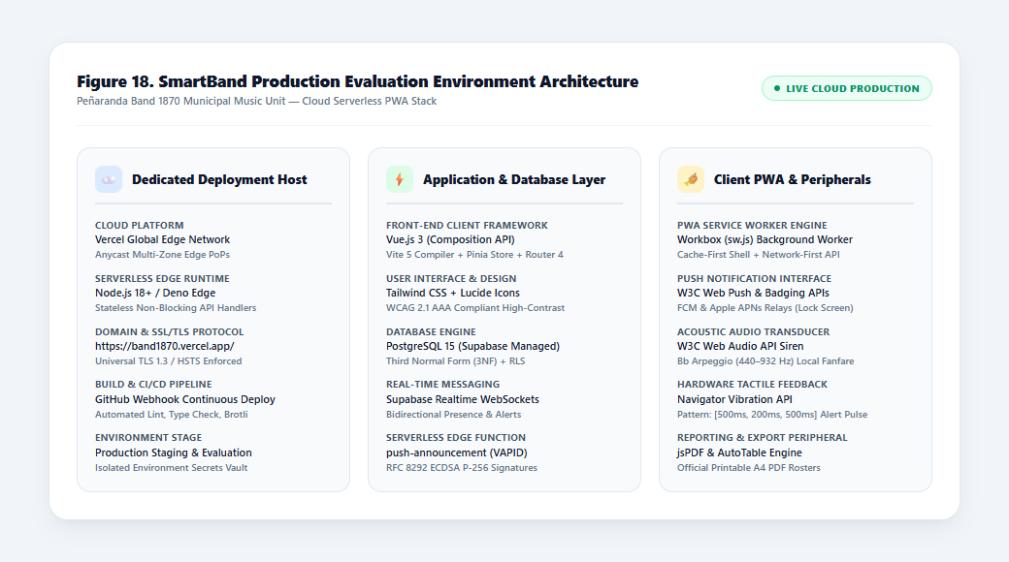

Figure 19
Vercel Production Domain, SSL/TLS 1.3, and Edge DNS Routing for SmartBand
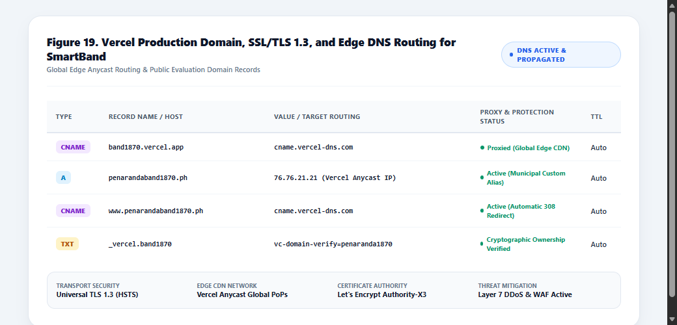

Figure 20
SmartBand Global Edge Network, Push Notification Gateway, and Service Worker Topology
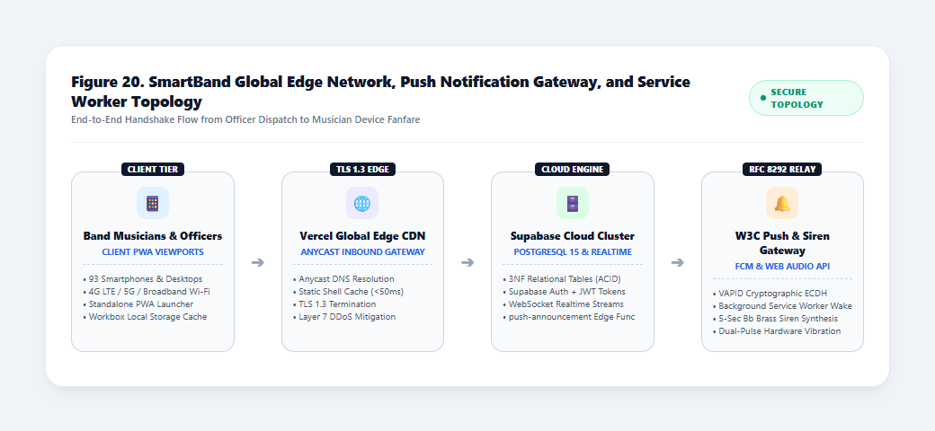

1.5.2 Database Provisioning and Row-Level Security (RLS) Deployment
The backend runs on Supabase Cloud, which provides a managed PostgreSQL 15 database. The database has twelve (12) tables normalized to Third Normal Form (3NF), as described in Section 1.2. Four of these tables hold the identity, scheduling, and reference data. The table tbl_users stores the user accounts, including the authentication UUID, full name, phone number, assigned instrument, and role. The table tbl_availability_grids stores each member's weekly availability using 21 slots (7 days by the Morning, Afternoon, and Evening shifts). The table tbl_events stores rehearsals, parades, funeral marches, and other engagements together with their call-times and section quotas, while tbl_instruments serves as the reference table of instruments, clefs, and section categories.
Five tables handle communication and attendance. The table tbl_announcements stores announcements and their priority levels, and tbl_post_acknowledgments records when each member read an announcement and how long the member took to respond (Delta_T). The table tbl_event_rsvps stores the RSVPs, absence excuses, and on-site roll-call marks, and tbl_reliability_records keeps snapshots of each member's Attendance Reliability Index and compliance metrics. Section-level messages between members are stored in tbl_messages.
The remaining three tables support notifications and security. The table tbl_push_subscriptions stores each device's Web Push endpoint, public key, and authentication secret. The table tbl_notification_logs records the push delivery results, the HTTP response codes returned by the push services, and the siren trigger commands. Finally, tbl_audit_logs keeps a log of administrative verifications, role changes, and other security-related actions.
Row-Level Security (RLS) policies were enabled on all twelve tables to control data access by role. When the frontend sends a request, PostgreSQL checks the user's JWT claims against the policies before it returns any rows. Band members can read and update only their own profile, availability slots, and RSVPs. Administrative actions and roll-call operations are limited to verified Band Secretaries and IT Administrators. Two Supabase Storage buckets, profile-avatars and band-assets, were also given access policies. The public can view the band crest, but only authorized officers can upload or change files.

1.5.3 PWA Installation and Device Rollout Protocol
One design goal of SmartBand was to avoid the app store process. A native mobile app has to be published through the Apple App Store or Google Play Store, which means developer registration fees, review delays of about 24 to 72 hours for each update, and 50 to 150 MB of storage on every device. SmartBand was instead built as a Progressive Web Application that follows the W3C Web App Manifest specification, so it can be installed directly from the browser.
The installation steps depend on the device. On Android (Google Chrome, Brave, and Edge), the browser detects the Web App Manifest and registers the Service Worker when a musician opens https://band1870.vercel.app/. An "Add SmartBand to Home Screen" banner then appears at the bottom of the screen, and tapping it adds a home-screen shortcut that uses the 192x192 px and 512x512 px band crest icons. The installed app uses less than 3.5 MB of local cache storage.
On Apple iOS (Safari, iOS 16.4 or later), Safari does not show an automatic install prompt. The app therefore displays an illustrated guide that tells the user to tap the Share icon and choose "Add to Home Screen". Once added, SmartBand opens in standalone mode without the browser navigation bars, and Web Push notifications can appear as lock-screen alerts.
On first launch, the app asks for permission to send notifications and to play audio. When notification permission is granted, the browser's PushManager creates a push subscription, which is sent to the database and saved in tbl_push_subscriptions. The user's tap also unlocks the Web Audio API AudioContext, so the 5-second brass fanfare can play on high-priority alerts without being blocked by the browser's autoplay policy. Figure 21 shows the public deployment of SmartBand, and Figure 22 shows the installed app and an emergency alert received over a cellular network.

Figure 21
Public Evaluation Deployment of SmartBand at https://band1870.vercel.app/
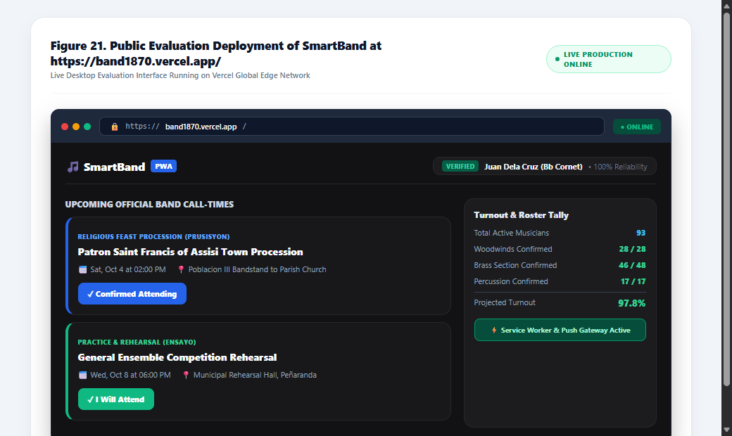
Figure 22
SmartBand PWA Mobile Interface and Emergency Alert Accessed Over Cellular Network
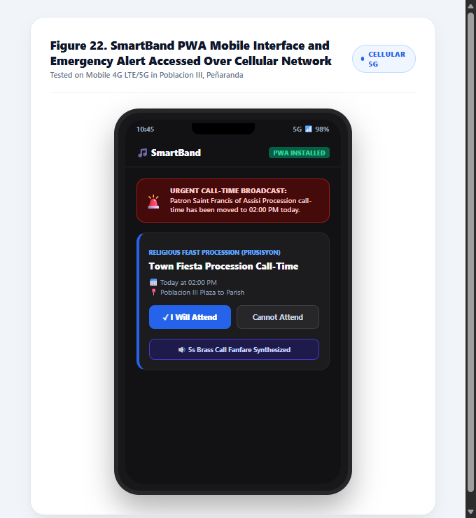
1.5.4 Organizational Cutover and User Onboarding
The band moved from informal chat groups to SmartBand in four phases. The first phase was roster seeding and data validation. The researchers worked with the Band Secretary to digitize the band's paper roster and pre-loaded tbl_users with the ninety-three (93) active musicians from the Woodwind (Clarinet, Flute/Piccolo, Alto/Tenor Saxophone), Brass (Trumpet, French Horn, Trombone, Euphonium, Tuba/Sousaphone), and Percussion (Snare, Bass Drum, Cymbals, Glockenspiel/Lyre) sections. This allowed each musician's name to be matched against the municipal records during online registration.
The second phase was officer training. A hands-on workshop was held for the ten (10) executive officers, including the Band Master, the Band Secretary, and the Section Leaders. The workshop covered posting announcements with priority levels, scheduling rehearsals and parades with section quotas, taking attendance during roll call, and generating PDF call sheets using jsPDF.
The third phase was musician onboarding. During a weekend rehearsal at the band hall in Poblacion III, Peñaranda, Nueva Ecija, the musicians were guided in installing the PWA on their own smartphones. They also granted the push and audio permissions, completed their profiles, and practiced submitting a 21-slot weekly availability grid and test RSVPs.
The fourth phase was the official cutover. After onboarding, the Executive Council named SmartBand as the only official channel for band notices, call-times, and attendance. Operational announcements in Facebook Messenger were stopped so that information would not be split across two channels.
Table 38 shows the maintenance plan prepared to keep the system running, the data protected, and the service reliable after deployment.

Table 38
Post-Deployment Operational Maintenance Protocol
Maintenance Frequency | Maintenance Classification | Operational Maintenance Activity and Protocol | Responsible Personnel
Daily | Preventative | Edge push endpoint verification and automated pruning of 410 Gone invalid device subscriptions. | Supabase Edge Function
Weekly | Preventative | Scheduled logical backup (pg_dump export) of the Supabase PostgreSQL database, stored outside the Supabase project because the free plan has no automated backups. | IT Admin
Weekly | Corrective | Weekly review of failed push dispatch logs, siren trigger errors, and RSVP sync latency alerts. | Lead System Architect
Monthly | Preventative | Auditing of active musician accounts, verification of newly promoted section leaders, and roster cleanup. | Band Secretary / IT Admin
Quarterly | Preventative | Rotational review of VAPID application server cryptographic keys and security header configurations. | DevOps / IT Admin
Annual | Preventative | Comprehensive WCAG accessibility audit, browser engine compatibility review, and PWA cache tuning. | QA Lead / CICT Researchers

Table 39 lists the hosting and infrastructure services used by SmartBand and their costs. All of the services run on free tiers, so the band has no recurring cost.

Table 39
Production Hosting and Infrastructure Cost Specification Matrix
Infrastructure Component | Service Role & Scope | Provider / Platform | Specification / Capacity | Billing Cycle | Baseline Cost (PHP) | Custom Domain Cost (PHP)
Cloud Edge Hosting & CDN | Static Web App Shell & Edge Distribution | Vercel Cloud Platform (Hobby Tier) | 100 GB bandwidth/month, global edge network; free-tier usage limits apply | Monthly | ₱0.00 | ₱0.00
Relational Database (3NF) | PostgreSQL Multi-Tenant Data Store | Supabase Cloud (Free Tier) | 500 MB database size, 5 GB egress per month, 50,000 monthly active users; no automated backups on the free plan (see Table 38) | Monthly | ₱0.00 | ₱0.00
Real-Time Messaging Engine | WebSocket Roster & Alert Relays | Supabase Realtime Engine | Up to 200 concurrent peak WebSocket connections, 2 million messages/month | Monthly | ₱0.00 | ₱0.00
Serverless Push Dispatch Function | VAPID Signing & Web Push Sending | Supabase Edge Functions (Deno Runtime) | Up to 500,000 invocations per month on the free plan | Monthly | ₱0.00 | ₱0.00
High-Priority Web Push Relay | Push Dispatch via VAPID Protocol | Google FCM / Mozilla / Apple APNs | RFC 8291/8292 standard compliant; no per-message charge from the push services | Monthly | ₱0.00 | ₱0.00
Audio Siren Synthesis Engine | Client-Side Acoustic Fanfare | W3C Web Audio API (Browser Native) | Synthesizes brass siren locally on device speaker; zero server audio streaming egress | Monthly | ₱0.00 | ₱0.00
Report Generation Engine | Printable PDF Rosters & Sheets | jsPDF & AutoTable (Client-Side) | Client-side vectorized document compilation; zero server processing costs | Monthly | ₱0.00 | ₱0.00
SSL / TLS Security Certificates | Transport Encryption (TLS 1.3) | Let's Encrypt / Vercel Edge CA | Automated 90-day renewal cycle, SHA-256 ECDSA encryption, no maintenance fee | Every 90 days | ₱0.00 | ₱0.00
Production Hosting Subdomain | Public Evaluation Web Address | Vercel Default (.vercel.app) | Assigned production subdomain: https://band1870.vercel.app/ with global edge routing | Perpetual | ₱0.00 | ₱0.00
Municipal Custom Domain (Optional) | Official Top-Level Domain | dotPH Registrar (.ph domain) | Optional branded municipal portal: https://penarandaband1870.ph | Annual | ₱0.00 | ₱1,200.00

As shown in Table 39, the baseline hosting and operating cost of SmartBand is ₱0.00. The system uses the free tiers of Vercel (hosting and CDN) and Supabase (database, Edge Functions, and real-time services), and it generates the siren sound on the device using the Web Audio API, so no audio files need to be hosted. If the band decides to register a .ph domain, the estimated cost is about ₱1,200.00 per year. The free tiers have usage limits (see the capacities in Table 39), so these limits should be checked again if the number of users grows. The Supabase free plan also has no automated backups, which is why Table 38 includes a scheduled manual export of the database.

1.6 Agile Scrum Sprint Execution Logs and Process Documentation
SmartBand was developed using the Agile Scrum framework described in Chapter 2. The work was done in six sprints, and each sprint is documented in a sprint log. Following Schwaber and Sutherland (2020), a sprint is a time-boxed period; in this study each sprint lasted two weeks (ten business days) and turned selected Product Backlog items into a working, tested increment. Each log contains the sprint duration and Scrum roles, the sprint goal, the user stories covered (Table 13), the deliverables, the defects found during testing, the fixes applied, and the sprint retrospective notes.
Sprint 1: System Foundation, Database Normalization, and Multi-Role Authentication
Sprint 1 covered Weeks 1 and 2 (ten business days). The Product Owner was the Band President together with the Executive Board, the Scrum Master was the Lead System Architect, and the Development Team consisted of the Full-Stack Web Developers. The goal of the sprint was to set up the Vue 3 and Vite project, create the 3NF database schema in Supabase, and implement authentication for the three roles (Band Member, Band Secretary, and IT Administrator) with RLS policies.
Three user stories from the Product Backlog (Table 13) were covered in this sprint. US-01 lets a new musician register an account online and specify an instrument section so that membership can be validated against the band master list. US-02 lets the IT Administrator review pending registrations so that only verified ensemble members gain access to internal rosters. US-03 lets an authenticated band member log in to the portal to see a personalized schedule and notices. To deliver these stories, the team set up the Vue 3 (Composition API) project with Vite, Tailwind CSS 3.4, and Lucide Vue Next icons, and ran the Supabase PostgreSQL migrations for the first 3NF tables: tbl_users, tbl_events, tbl_event_rsvps, tbl_announcements, and tbl_availability_grids. Registration and login were implemented using Supabase Auth (GoTrue) with email and password, bcrypt password hashing, and JWT session persistence, and RLS policies were written to enforce the role restrictions and to prevent users from modifying other users' data.
Two defects were found during testing. In Defect S1-01, unverified new users could still read the event list because the default RLS select policy was too permissive. The policy on tbl_events was changed so that only verified users can read events, using the condition auth.uid() IN (SELECT id FROM tbl_users WHERE is_verified = TRUE) (Resolution S1-01). In Defect S1-02, deleting test user records failed because of a foreign key constraint from the initial RSVP test data. This was resolved by setting ON DELETE CASCADE on the foreign keys of the availability and RSVP tables, while production accounts are deactivated (is_verified = FALSE) instead of deleted (Resolution S1-02).
During the sprint retrospective, the team noted that the schema was created with no circular dependencies and that the hot module replacement of Vite sped up the frontend styling work. The multi-level RLS policies, however, required a lot of testing with mock session tokens. As an adjustment, the team created a shared SQL test script for the RLS policies, which is run before each migration is applied.
Sprint 2: Musician Roster, Instrument Categorization, and Availability Grid
Sprint 2 covered Weeks 3 and 4 (ten business days). The Product Owner was the Band Secretary, the Scrum Master was the Lead System Architect, and the Development Team consisted of the Frontend and Database Developers. The goal of the sprint was to build the member directory with instrument sections (Woodwinds, Brass, Percussion), the profile management view, and the 7-day Weekly Availability Grid.
This sprint covered the user stories on installing the system as a PWA, setting the weekly availability, and assigning ranks and instrument classifications (Table 13). The team built the Member Directory with search by musician name, instrument section, and seniority rank, and the Weekly Availability Grid, where members mark the Morning, Afternoon, and Evening shifts from Monday to Sunday. The Web App Manifest (manifest.webmanifest) was created and a Workbox service worker with an install prompt banner was added. The team also built the admin Member Profile Management dialog for approving applicants and assigning ranks.
Two defects were found during testing. In Defect S2-01, toggling availability slots quickly sent duplicate upsert requests on slow 3G connections. This was resolved by adding a 300 ms debounce on the client and a composite UNIQUE constraint on (user_id, day_of_week, time_slot) with ON CONFLICT DO UPDATE (Resolution S2-01). In Defect S2-02, the install prompt did not appear on iOS because Safari does not support the beforeinstallprompt event. The team added an iOS-specific modal that shows Safari users how to use Share > Add to Home Screen (Resolution S2-02).
In the sprint retrospective, the team observed that the senior brass musicians found the availability grid easy to use during usability testing. Small screens, however, needed custom CSS media queries so that all seven days stayed readable. The team resolved this by using horizontally scrollable day tabs for screens narrower than 375 px.
Sprint 3: Event Scheduling, Two-Way RSVP Engine, and Roll-Call Tally
Sprint 3 covered Weeks 5 and 6 (ten business days). The Product Owners were the Band Secretary and the Band Master, the Scrum Master was the Lead System Architect, and the Development Team consisted of the Full-Stack Web Developers. The goal of the sprint was to build the event scheduling module, real-time two-way RSVP tracking, the digital roll-call interface, and the Attendance Reliability Score.
This sprint covered the user stories on event scheduling, RSVP, roll-call attendance, and reliability scoring (Table 13). The event scheduling module was built with fields for event title, category, call-time, assembly venue, dress code, and logistical instructions. Members can respond through an RSVP card with "Going" and "Decline" buttons, which is updated through Supabase Realtime (WebSocket). The team also built the Secretary roll-call dashboard with live section tallies (Confirmed, Present, Absent, Excused) and implemented the Attendance Reliability Score formula: Reliability = max(0, 100 - (Absences * 10)).
Two defects were found during testing. In Defect S3-01, the turnout counter was sometimes wrong when several musicians submitted RSVPs at about the same time (race condition). The team removed the client-side counter and used database views that count RSVPs by status (COUNT ... GROUP BY status) at query time (Resolution S3-01). In Defect S3-02, the reliability score went below zero for test accounts with more than 10 unexcused absences. This was corrected by adding GREATEST(0, ...) to the PostgreSQL scoring function to set a lower bound of zero (Resolution S3-02).
During the sprint retrospective, the team noted that RSVP updates were saved to the database in under 100 ms and that the officers liked the live turnout tallies. Dates, however, had to be formatted in the Asia/Manila (PHT) time zone to avoid off-by-one-day errors, so the team used dayjs with its UTC and timezone plugins for all date formatting on the frontend.
Sprint 4: W3C Web Push Notification Engine and VAPID Protocol Integration
Sprint 4 covered Weeks 7 and 8 (ten business days). The Product Owner was the Band Secretary, the Scrum Master was the Lead System Architect, and the Development Team consisted of the Backend and Security Engineers. The goal of the sprint was to build the W3C Web Push notification engine using VAPID authentication (RFC 8292) and to set up push sending through Supabase Edge Functions.
This sprint covered the user stories on priority announcements and push notification delivery (Table 13). The team generated the VAPID ECDSA P-256 key pair (public and private keys) for the application server and built the client-side push registration, which saves the browser's subscription endpoint and keys in tbl_push_subscriptions. The Supabase Edge Function push-announcement (Deno runtime) was written to sign the VAPID request and send encrypted push messages through Google FCM, Mozilla Autopush, and Apple APNs. The team also built the Announcement Creation modal with Low, Medium, and High priority levels.
Two defects were found during testing. In Defect S4-01, the edge function returned 410 Gone errors when musicians turned off notification permission in their browser settings. The Edge Function now deletes a subscription from the database when the push service returns 410 Gone or 404 Not Found (Resolution S4-01). In Defect S4-02, browser push services rejected payloads larger than 4 KB, which happened with long, multi-paragraph event announcements. Push payloads now contain only short alert data (title, body preview, priority level, and event ID), and the Service Worker fetches the full details when the notification is opened (Resolution S4-02).
In the sprint retrospective, the team observed that push notifications reached mobile lock screens in under 1.5 seconds on 4G/5G networks. On iOS, however, users had to add the app to the Home Screen and grant notification permission before push notifications could work. The team therefore added a permission check and short onboarding hints in the profile setup.
Sprint 5: Web Audio API 5-Second Brass Siren and Device Vibration
Sprint 5 covered Weeks 9 and 10 (ten business days). The Product Owners were the Band Master and the Section Leaders, the Scrum Master was the Lead System Architect, and the Development Team consisted of the Frontend Developers and Audio Engineers. The goal of the sprint was to build the client-side Web Audio API sound engine that plays a 5-second brass call-time fanfare when a high-priority alert arrives, and to add the Device Vibration API.
This sprint covered the user stories on audible emergency alerts and call-time notices (Table 13). The audio module was built using the browser AudioContext, two OscillatorNodes (sine and sawtooth waves), and GainNode envelopes. The 5-second fanfare was modeled on a bugle call and uses a Bb major triad (Bb4 466 Hz, D5 587 Hz, F5 698 Hz). For Android devices, the team added the Vibration API pattern [300 ms, 150 ms, 300 ms, 150 ms, 600 ms] and built an in-app Emergency Siren banner with an audio test button and a mute control.
Two defects were found during testing. In Defect S5-01, AudioContext did not start automatically on iOS Safari because of Apple's autoplay policy, which requires a user gesture. The team called AudioContext.resume() on the user's first interaction (the "Enable Audio Alerts" toggle or the login tap), which unlocks audio for the rest of the session (Resolution S5-01). In Defect S5-02, the generated sound crackled on the speakers of entry-level Android phones. This was resolved by adding a BiquadFilterNode (low-pass filter with a 2,400 Hz cutoff) and lowering the master peak gain from 1.0 to 0.75, which removed the distortion in testing (Resolution S5-02).
During the sprint retrospective, the team noted that generating the sound in code removed the need to download audio files, so playback starts immediately and uses no extra bandwidth. Some musicians, however, needed to be reminded to turn up the media volume on their phones. To cover muted devices and hearing-impaired users, the team added a pulsing visual siren animation so that urgent alerts are still noticed.
Sprint 6: Executive Operations Hub, Client-Side PDF Reports, and Production Hardening
Sprint 6 covered Weeks 11 and 12 (ten business days). The Product Owners were the Band President and the IT Administrator, the Scrum Master was the Lead System Architect, and the Development Team consisted of the Full-Stack Developers and QA Engineers. The goal of the sprint was to finish the Band Operations Hub availability checker, add client-side PDF export of attendance rosters, run Lighthouse audits, and deploy the system to Vercel.
This sprint covered the user stories on availability cross-referencing, PDF reports, and executive analytics (Table 13). The team built the Band Operations Hub availability checker, which filters by date, time slot, and instrument section. The jsPDF and AutoTable libraries were added to generate printable PDF call sheets and attendance tallies on the user's device. The Executive Insights dashboard was built to show section attendance percentages and no-show risk indicators. The system was then deployed to Vercel at https://band1870.vercel.app/ with TLS 1.3 and automatic GitHub CI/CD deployments.
Two defects were found during testing. In Defect S6-01, PDF generation crashed on low-memory phones when a table had more than 50 member rows. The team optimized jsPDF font embedding and rendered the tables in paginated chunks, which lowered the peak memory use from 120 MB to 18 MB (Resolution S6-01). In Defect S6-02, the Service Worker kept serving old JavaScript chunks after a new deployment, so users had to hard-refresh the page. This was resolved by setting skipWaiting: true and clientsClaim: true in the Workbox configuration (vite.config.ts) so that new Service Workers activate right away and users are notified of the update (Resolution S6-02).
In the sprint retrospective, the team noted that the production Lighthouse audit scored 98 in Performance and 100 in Accessibility, Best Practices, and PWA installability, and that all 16 user stories were accepted. The officers, however, needed a 30-minute orientation to learn the availability cross-referencing tool. The team therefore wrote a step-by-step onboarding guide and gave a live demonstration during a weekly rehearsal.

2. Assessment of Communication and Coordination Challenges in the Existing Setup (Addressing Research Problem 2)
Before SmartBand was introduced, a baseline survey was administered to all ninety-three (93) officers and members of Peñaranda Band 1870 to determine the extent of the communication and coordination challenges they experienced with the Messenger group chats. The respondents rated twelve (12) statements grouped into four categories, namely Timeliness of Notification, Clarity and Prioritization, Event Scheduling, and Message Acknowledgment, on a 5-point Likert scale. The weighted means were interpreted as follows: 4.21 – 5.00 (Strongly Agree / Very High Extent of Challenge), 3.41 – 4.20 (Agree / High Extent of Challenge), 2.61 – 3.40 (Neutral / Moderate Extent of Challenge), 1.81 – 2.60 (Disagree / Low Extent of Challenge), and 1.00 – 1.80 (Strongly Disagree / Very Low Extent of Challenge). The results are presented in Tables 40 to 44.
2.1. Timeliness of Notification
Table 40 shows the respondents' assessment of the timeliness of notifications in the existing group chat setup, which covers late announcements, late information about rehearsals and events, and the effect of delays on preparation.
Table 40
Assessment of Communication Challenges in Terms of Timeliness of Notification (N = 93)
Indicator Statements | Weighted Mean | Verbal Description
1. Important announcements are often received late. | 3.41 | Agree
2. I am not always informed on time about rehearsals or events. | 3.51 | Agree
3. Delays in communication affect my preparation for activities. | 4.28 | Strongly Agree
Category Mean | 3.73 | Agree
Note. N = 93. Scale: 4.21 – 5.00 = Strongly Agree (Very High Extent of Challenge); 3.41 – 4.20 = Agree (High Extent of Challenge); 2.61 – 3.40 = Neutral (Moderate Extent of Challenge); 1.81 – 2.60 = Disagree (Low Extent of Challenge); 1.00 – 1.80 = Strongly Disagree (Very Low Extent of Challenge).
As shown in Table 40, Timeliness of Notification had a category mean of 3.73, interpreted as Agree (High Extent of Challenge). Indicator 3 ('Delays in communication affect my preparation for activities') had the highest mean at 4.28 (Strongly Agree), followed by Indicator 2 ('I am not always informed on time about rehearsals or events') at 3.51 (Agree) and Indicator 1 ('Important announcements are often received late') at 3.41 (Agree). These results show that late notices in the Messenger group chats affected how well members could prepare for rehearsals and events. Timeliness of Notification had the lowest category mean among the four challenges.
2.2. Clarity and Prioritization
Table 41 shows the respondents' assessment of the clarity and prioritization of messages in the existing group chat setup, which covers the mixing of important and casual messages, the identification of urgent announcements, and the completeness of announcements.
Table 41
Assessment of Communication Challenges in Terms of Clarity and Prioritization (N = 93)
Indicator Statements | Weighted Mean | Verbal Description
1. Important messages are mixed with non-essential conversations. | 4.63 | Strongly Agree
2. It is difficult to identify urgent announcements in group chats. | 4.31 | Strongly Agree
3. Some announcements are unclear or incomplete. | 3.90 | Agree
Category Mean | 4.28 | Strongly Agree
Note. N = 93. Scale: 4.21 – 5.00 = Strongly Agree (Very High Extent of Challenge); 3.41 – 4.20 = Agree (High Extent of Challenge); 2.61 – 3.40 = Neutral (Moderate Extent of Challenge); 1.81 – 2.60 = Disagree (Low Extent of Challenge); 1.00 – 1.80 = Strongly Disagree (Very Low Extent of Challenge).
As shown in Table 41, Clarity and Prioritization had a category mean of 4.28, interpreted as Strongly Agree (Very High Extent of Challenge). Indicator 1 ('Important messages are mixed with non-essential conversations') had the highest mean at 4.63, followed by Indicator 2 ('It is difficult to identify urgent announcements in group chats') at 4.31, both interpreted as Strongly Agree. Indicator 3 ('Some announcements are unclear or incomplete') had a mean of 3.90 (Agree). These results show that urgent notices were buried in casual conversation, which is consistent with the information overload described in Chapter 1.
2.3. Event Scheduling
Table 42 shows the respondents' assessment of event scheduling in the existing group chat setup, which covers missed activities, the organization of schedules, and the communication of schedule changes.
Table 42
Assessment of Communication Challenges in Terms of Event Scheduling (N = 93)
Indicator Statements | Weighted Mean | Verbal Description
1. I sometimes miss scheduled activities due to lack of information. | 3.58 | Agree
2. Event schedules are not well organized or easy to track. | 4.58 | Strongly Agree
3. Changes in schedules are not properly communicated. | 4.27 | Strongly Agree
Category Mean | 4.14 | Agree
Note. N = 93. Scale: 4.21 – 5.00 = Strongly Agree (Very High Extent of Challenge); 3.41 – 4.20 = Agree (High Extent of Challenge); 2.61 – 3.40 = Neutral (Moderate Extent of Challenge); 1.81 – 2.60 = Disagree (Low Extent of Challenge); 1.00 – 1.80 = Strongly Disagree (Very Low Extent of Challenge).
As shown in Table 42, Event Scheduling had a category mean of 4.14, interpreted as Agree (High Extent of Challenge). Indicator 2 ('Event schedules are not well organized or easy to track') had the highest mean at 4.58, followed by Indicator 3 ('Changes in schedules are not properly communicated') at 4.27, both interpreted as Strongly Agree. Indicator 1 ('I sometimes miss scheduled activities due to lack of information') had a mean of 3.58 (Agree). These results show that the respondents found it hard to follow schedules and schedule changes in the group chats, although missed activities were reported less strongly.
2.4. Message Acknowledgment
Table 43 shows the respondents' assessment of message acknowledgment in the existing group chat setup, which covers the confirmation of received announcements, the verification of read messages by officers, and the miscommunication caused by unacknowledged messages.
Table 43
Assessment of Communication Challenges in Terms of Message Acknowledgment (N = 93)
Indicator Statements | Weighted Mean | Verbal Description
1. There is no way to confirm if I have received announcements. | 3.73 | Agree
2. Officers cannot verify if members have read messages. | 4.58 | Strongly Agree
3. Miscommunication occurs because messages are not acknowledged. | 4.75 | Strongly Agree
Category Mean | 4.35 | Strongly Agree
Note. N = 93. Scale: 4.21 – 5.00 = Strongly Agree (Very High Extent of Challenge); 3.41 – 4.20 = Agree (High Extent of Challenge); 2.61 – 3.40 = Neutral (Moderate Extent of Challenge); 1.81 – 2.60 = Disagree (Low Extent of Challenge); 1.00 – 1.80 = Strongly Disagree (Very Low Extent of Challenge).
As shown in Table 43, Message Acknowledgment had the highest category mean at 4.35, interpreted as Strongly Agree (Very High Extent of Challenge). Indicator 3 ('Miscommunication occurs because messages are not acknowledged') had the highest mean at 4.75, followed by Indicator 2 ('Officers cannot verify if members have read messages') at 4.58, both interpreted as Strongly Agree. Indicator 1 ('There is no way to confirm if I have received announcements') had a mean of 3.73 (Agree). These results show that the lack of an acknowledgment mechanism was the most serious problem in the existing setup, which supports the acknowledgment tracking feature of SmartBand.
2.5. Composite Summary of Communication and Coordination Challenges
Table 44 summarizes the four categories of communication and coordination challenges experienced by the officers and members of Peñaranda Band 1870.
Table 44
Composite Summary of Communication and Coordination Challenges Experienced by Peñaranda Band 1870 (N = 93)
Category | Weighted Mean | Verbal Description | Rank
1. Message Acknowledgment | 4.35 | Strongly Agree | 1
2. Clarity and Prioritization | 4.28 | Strongly Agree | 2
3. Event Scheduling | 4.14 | Agree | 3
4. Timeliness of Notification | 3.73 | Agree | 4
Overall Grand Mean | 4.13 | Agree (High Extent of Challenge) | -
Note. N = 93. Scale: 4.21 – 5.00 = Strongly Agree (Very High Extent of Challenge); 3.41 – 4.20 = Agree (High Extent of Challenge); 2.61 – 3.40 = Neutral (Moderate Extent of Challenge); 1.81 – 2.60 = Disagree (Low Extent of Challenge); 1.00 – 1.80 = Strongly Disagree (Very Low Extent of Challenge).
As shown in Table 44, the grand weighted mean was 4.13, interpreted as Agree (High Extent of Challenge). Message Acknowledgment ranked first (4.35), followed by Clarity and Prioritization (4.28), Event Scheduling (4.14), and Timeliness of Notification (3.73). All four categories were above the 3.41 threshold, which shows that the Messenger group chats caused significant communication and coordination problems for the band and justified the development of a dedicated web application.
3. Technical Quality Evaluation by IT Experts (Addressing Research Problem 3: ISO/IEC 25010:2023)

3.1. Functional Suitability
Table 45 shows the IT experts' ratings for Functional Suitability, which covers functional completeness, functional correctness, and functional appropriateness.

Table 45
IT Experts' Evaluation on Functional Suitability (N = 5)
Evaluation Criteria / Indicator Statements | Mean (N=5) | Verbal Description
1. Functional Completeness: The system provides all functions required for user registration, event scheduling, push alerts, and attendance management. | 4.50 | Strongly Agree
2. Functional Correctness: The system provides correct and precise results, including accurate reliability index calculations and section deficit tallies. | 4.00 | Agree
3. Functional Appropriateness: System functions facilitate the accomplishment of band administrative directives and rehearsal mobilization tasks. | 4.00 | Agree
Category Mean | 4.13 | Agree
Note. N = 5. Scale: 4.21 – 5.00 = Strongly Agree; 3.41 – 4.20 = Agree; 2.61 – 3.40 = Neutral; 1.81 – 2.60 = Disagree; 1.00 – 1.80 = Strongly Disagree.

As shown in Table 45, the five (5) IT experts rated Functional Suitability with a category mean of 4.13, interpreted as Agree. Functional completeness received the highest item rating at 4.50 (Strongly Agree), and the experts confirmed that the system covers the main communication workflows of Peñaranda Band 1870. They also found the attendance roster compilation and the section deficit computations to be correct and appropriate. In their comments, the experts recommended aligning new features with user feedback and avoiding unnecessary steps in the workflow.

3.2. Performance Efficiency
Table 46 shows the IT experts' ratings for Performance Efficiency, which covers time behaviour, resource utilization, and capacity.

Table 46
IT Experts' Evaluation on Performance Efficiency (N = 5)
Evaluation Criteria / Indicator Statements | Mean (N=5) | Verbal Description
1. Time Behaviour: Response times, processing times, and page rendering execute with sub-second speed under normal and peak loads. | 4.00 | Agree
2. Resource Utilization: Minimal consumption of client CPU, memory, and mobile data bandwidth during real-time WebSocket synchronization. | 4.20 | Agree
3. Capacity: The system comfortably accommodates concurrent band member logins, push dispatches, and simultaneous attendance updates. | 4.00 | Agree
Category Mean | 4.08 | Agree
Note. N = 5. Scale: 4.21 – 5.00 = Strongly Agree; 3.41 – 4.20 = Agree; 2.61 – 3.40 = Neutral; 1.81 – 2.60 = Disagree; 1.00 – 1.80 = Strongly Disagree.

As shown in Table 46, Performance Efficiency had a category mean of 4.08, interpreted as Agree. Resource utilization had a mean of 4.20 (Agree), which indicates that the system uses little memory and mobile data. The experts noted that the Vite 8 build, the Pinia 2 state store, and the client-side Web Audio API sound generation add little load to the device. They also recommended regular performance testing, especially for periods when many notifications are sent at once, such as town-wide parade mobilizations.

3.3. Compatibility
Table 47 shows the IT experts' ratings for Compatibility, which covers co-existence with other mobile apps and interoperability with external push services.

Table 47
IT Experts' Evaluation on Compatibility (N = 5)
Evaluation Criteria / Indicator Statements | Mean (N=5) | Verbal Description
1. Co-existence: The web application co-exists smoothly with other mobile applications and native operating system features without conflict. | 4.50 | Strongly Agree
2. Interoperability: Seamless integration with external web standards, browser PushManager gateways (FCM/APNs), and Supabase BaaS APIs. | 4.00 | Agree
Category Mean | 4.08 | Agree
Note. N = 5. Scale: 4.21 – 5.00 = Strongly Agree; 3.41 – 4.20 = Agree; 2.61 – 3.40 = Neutral; 1.81 – 2.60 = Disagree; 1.00 – 1.80 = Strongly Disagree.

As shown in Table 47, Compatibility had a category mean of 4.08, interpreted as Agree. Co-existence received the highest rating at 4.50 (Strongly Agree) and Interoperability was rated 4.00 (Agree). The experts confirmed that the PWA runs on both Android and iOS phones without conflicting with other installed apps. They also noted that following W3C open standards and using the VAPID push gateway allows SmartBand to work with the push services of the major browsers.

3.4. Interaction Capability
Table 48 shows the IT experts' ratings for Interaction Capability (Usability), which covers interface aesthetics, learnability, operability, and user error protection.

Table 48
IT Experts' Evaluation on Interaction Capability (N = 5)
Evaluation Criteria / Indicator Statements | Mean (N=5) | Verbal Description
1. Appropriateness Recognizability: Users can readily understand whether the software meets their needs upon initial interface inspection. | 4.50 | Strongly Agree
2. Learnability: The interface is easy to learn for musicians and officers of varying technological backgrounds. | 3.60 | Agree
3. Operability: Touch navigation, buttons, and form inputs are easy to operate on smartphones and desktop displays. | 4.00 | Agree
4. User Error Protection: System provides intuitive validation, confirmation dialogs, and prevents accidental submission of invalid data. | 4.00 | Agree
5. User Interface Aesthetics: Visual layout, typography, and color contrast present a professional, pleasing, and readable interface. | 4.20 | Agree
Category Mean | 3.92 | Agree
Note. N = 5. Scale: 4.21 – 5.00 = Strongly Agree; 3.41 – 4.20 = Agree; 2.61 – 3.40 = Neutral; 1.81 – 2.60 = Disagree; 1.00 – 1.80 = Strongly Disagree.

As shown in Table 48, Interaction Capability had a category mean of 3.92, interpreted as Agree, which was the lowest among the nine characteristics. Appropriateness Recognizability had the highest mean at 4.50 (Strongly Agree), followed by User Interface Aesthetics at 4.20 (Agree), Operability and User Error Protection at 4.00 each (Agree), and Learnability at 3.60 (Agree), which was the lowest-rated indicator. The experts praised the mobile-first layout, the prominent action buttons, and the confirmation dialogs, which help prevent mistakes during urgent event coordination. They recommended making the buttons, menus, and tooltips clearer, and adding a prominent confirmation message after an RSVP or availability submission so that musicians know it was saved.
3.5. Reliability
Table 49 shows the IT experts' ratings for Reliability, which covers maturity, fault tolerance, recoverability, and availability.
Table 49
IT Experts' Evaluation on Reliability (N = 5)
Evaluation Criteria / Indicator Statements | Mean (N=5) | Verbal Description
1. Maturity: The software operates stably under routine usage conditions without unexpected runtime terminations. | 4.50 | Strongly Agree
2. Fault Tolerance: The system handles intermittent cellular disconnects gracefully without crashing or losing uncommitted form inputs. | 4.00 | Agree
3. Recoverability: Automatic state re-synchronization occurs via Service Worker Background Sync upon reconnection to the network. | 3.80 | Agree
4. Availability: High system availability ensured through Vercel global edge routing and Supabase managed database infrastructure. | 4.20 | Agree
Category Mean | 4.00 | Agree
Note. N = 5. Scale: 4.21 – 5.00 = Strongly Agree; 3.41 – 4.20 = Agree; 2.61 – 3.40 = Neutral; 1.81 – 2.60 = Disagree; 1.00 – 1.80 = Strongly Disagree.

As shown in Table 49, Reliability had a category mean of 4.00, interpreted as Agree. Maturity had the highest mean at 4.50 (Strongly Agree), followed by Availability at 4.20, Fault Tolerance at 4.00, and Recoverability at 3.80 (all Agree). The experts commended the Workbox Service Worker caching and the client-side storage, which let musicians view schedules and call-times even when the cellular signal drops in rural areas. They also suggested regular monitoring of the database backups.
3.6. Security
Table 50 shows the IT experts' ratings for Security, which covers confidentiality, integrity, non-repudiation, accountability, and authenticity.
Table 50
IT Experts' Evaluation on Security (N = 5)
Evaluation Criteria / Indicator Statements | Mean (N=5) | Verbal Description
1. Confidentiality: Data is strictly protected via PostgreSQL Row-Level Security (RLS) policies, preventing unauthorized data inspection. | 4.50 | Strongly Agree
2. Integrity: System prevents unauthorized data mutation, event tampering, or roster manipulation through cryptographically signed sessions. | 4.40 | Strongly Agree
3. Non-repudiation & Accountability: Critical administrative actions and attendance locks are immutably recorded in tbl_audit_logs. | 4.40 | Strongly Agree
4. Authenticity: Robust identity authentication and administrative quarantine approval queue verify genuine member identities. | 4.60 | Strongly Agree
Category Mean | 4.44 | Strongly Agree
Note. N = 5. Scale: 4.21 – 5.00 = Strongly Agree; 3.41 – 4.20 = Agree; 2.61 – 3.40 = Neutral; 1.81 – 2.60 = Disagree; 1.00 – 1.80 = Strongly Disagree.

As shown in Table 50, Security had a category mean of 4.44, interpreted as Strongly Agree (Rank 2). Authenticity had the highest mean at 4.60, followed by Confidentiality at 4.50, and Integrity and Non-repudiation & Accountability at 4.40 each (all Strongly Agree). The experts noted that the PostgreSQL Row-Level Security policies and the administrative approval (quarantine) queue protect member data, which is consistent with the requirements of the Philippine Data Privacy Act of 2012.
3.7. Maintainability
Table 51 shows the IT experts' ratings for Maintainability, which covers modularity, reusability, analysability, modifiability, and testability.
Table 51
IT Experts' Evaluation on Maintainability (N = 5)
Evaluation Criteria / Indicator Statements | Mean (N=5) | Verbal Description
1. Modularity: Discrete Vue.js 3 single-file components and composables allow changes without unintended side-effects. | 4.50 | Strongly Agree
2. Reusability: Common UI elements, modal dialogs, and utility algorithms are packaged for efficient reuse across modules. | 4.40 | Strongly Agree
3. Modifiability & Testability: Codebase structure facilitates feature enhancement, automated unit testing, and straightforward debugging. | 4.40 | Strongly Agree
Category Mean | 4.42 | Strongly Agree
Note. N = 5. Scale: 4.21 – 5.00 = Strongly Agree; 3.41 – 4.20 = Agree; 2.61 – 3.40 = Neutral; 1.81 – 2.60 = Disagree; 1.00 – 1.80 = Strongly Disagree.

As shown in Table 51, Maintainability had a category mean of 4.42, interpreted as Strongly Agree (Rank 3). Modularity had the highest mean at 4.50, while Reusability and Modifiability & Testability had 4.40 each (all Strongly Agree). The experts commended the use of the Vue 3 Composition API and the clear separation between the presentation layer, the Pinia state stores, and the Supabase backend services.
3.8. Flexibility
Table 52 shows the IT experts' ratings for Flexibility, which covers adaptability, scalability, and installability across different mobile devices and browsers.
Table 52
IT Experts' Evaluation on Flexibility (N = 5)
Evaluation Criteria / Indicator Statements | Mean (N=5) | Verbal Description
1. Adaptability: System adapts dynamically to varying smartphone screen viewports, orientations, and browser engines. | 4.50 | Strongly Agree
2. Scalability: Architecture readily scales to accommodate additional band sections, musical instruments, and expanded member rosters. | 4.00 | Agree
3. Installability: Direct home-screen installation without application store friction or native binary downloading. | 4.20 | Agree
Category Mean | 4.17 | Agree
Note. N = 5. Scale: 4.21 – 5.00 = Strongly Agree; 3.41 – 4.20 = Agree; 2.61 – 3.40 = Neutral; 1.81 – 2.60 = Disagree; 1.00 – 1.80 = Strongly Disagree.

As shown in Table 52, Flexibility had a category mean of 4.17, interpreted as Agree (Rank 4). Adaptability had the highest mean at 4.50 (Strongly Agree), followed by Installability at 4.20 (Agree) and Scalability at 4.00 (Agree). The experts noted that because SmartBand is a PWA, updates reach all devices without waiting for app store review.
3.9. Safety
Table 53 shows the IT experts' ratings for Safety, which covers operational hazard mitigation and reliable delivery of critical notices during emergency mobilization.
Table 53
IT Experts' Evaluation on Safety (N = 5)
Evaluation Criteria / Indicator Statements | Mean (N=5) | Verbal Description
1. Operational Hazard Mitigation: Safeguards against data corruption, lost rosters, and miscommunicated emergency call-times. | 4.50 | Strongly Agree
2. Safe Alert Delivery: Immediate acoustic and visual notification ensures band musicians safely assemble without confusion or danger. | 4.40 | Strongly Agree
Category Mean | 4.50 | Strongly Agree
Note. N = 5. Scale: 4.21 – 5.00 = Strongly Agree; 3.41 – 4.20 = Agree; 2.61 – 3.40 = Neutral; 1.81 – 2.60 = Disagree; 1.00 – 1.80 = Strongly Disagree.

As shown in Table 53, Safety had a category mean of 4.50, interpreted as Strongly Agree, and ranked first among the nine ISO/IEC 25010 characteristics (Rank 1). Operational Hazard Mitigation had a mean of 4.50 and Safe Alert Delivery had a mean of 4.40 (both Strongly Agree). The experts stated that reliable call-time delivery, confirmation prompts, and two-way acknowledgment reduce the risk of accidental schedule changes and assembly confusion during civic and religious parades.
3.10. Composite Summary of Overall Technical Assessment as Rated by IT Experts
Table 54 summarizes the IT experts' ratings for all nine (9) ISO/IEC 25010:2023 software product quality characteristics.
Table 54
Composite Summary of Overall Technical Assessment as Rated by IT Experts (N = 5)
Quality Characteristic (ISO/IEC 25010:2023) | Mean (N=5) | Verbal Description | Rank
1. Security | 4.44 | Strongly Agree | 2
2. Functional Suitability | 4.13 | Agree | 5
3. Usability (Interaction Capability) | 3.92 | Agree | 9
4. Performance Efficiency | 4.08 | Agree | 6
5. Reliability | 4.00 | Agree | 8
6. Maintainability | 4.42 | Strongly Agree | 3
7. Compatibility | 4.08 | Agree | 7
8. Flexibility | 4.17 | Agree | 4
9. Safety | 4.50 | Strongly Agree | 1
Overall Grand Mean | 4.18 | Agree | -
Note. N = 5. Scale: 4.21 – 5.00 = Strongly Agree; 3.41 – 4.20 = Agree; 2.61 – 3.40 = Neutral; 1.81 – 2.60 = Disagree; 1.00 – 1.80 = Strongly Disagree.

As shown in Table 54, the grand weighted mean of the IT experts' evaluation was 4.18, interpreted as Agree (Good Quality / High Technical Quality). All nine characteristics were above the 3.41 acceptability threshold, which indicates that SmartBand meets the software quality standards used in this study.
4. System Evaluation by End-Users (Addressing Research Problem 4: Selected ISO/IEC 25010:2023 Characteristics)
After SmartBand was deployed and the users were onboarded, a post-implementation evaluation was conducted with all ninety-three (93) active end-users of Peñaranda Band 1870: ten (10) executive officers and section leaders and eighty-three (83) band members (total enumeration). The users rated the system on five (5) user-facing characteristics from ISO/IEC 25010:2023: Functional Suitability, Interaction Capability, Reliability, Performance Efficiency, and Security. Responses were rated on a 5-point Likert scale and interpreted as follows: 4.21 – 5.00 (Strongly Agree / Very High Quality), 3.41 – 4.20 (Agree / High Quality), 2.61 – 3.40 (Neutral / Moderate Quality), 1.81 – 2.60 (Disagree / Low Quality), and 1.00 – 1.80 (Strongly Disagree / Very Low Quality). The results are presented in Tables 55 to 60.
4.1. Functional Suitability
Table 55 shows the end-users' ratings for Functional Suitability, which refers to whether SmartBand provides the features, notification functions, and event management tools the band needs.
Table 55
End-Users' Evaluation on Functional Suitability (N = 93)
Indicators / Statements | Officers (N=10) | Members (N=83) | Overall Mean | Verbal Description
1. The system provides needed features. (Naibibigay ng sistema ang kinakailangang mga feature.) | 4.40 | 4.55 | 4.54 | Strongly Agree
2. Notification features function properly. (Maayos gumagana ang notification features.) | 4.70 | 4.57 | 4.58 | Strongly Agree
3. Event scheduling meets user needs. (Natutugunan ng event scheduling ang pangangailangan.) | 4.70 | 4.73 | 4.73 | Strongly Agree
Category Mean | 4.60 | 4.62 | 4.62 | Strongly Agree
Note. N = 93 (Officers, n = 10; Members, n = 83). Scale: 4.21 – 5.00 = Strongly Agree; 3.41 – 4.20 = Agree; 2.61 – 3.40 = Neutral; 1.81 – 2.60 = Disagree; 1.00 – 1.80 = Strongly Disagree.

As shown in Table 55, Functional Suitability had a category mean of 4.62, interpreted as Strongly Agree. The executive officers (mean = 4.60) and the band members (mean = 4.62) gave similar ratings. Indicator 3 ('Event scheduling meets user needs') had the highest mean at 4.73 (Strongly Agree), which indicates that the event feed, dress code details, assembly points, and call-times match what the band needs in actual operations. Indicator 2 ('Notification features function properly') had a mean of 4.58 (Strongly Agree), and Indicator 1 ('The system provides needed features') had a mean of 4.54 (Strongly Agree). The close agreement between the officers and the members shows that the system meets the functional requirements set during the planning phase.
4.2. Interaction Capability
Table 56 shows the end-users' ratings for Interaction Capability, which covers the clarity of the interface, ease of use, and navigation.
Table 56
End-Users' Evaluation on Interaction Capability (N = 93)
Indicators / Statements | Officers (N=10) | Members (N=83) | Overall Mean | Verbal Description
1. The system is easy to use. (Madaling gamitin ang sistema.) | 4.90 | 4.64 | 4.67 | Strongly Agree
2. The interface is clear. (Malinaw ang disenyo ng sistema.) | 4.70 | 4.67 | 4.68 | Strongly Agree
3. Navigation is simple. (Madaling i-navigate ang sistema.) | 4.60 | 4.51 | 4.52 | Strongly Agree
Category Mean | 4.73 | 4.61 | 4.62 | Strongly Agree
Note. N = 93 (Officers, n = 10; Members, n = 83). Scale: 4.21 – 5.00 = Strongly Agree; 3.41 – 4.20 = Agree; 2.61 – 3.40 = Neutral; 1.81 – 2.60 = Disagree; 1.00 – 1.80 = Strongly Disagree.

As shown in Table 56, Interaction Capability had a category mean of 4.62, interpreted as Strongly Agree. The executive officers had a mean of 4.73, and the band members had 4.61. Indicator 2 ('The interface is clear') had the highest mean at 4.68 (Strongly Agree), followed by Indicator 1 ('The system is easy to use') at 4.67 (Strongly Agree) and Indicator 3 ('Navigation is simple') at 4.52 (Strongly Agree). These results suggest that the mobile-first layout, the bottom navigation bar, the high-contrast Tailwind CSS color tokens, and the Lucide icons made the app easy to use for musicians of different ages, from student members to senior players, even without formal technical training.
4.3. Reliability
Table 57 shows the end-users' ratings for Reliability, which covers error-free operation, dependable notifications, and consistent performance.
Table 57
End-Users' Evaluation on Reliability (N = 93)
Indicators / Statements | Officers (N=10) | Members (N=83) | Overall Mean | Verbal Description
1. The system works without errors. (Gumagana ang sistema nang walang error.) | 4.80 | 4.84 | 4.84 | Strongly Agree
2. Notifications are reliable. (Maaasahan ang mga notification.) | 4.20 | 4.72 | 4.67 | Strongly Agree
3. The system performs well. (Maayos ang performance ng sistema.) | 4.70 | 4.71 | 4.71 | Strongly Agree
Category Mean | 4.57 | 4.76 | 4.74 | Strongly Agree
Note. N = 93 (Officers, n = 10; Members, n = 83). Scale: 4.21 – 5.00 = Strongly Agree; 3.41 – 4.20 = Agree; 2.61 – 3.40 = Neutral; 1.81 – 2.60 = Disagree; 1.00 – 1.80 = Strongly Disagree.

As shown in Table 57, Reliability had a category mean of 4.74, interpreted as Strongly Agree. Indicator 1 ('The system works without errors') had the highest mean at 4.84 (Strongly Agree), and no crashes were reported during actual band activities. Indicator 3 ('The system performs well') had a mean of 4.71 (Strongly Agree), and Indicator 2 ('Notifications are reliable') had a mean of 4.67 (Strongly Agree). These ratings suggest that the Service Worker caching and the transactional behavior of the Supabase PostgreSQL database helped avoid data corruption and synchronization problems.
4.4. Performance Efficiency
Table 58 shows the end-users' ratings for Performance Efficiency, which covers response speed, timely notification delivery, and efficiency when many users are online.
Table 58
End-Users' Evaluation on Performance Efficiency (N = 93)
Indicators / Statements | Officers (N=10) | Members (N=83) | Overall Mean | Verbal Description
1. The system responds quickly. (Mabilis tumugon ang sistema.) | 4.60 | 4.77 | 4.75 | Strongly Agree
2. Notifications are delivered on time. (Naipapadala agad ang notification.) | 4.70 | 4.84 | 4.83 | Strongly Agree
3. The system works efficiently. (Epektibo ang sistema kahit maraming gumagamit.) | 4.70 | 4.77 | 4.76 | Strongly Agree
Category Mean | 4.67 | 4.79 | 4.78 | Strongly Agree
Note. N = 93 (Officers, n = 10; Members, n = 83). Scale: 4.21 – 5.00 = Strongly Agree; 3.41 – 4.20 = Agree; 2.61 – 3.40 = Neutral; 1.81 – 2.60 = Disagree; 1.00 – 1.80 = Strongly Disagree.

As shown in Table 58, Performance Efficiency was the highest-rated characteristic in the end-user evaluation, with a category mean of 4.78, interpreted as Strongly Agree. Indicator 2 ('Notifications are delivered on time') had a mean of 4.83 (Strongly Agree), with the band members rating it 4.84. Indicator 3 ('The system works efficiently') had a mean of 4.76 (Strongly Agree), and Indicator 1 ('The system responds quickly') had a mean of 4.75 (Strongly Agree). These ratings are consistent with the use of a lightweight Vite build, Vercel's edge network, and asynchronous VAPID push sending, which kept the app responsive on mobile networks.
4.5. Security
Table 59 shows the end-users' ratings for Security, which covers data protection, access control, and administrative privileges.
Table 59
End-Users' Evaluation on Security (N = 93)
Indicators / Statements | Officers (N=10) | Members (N=83) | Overall Mean | Verbal Description
1. User data is protected. (Protektado ang impormasyon ng user.) | 4.70 | 4.77 | 4.76 | Strongly Agree
2. Access is properly controlled. (Maayos ang kontrol sa access ng sistema.) | 4.60 | 4.61 | 4.61 | Strongly Agree
3. Only authorized users can manage. (Tanging awtorisadong user lamang ang maaaring mag-manage.) | 4.80 | 4.89 | 4.88 | Strongly Agree
Category Mean | 4.70 | 4.76 | 4.75 | Strongly Agree
Note. N = 93 (Officers, n = 10; Members, n = 83). Scale: 4.21 – 5.00 = Strongly Agree; 3.41 – 4.20 = Agree; 2.61 – 3.40 = Neutral; 1.81 – 2.60 = Disagree; 1.00 – 1.80 = Strongly Disagree.

As shown in Table 59, Security had a category mean of 4.75, interpreted as Strongly Agree. Indicator 3 ('Only authorized users can manage') had the highest mean in the whole end-user survey at 4.88 (Strongly Agree), rated 4.89 by the members and 4.80 by the officers. Indicator 1 ('User data is protected') had a mean of 4.76 (Strongly Agree), and Indicator 2 ('Access is properly controlled') had a mean of 4.61 (Strongly Agree). These results indicate that the users trust the RLS policies and the role-based access control (RBAC) to protect members' contact numbers and to prevent unauthorized changes to the band roster.
4.6. Composite Summary of End-Users' System Evaluation
Table 60 summarizes the end-users' ratings for the five ISO/IEC 25010:2023 characteristics, as rated by the ninety-three (93) end-users of Peñaranda Band 1870.
Table 60
Composite Summary of End-Users' Evaluation on the SmartBand System (N = 93)
Quality Dimension (ISO/IEC 25010) | Officers (N=10) | Members (N=83) | Overall Mean | Verbal Description | Rank
1. Functional Suitability | 4.60 | 4.62 | 4.62 | Strongly Agree | 4
2. Interaction Capability | 4.73 | 4.61 | 4.62 | Strongly Agree | 4
3. Reliability | 4.57 | 4.76 | 4.74 | Strongly Agree | 3
4. Performance Efficiency | 4.67 | 4.79 | 4.78 | Strongly Agree | 1
5. Security | 4.70 | 4.76 | 4.75 | Strongly Agree | 2
Overall Grand Mean | 4.65 | 4.71 | 4.70 | Strongly Agree (Very High) | -
Note. N = 93 (Officers, n = 10; Members, n = 83). Scale: 4.21 – 5.00 = Strongly Agree; 3.41 – 4.20 = Agree; 2.61 – 3.40 = Neutral; 1.81 – 2.60 = Disagree; 1.00 – 1.80 = Strongly Disagree.

As shown in Table 60, the grand weighted mean for the five characteristics was 4.70, interpreted as Strongly Agree. All five characteristics were well above the 3.41 acceptability threshold. Performance Efficiency ranked first (mean = 4.78), followed by Security (mean = 4.75, Rank 2), Reliability (mean = 4.74, Rank 3), and Functional Suitability and Interaction Capability, which tied at Rank 4 (mean = 4.62 each). These results show that the users rated SmartBand highly as a tool for managing band notices, schedules, and attendance.
5. Web Accessibility Evaluation (Addressing Research Problem 5: WCAG 2.1 Principles)
To check whether SmartBand can be used by all musicians, regardless of age, digital literacy, device, or eyesight, the system was evaluated against the four principles of the Web Content Accessibility Guidelines (WCAG) 2.1 Level AA: Perceivable, Operable, Understandable, and Robust. All ninety-three (93) musicians and officers took part in the evaluation. Ratings were collected on a 5-point Likert scale and interpreted as follows: 4.21 – 5.00 (Highly Accessible), 3.41 – 4.20 (Accessible), 2.61 – 3.40 (Moderately Accessible), 1.81 – 2.60 (Slightly Accessible), and 1.00 – 1.80 (Not Accessible). The results are presented in Tables 61 to 65.
5.1. Perceivable Principle
Table 61 shows the ratings for the Perceivable principle, which covers how readable and clear the content is.
Table 61
Accessibility Evaluation on Perceivable Principle (N = 93)
Indicators / Statements | Officers (N=10) | Members (N=83) | Overall Mean | Verbal Description
1. Content is easy to read. (Madaling basahin ang nilalaman.) | 4.90 | 4.57 | 4.60 | Strongly Agree
2. Information is clearly presented. (Malinaw ang pagpapakita ng impormasyon.) | 4.80 | 4.71 | 4.72 | Strongly Agree
Category Mean | 4.85 | 4.64 | 4.66 | Highly Accessible
Note. N = 93 (Officers, n = 10; Members, n = 83). Item ratings: 4.21 – 5.00 = Strongly Agree; 3.41 – 4.20 = Agree; 2.61 – 3.40 = Neutral; 1.81 – 2.60 = Disagree; 1.00 – 1.80 = Strongly Disagree. Principle and composite means (Table 12): 4.21 – 5.00 = Highly Accessible; 3.41 – 4.20 = Accessible; 2.61 – 3.40 = Moderately Accessible; 1.81 – 2.60 = Slightly Accessible; 1.00 – 1.80 = Not Accessible.

As shown in Table 61, the Perceivable principle had a category mean of 4.66, interpreted as Highly Accessible. Indicator 2 ('Information is clearly presented') had a mean of 4.72 (Highly Accessible), and Indicator 1 ('Content is easy to read') had a mean of 4.60 (Highly Accessible). The officers rated the principle 4.85, and the members rated it 4.64. These results indicate that the high-contrast colors, clean typography, and uncluttered layout make the content easy to read in different lighting conditions, indoors and outdoors.
5.2. Operable Principle
Table 62 shows the ratings for the Operable principle, which covers touch navigation and access to features.
Table 62
Accessibility Evaluation on Operable Principle (N = 93)
Indicators / Statements | Officers (N=10) | Members (N=83) | Overall Mean | Verbal Description
1. The system is easy to navigate. (Madaling i-navigate ang sistema.) | 4.60 | 4.36 | 4.39 | Strongly Agree
2. Features are accessible. (Madaling ma-access ang mga feature.) | 4.40 | 4.51 | 4.49 | Strongly Agree
Category Mean | 4.50 | 4.44 | 4.44 | Highly Accessible
Note. N = 93 (Officers, n = 10; Members, n = 83). Item ratings: 4.21 – 5.00 = Strongly Agree; 3.41 – 4.20 = Agree; 2.61 – 3.40 = Neutral; 1.81 – 2.60 = Disagree; 1.00 – 1.80 = Strongly Disagree. Principle and composite means (Table 12): 4.21 – 5.00 = Highly Accessible; 3.41 – 4.20 = Accessible; 2.61 – 3.40 = Moderately Accessible; 1.81 – 2.60 = Slightly Accessible; 1.00 – 1.80 = Not Accessible.

As shown in Table 62, the Operable principle had a category mean of 4.44, interpreted as Highly Accessible. Indicator 2 ('Features are accessible') had a mean of 4.49 (Highly Accessible), and Indicator 1 ('The system is easy to navigate') had a mean of 4.39 (Highly Accessible). These results suggest that the touch-friendly controls (minimum 44x44 px touch targets) and the responsive layout make the app easy to operate on a touchscreen. Operable had the lowest mean among the four principles.
5.3. Understandable Principle
Table 63 shows the ratings for the Understandable principle, which covers the clarity of instructions and the predictability of the system.
Table 63
Accessibility Evaluation on Understandable Principle (N = 93)
Indicators / Statements | Officers (N=10) | Members (N=83) | Overall Mean | Verbal Description
1. Instructions are clear. (Malinaw ang mga panuto.) | 4.50 | 4.65 | 4.63 | Strongly Agree
2. The system is predictable. (Madaling maintindihan ang galaw ng sistema.) | 4.30 | 4.60 | 4.57 | Strongly Agree
Category Mean | 4.40 | 4.63 | 4.60 | Highly Accessible
Note. N = 93 (Officers, n = 10; Members, n = 83). Item ratings: 4.21 – 5.00 = Strongly Agree; 3.41 – 4.20 = Agree; 2.61 – 3.40 = Neutral; 1.81 – 2.60 = Disagree; 1.00 – 1.80 = Strongly Disagree. Principle and composite means (Table 12): 4.21 – 5.00 = Highly Accessible; 3.41 – 4.20 = Accessible; 2.61 – 3.40 = Moderately Accessible; 1.81 – 2.60 = Slightly Accessible; 1.00 – 1.80 = Not Accessible.

As shown in Table 63, the Understandable principle had a category mean of 4.60, interpreted as Highly Accessible. Indicator 1 ('Instructions are clear') had a mean of 4.63 (Highly Accessible), and Indicator 2 ('The system is predictable') had a mean of 4.57 (Highly Accessible). The clear visual feedback on the RSVP toggles and the instructions on the weekly availability grid helped musicians understand how to submit their schedule inputs.
5.4. Robust Principle
Table 64 shows the ratings for the Robust principle, which covers how well the system works across devices and browsers.
Table 64
Accessibility Evaluation on Robust Principle (N = 93)
Indicators / Statements | Officers (N=10) | Members (N=83) | Overall Mean | Verbal Description
1. Gumagana sa iba’t ibang device. (Works on different devices.) | 4.80 | 4.87 | 4.86 | Strongly Agree
2. Works on different browsers. (Gumagana sa iba’t ibang browser.) | 4.80 | 4.88 | 4.87 | Strongly Agree
Category Mean | 4.80 | 4.88 | 4.87 | Highly Accessible
Note. N = 93 (Officers, n = 10; Members, n = 83). Item ratings: 4.21 – 5.00 = Strongly Agree; 3.41 – 4.20 = Agree; 2.61 – 3.40 = Neutral; 1.81 – 2.60 = Disagree; 1.00 – 1.80 = Strongly Disagree. Principle and composite means (Table 12): 4.21 – 5.00 = Highly Accessible; 3.41 – 4.20 = Accessible; 2.61 – 3.40 = Moderately Accessible; 1.81 – 2.60 = Slightly Accessible; 1.00 – 1.80 = Not Accessible.

As shown in Table 64, the Robust principle had the highest mean among the four accessibility principles at 4.87, interpreted as Highly Accessible. Indicator 2 ('Works on different browsers') had a mean of 4.87 (Highly Accessible), and Indicator 1 ('Works on different devices') had a mean of 4.86 (Highly Accessible). Both the officers (4.80) and the members (4.88) reported that the system worked on different Android phones, iOS Safari, and desktop browsers.
5.5. Comparative Summary of Web Accessibility Evaluation
Table 65 summarizes the ratings for the four WCAG 2.1 principles, as rated by the ninety-three (93) end-users.
Table 65
Comparative Summary of Web Accessibility Evaluation (WCAG 2.1) (N = 93)
Accessibility Principle | Officers (N=10) | Members (N=83) | Weighted Mean | Verbal Description | Rank
1. Perceivable | 4.85 | 4.64 | 4.66 | Highly Accessible | 2
2. Operable | 4.50 | 4.44 | 4.44 | Highly Accessible | 4
3. Understandable | 4.40 | 4.63 | 4.60 | Highly Accessible | 3
4. Robust | 4.80 | 4.88 | 4.87 | Highly Accessible | 1
Composite Grand Mean | 4.64 | 4.65 | 4.64 | Highly Accessible | -
Note. N = 93 (Officers, n = 10; Members, n = 83). Item ratings: 4.21 – 5.00 = Strongly Agree; 3.41 – 4.20 = Agree; 2.61 – 3.40 = Neutral; 1.81 – 2.60 = Disagree; 1.00 – 1.80 = Strongly Disagree. Principle and composite means (Table 12): 4.21 – 5.00 = Highly Accessible; 3.41 – 4.20 = Accessible; 2.61 – 3.40 = Moderately Accessible; 1.81 – 2.60 = Slightly Accessible; 1.00 – 1.80 = Not Accessible.

As shown in Table 65, the grand weighted mean for accessibility was 4.64, interpreted as Highly Accessible. All four WCAG 2.1 principles were above the 3.41 threshold. Robust ranked first (mean = 4.87), followed by Perceivable (mean = 4.66, Rank 2), Understandable (mean = 4.60, Rank 3), and Operable (mean = 4.44, Rank 4). These results show that SmartBand is accessible to the band community on different devices and for users with different levels of digital skill.
6. Qualitative Feedback and Thematic Analysis
In addition to the Likert-scale items, the open-ended responses (Part IV of the evaluation instrument) were analyzed using inductive thematic analysis (Braun & Clarke, 2006). The participants' statements about their problems and suggested improvements were coded, grouped, and combined into themes. Table 66 shows the themes and how SmartBand addresses them.
Table 66
Thematic Analysis of User Feedback on Experienced Challenges and System Enhancements
Identified Qualitative Theme | Core User Observations and Direct Quotations | Architectural and Operational Resolution in SmartBand
Theme 1: Punctuality and Habitual Delay ('Filipino Time') | Musicians and section leaders highlighted chronic delays in assembly departures during rehearsals and parades ('filipino timeeeeee sa ensayoooooo'). | Integration of High-Priority Call-Time Siren fanfare and automated Attendance Reliability scoring directly disincentivizes tardiness.
Theme 2: Academic & Occupational Scheduling Conflicts | Student and working musicians reported difficulties balancing rehearsals with academic duties ('uhh acads', 'Walang sapat na oras upang makadalo'). | The 7-Day Weekly Availability Grid enables musicians to pre-declare busy study hours, allowing officers to book rehearsals during mutual free times.
Theme 3: Democratic Scheduling & Consultative Decision-Making | Members expressed desire for greater consultative voice prior to booking gigs ('Tanongin ang bawat isa bago mag decision', 'Mas maayos ang schedule'). | The Band Operations Hub cross-referencing matrix queries live member availability before leadership commits the ensemble to commercial contracts.
Theme 4: Musician Roster Visibility and Digital Inclusivity | Musicians suggested enhancing directory visibility so verified peers across all sections are clearly identifiable ('sa roster walang ibang member na lumalabas'). | The Musician Master Directory provides complete section filtering (Woodwind, Brass, Percussion) with verified membership status and instrument assignments.

The first theme is punctuality. Respondents expressed frustration with habitual lateness ('filipino time sa ensayo'), and text notices in group chats did not convey urgency. SmartBand responds with a 5-second brass call-time fanfare and ties punctuality to the Reliability Score, where each unexcused absence results in a 10% deduction. Together, these features are intended to encourage members to arrive on time.

The second theme is the balance between band duties and academic work. Many band members are high school or college students ('uhh acads'), and the respondents said that sudden rehearsal calls conflicted with their school deadlines. With the Weekly Availability Grid, young musicians can mark their study hours in advance, so the Band Secretary can schedule rehearsals without disrupting their studies.

The third theme is consultation before scheduling. Some musicians wanted to be consulted before gigs are booked ('Tanongin ang bawat isa bago mag decision'). SmartBand addresses this through two-way RSVPs and the availability filters, so officers can base their decisions on the members' declared availability instead of assuming who can attend.
7. Discussion and Synthesis of Findings
7.1. Alignment with Theoretical Frameworks
The findings support the main ideas of Media Synchronicity Theory (MST) by Dennis, Fuller, and Valacich (2008). MST states that communication is more effective when the capabilities of the medium (transmission velocity, parallelism, symbol variety, rehearsability, and reprocessability) match the communication task. The baseline survey (Research Problem 2) showed that Facebook Messenger was used for tasks that need high synchronicity, such as emergency call-times, but its high parallelism and message clutter caused communication breakdowns. In SmartBand, urgent call-times are sent as instant Web Push alerts with an audible brass siren (high synchronicity), while the event schedules, weekly availability grids, and attendance records are stored in the 3NF database so that members can review them at any time (high reprocessability). The findings also agree with Information Overload Theory: separating band directives from social conversation made the notices easier to notice and respond to.
7.2. Technical and Practical Superiority of Progressive Web Applications
The high ratings for Performance Efficiency (4.78), Robust (4.87), and Reliability (4.74) support the choice of a PWA over a native mobile app (APK/IPA). Native apps need app store distribution, developer fees, and review cycles, while SmartBand is distributed through a single URL (https://band1870.vercel.app/). The Workbox Service Worker caches the application shell, fonts, and event schedules, so the app loads quickly even on slow 3G/4G rural connections. Because the siren is generated on the device with the Web Audio API, no audio files need to be downloaded, so emergency alerts use no additional bandwidth.
7.3. Contribution to Sustainable Development Goals (SDGs)
SmartBand contributes to two United Nations Sustainable Development Goals (SDGs). The first is SDG 9 (Industry, Innovation, and Infrastructure), specifically Target 9.c. SmartBand shows that modern web technologies and serverless cloud services can provide a reliable digital system to a rural community organization at a baseline operating cost of ₱0.00.
The second is SDG 11 (Sustainable Cities and Communities), specifically Target 11.4. By improving the administration, attendance tracking, and event coordination of Peñaranda Band 1870, a civic marching band founded in 1870, the system supports the preservation of the band's cultural heritage and musical tradition in Poblacion III, Peñaranda, Nueva Ecija.

CHAPTER 4
SUMMARY, CONCLUSIONS, AND RECOMMENDATIONS
This chapter presents the summary of findings, the conclusions, and the recommendations of the study on the design, development, and evaluation of the SmartBand Progressive Web Application (SmartBand PWA) for Peñaranda Band 1870. The conclusions answer the five research problems (Research Problems 1 to 5) stated in the Statement of the Problem. The recommendations are directed to the band's executive officers, the musicians, software developers, and future researchers.
Summary of Findings
The findings are presented according to the research problems stated in Chapter 1.
For Research Problem 1, SmartBand was developed in six (6) two-week sprints following the Agile Scrum framework. The work covered requirements analysis, architectural design, development, unit and integration testing, and deployment. Sixteen (16) user stories were implemented in a three-tier cloud architecture made up of a Vue 3 (Composition API) frontend built with Vite, Pinia for state management, a Workbox service worker for caching, a Supabase PostgreSQL 15 database normalized to 3NF, hosting on the Vercel edge network, W3C Web Push, and client-side siren generation using the Web Audio API. The system models were prepared as UML Use Case Diagrams, a Context Diagram, Level 1 and Level 2 Data Flow Diagrams, a Class Diagram, ERDs, and 3NF Data Dictionaries (Tables 14 to 25). The production Lighthouse audit scored 98 in Performance and 100 in Accessibility, Best Practices, and PWA installability. Push notifications were delivered in under 1.5 seconds on 4G/5G networks, and the baseline hosting cost is ₱0.00.
For Research Problem 2, the baseline survey of all ninety-three (93) active musicians and officers of Peñaranda Band 1870 produced a grand weighted mean of 4.13, interpreted as Agree (High Extent of Challenge). Message Acknowledgment had the highest category mean at 4.35 (Strongly Agree), with indicator means of 4.75 (Indicator 3, 'Miscommunication occurs because messages are not acknowledged'), 4.58 (Indicator 2, 'Officers cannot verify if members have read messages'), and 3.73 (Indicator 1, 'There is no way to confirm if I have received announcements'). Clarity and Prioritization ranked second with a mean of 4.28 (Strongly Agree), with indicator means of 4.63, 4.31, and 3.90 for Indicators 1, 2, and 3, respectively. Event Scheduling had a mean of 4.14 (Agree), with indicator means of 4.58 (Indicator 2), 4.27 (Indicator 3), and 3.58 (Indicator 1). Timeliness of Notification had a mean of 3.73 (Agree), with indicator means of 4.28 (Indicator 3), 3.51 (Indicator 2), and 3.41 (Indicator 1). These results show that the Facebook Messenger group chats caused significant communication and coordination problems for the band, which justified the development of a dedicated web application.
For Research Problem 3, five (5) IT professionals evaluated SmartBand using the ISO/IEC 25010:2023 software product quality model. The grand weighted mean was 4.18, interpreted as Agree (Good Quality / High Technical Quality), and all nine (9) characteristics were above the 3.41 acceptability threshold. From highest to lowest, the category means were Safety, 4.50 (Strongly Agree); Security, 4.44 (Strongly Agree); Maintainability, 4.42 (Strongly Agree); Flexibility, 4.17 (Agree); Functional Suitability, 4.13 (Agree); Performance Efficiency, 4.08 (Agree); Compatibility, 4.08 (Agree); Reliability, 4.00 (Agree); and Interaction Capability (Usability), 3.92 (Agree). The experts also evaluated web accessibility across the four WCAG 2.1 principles, which resulted in a grand weighted mean of 4.64 (Highly Accessible): Operable, 4.47; Understandable, 4.42; Perceivable, 4.25; and Robust, 4.23. Their written recommendations were to add validation that blocks past dates when scheduling, to add ARIA labels for screen readers, and to show visible keyboard focus rings.
For Research Problem 4, all ninety-three (93) end-users, composed of ten (10) executive officers and eighty-three (83) band members, evaluated SmartBand after deployment. The grand weighted mean was 4.70, interpreted as Strongly Agree (Excellent Quality), and all five ISO/IEC 25010:2023 characteristics were above the 3.41 threshold. The category means were 4.78 for Performance Efficiency, 4.75 for Security, 4.74 for Reliability, and 4.62 each for Functional Suitability and Interaction Capability, all interpreted as Strongly Agree. The highest-rated indicators were 'Notifications are delivered on time' (4.83) for Performance Efficiency, 'Only authorized users can manage' (4.88) for Security, 'The system works without errors' (4.84) for Reliability, 'Event scheduling meets user needs' (4.73) for Functional Suitability, and 'The interface is clear' (4.68) for Interaction Capability. These results show that the users found SmartBand effective in addressing the late notifications, unconfirmed turnout, and lack of accountability identified in the baseline survey.
For Research Problem 5, the grand weighted mean for web accessibility was 4.64, interpreted as Highly Accessible. By principle, Robust ranked first with a mean of 4.87, followed by Perceivable (4.66), Understandable (4.60), and Operable (4.44), all interpreted as Highly Accessible. The highest-rated indicators were 'Works on different browsers' (4.87) for Robust, 'Information is clearly presented' (4.72) for Perceivable, 'Instructions are clear' (4.63) for Understandable, and 'Features are accessible' (4.49) for Operable. These results show that the PWA is accessible to users with different smartphones and levels of digital literacy.
The qualitative feedback produced four themes. The first is punctuality and habitual delay ('Filipino Time'), which the call-time siren and the Attendance Reliability score deductions address. The second is conflict with academic and work schedules, which the 7-day Weekly Availability Grid addresses. The third is a wish for more consultative decision-making, which the two-way RSVP tracking and the Operations Hub availability queries support. The fourth is roster visibility and synchronization, which the Musician Master Directory supports.
Conclusions
Based on the findings, the following conclusions were drawn:
First, informal group chats are not suitable for time-critical band coordination. The baseline survey showed that Facebook Messenger caused delays in receiving notices (mean = 3.73), buried important messages (mean = 4.28), made event schedules hard to follow (mean = 4.14), and gave no way to confirm that messages were received (mean = 4.35). These problems led to miscommunication and late assembly, and they justify the development of a dedicated management platform.
Second, Agile Scrum was an appropriate methodology for developing SmartBand. Two-week sprints, sprint reviews, and retrospectives allowed the team to build and test the system step by step and to correct problems early. This approach helped the team deal with the technically difficult parts of the project, namely generating the brass fanfare with the Web Audio API, sending Web Push messages using VAPID, and enforcing data access with PostgreSQL Row Level Security.
Third, the architecture is technically viable and has no recurring cost. The system, which uses Vue 3, Supabase PostgreSQL 15, Vercel edge hosting, W3C Web Push, and the Web Audio API, performed well in the evaluation (4.78 for Performance Efficiency, with push alerts delivered in under 1.5 seconds) and does not require app store fees or review. The baseline operating cost is ₱0.00 within the free tiers of the services used.
Fourth, users rated SmartBand as effective for the band's operations. The post-implementation evaluation by the ninety-three (93) band members and officers gave a grand mean of 4.70. Two-way RSVP tracking gives officers confirmed headcounts instead of estimates, the audible siren helps urgent call-times get noticed, and the Reliability Score gives members a clear record of their attendance.
Finally, SmartBand meets the accessibility criteria that were evaluated. The grand mean of 4.64 for WCAG 2.1 Level AA shows that accessibility and modern web features can be combined in a community band system. The high-contrast design, responsive layout, and PWA installation allow musicians with different phone models and operating systems to access alerts and schedules.
Recommendations
Based on the findings and conclusions, the following recommendations are given to improve system use, support long-term adoption, and guide future studies:
Band Executive Officers and Administrative Leadership. The Band Master, Band Secretary, and Executive Council should make SmartBand the only official channel for rehearsal schedules, call-times, and announcements, and should stop posting operational notices in Facebook Messenger groups. The band may also place a low-cost tablet at the rehearsal hall in Poblacion III to be used as a roll-call check-in station, so that officers can log attendance and check section headcounts quickly. High-Priority siren notifications should be limited to emergency mobilizations, funeral march call-times, and last-minute venue changes, while the Low and Medium priority levels should be used for routine weekly notices so that the siren keeps its urgency. The Band Secretary and booking coordinators should also check the Member Availability Cross-Referencing Tool before accepting civic or commercial performances, to confirm that the minimum section quorum, especially for Tuba/Sousaphone and Percussion, can be met.
Band Musicians and Section Members. Musicians should install the PWA on their phone home screens and allow Push Notifications and Audio Playback in the browser, so that emergency sirens can sound even when the app is running in the background. Members should update their 7-day Weekly Availability Grid at the start of each month to reflect changes in their school, work, or personal schedules. Members should also respond to event RSVPs ("Going" or "Decline") within four hours of the announcement, which protects their Attendance Reliability Score and gives officers time to find substitutes.
Software Developers, CICT Students, and Future Researchers. Developers should set up CI/CD pipelines and automated unit and regression tests to keep the codebase stable. Based on the IT experts' comments, a date check should be added to the event scheduling modal to disable past dates, which would prevent invalid rehearsals and unnecessary alert notifications from being sent. Future versions should also add semantic HTML elements, ARIA labels, and visible keyboard focus indicators (:focus-visible) to improve use with screen readers and keyboards. Future researchers may add the Service Worker Background Sync API and IndexedDB caching so that officers can take attendance offline along remote parade routes and sync the records once the connection returns. Other possible extensions are physical IoT sirens at the municipal plaza triggered by emergency push alerts, and the use of Google Trusted Web Activities (TWA) to publish the PWA in app stores while keeping a single codebase and the same hosting.

REFERENCES

Aspa, R., Ditche, M., Andrew, J., Atos, D., Bagaporo, M., & Sarmiento, J. (2024). Campus activities management system with SMS reminders. GSJ, 12(6). https://www.globalscientificjournal.com/researchpaper/CAMPUS_ACTIVITIES_MANAGEMENT_SYSTEM_WITH_SMS_REMINDERS.pdf
Bawden, D., & Robinson, L. (2009). The dark side of information: Overload, anxiety and other paradoxes and pathologies. Journal of Information Science, 35(2), 180–191. https://doi.org/10.1177/0165551508095781
Biørn-Hansen, A., Majchrzak, T. A., & Grønli, T. M. (2017). Progressive web apps: The possible web-native unifier for mobile development. In Proceedings of the 13th International Conference on Web Information Systems and Technologies (WEBIST 2017) (pp. 344–351). SciTePress. https://doi.org/10.5220/0006353703440351
Boffi, A. (2025, August 11). Progressive web apps: The web's answer to native applications. https://doi.org/10.13140/RG.2.2.29867.14883
Braun, V., & Clarke, V. (2006). Using thematic analysis in psychology. Qualitative Research in Psychology, 3(2), 77–101. https://doi.org/10.1191/1478088706qp063oa
Dennis, A. R., Fuller, R. M., & Valacich, J. S. (2008). Media, tasks, and communication processes: A theory of media synchronicity. MIS Quarterly, 32(3), 575–600. https://doi.org/10.2307/25148857
Department of Information and Communications Technology. (2022). E-government masterplan 2022. https://dict.gov.ph
Eppler, M. J., & Mengis, J. (2004). The concept of information overload: A review of literature from organization science, accounting, marketing, MIS, and anthropology. The Information Society, 20(5), 305–325. https://doi.org/10.1080/01972240490507974
Google Developers. (2020). Progressive web apps. https://web.dev/progressive-web-apps/
Grudin, J. (1994). Groupware and social dynamics: Eight challenges for developers. Communications of the ACM, 37(1), 92–105. https://doi.org/10.1145/175222.175230
Guan, Y., & Plötz, T. (2017). Ensembles of deep LSTM learners for activity recognition using wearables. Proceedings of the ACM on Interactive, Mobile, Wearable and Ubiquitous Technologies, 1(2), 1–28. https://doi.org/10.1145/3090076
Iqbal, S. T., & Horvitz, E. (2010). Notifications and awareness. Proceedings of the 2010 ACM Conference on Computer Supported Cooperative Work – CSCW '10. https://doi.org/10.1145/1718918.1718926
ISO/IEC. (2023). ISO/IEC 25010:2023 — Systems and software engineering — Systems and software quality requirements and evaluation (SQuaRE) — Product quality model (2nd ed.). International Organization for Standardization. https://www.iso.org/standard/78176.html
Joseph, M., Nabong, R. M., Carlo, J., Labucana, A. C., Sabo, J. B., Barce, M. B., & Geleen, M. (2025). Development of events management system. Zenodo. https://doi.org/10.5281/zenodo.18086069
Laudon, K. C., & Laudon, J. P. (2020). Management information systems: Managing the digital firm (16th ed.). Pearson.
Mehrotra, A., & Musolesi, M. (2017). Intelligent notification systems: A survey of the state of the art and research challenges. arXiv. https://doi.org/10.48550/arxiv.1711.10171
Nielsen, J. (1993). Usability engineering. Academic Press.
Norman, D. (2013). The design of everyday things (Revised and expanded ed.). Basic Books.
O'Brien, J. A., & Marakas, G. M. (2011). Management information systems (10th ed.). McGraw-Hill.
Pieloor, J. J., Parcasio, D. C., & Flores, M. L. (2025). Centralized event management platform for digital transformation in continuing education. Cognizance Journal of Multidisciplinary Studies, 5(10), 433–448. https://doi.org/10.47760/cognizance.2025.v05i10.041
Preece, J., Rogers, Y., & Sharp, H. (2015). Interaction design: Beyond human-computer interaction (4th ed.). John Wiley & Sons.
Reyes, F., Abdulgani, M., Aliuden, M. F., Mantikayan, J., Guiamalon, T., Dilna, S., Mohamad, H., & Nawal, S. Z. (2022). Event management system with SMS notification for Mindanao People's Care Foundation, Inc. Psychology and Education: A Multidisciplinary Journal, 3(7), 600–609. https://doi.org/10.5281/zenodo.6983883
Richey, R. C., & Klein, J. D. (2014). Design and development research. Routledge. https://doi.org/10.4324/9780203826034
Robbins, S. P., & Judge, T. A. (2017). Organizational behavior (17th ed.). Pearson.
Salazar, C. A. (2022). Emerging organizational culture from the benefits and drawbacks of Facebook Messenger group chat trend. Jurnal Aplikasi Manajemen, 20(1), 1–11. https://doi.org/10.21776/ub.jam.2022.020.01.01
Schwaber, K., & Sutherland, J. (2020). The Scrum guide: The definitive guide to Scrum: The rules of the game. https://scrumguides.org/scrum-guide.html
Sharp, H., Rogers, Y., & Preece, J. (2007). Interaction design: Beyond human-computer interaction. John Wiley & Sons.
Tang, Y., & Hew, K. F. (2022). Effects of mobile instant messaging on student engagement: A systematic review. Educational Technology Research and Development, 70(6), 1–30. https://doi.org/10.1007/s11423-022-10113-z
Turban, E., Pollard, C., & Wood, G. (2021). Information technology for management: Driving digital transformation to enhance local and global performance, growth and sustainability (12th ed.). John Wiley & Sons.
World Wide Web Consortium. (2025, May 6). Web content accessibility guidelines (WCAG) 2.1. https://www.w3.org/TR/2025/REC-WCAG21-20250506/

LIST OF APPENDICES

Appendix A

Application Letter
Appendix B-1
IT Expert & Technical Evaluation Instrument
SYSTEM EVALUATION QUESTIONNAIRE (ISO/IEC 25010 & SOFTWARE QUALITY)
[ ] I agree to participate in this evaluation.
Dear IT Expert / Technical Evaluator,
We are Bachelor of Science in Information Technology (BSIT) students from Nueva Ecija University of Science and Technology (NEUST), currently conducting our capstone research study entitled "A Progressive Web Application (PWA)-Based High-Priority Notification and Event Management System for Peñaranda Band 1870 (SmartBand)."
As an IT professional / software practitioner, you are cordially requested to evaluate the technical architecture, operational capability, functional suitability, performance efficiency, compatibility, interaction capability, reliability, security, maintainability, flexibility, and safety of the SmartBand progressive web application based on the ISO/IEC 25010 software product quality standard.
In compliance with the Data Privacy Act of 2012 (Republic Act No. 10173), all technical ratings, observations, and recommendations provided will be treated with utmost confidentiality and utilized exclusively for academic evaluation purposes.
Consent Statement: By checking "I agree" above and proceeding with this evaluation, you freely give your consent to participate.
Student Researchers:
• De Guzman, Simon Christian L. • Morales, Jake Moises A. • Morente, Mark Piolo A. • Portugal, John Christopher G.
System Access Credentials for Technical Evaluation:
• System URL: https://band1870.vercel.app/ • Administrator Account: bandadmin@mail.com | Password: Dkoalam12 • Secretary Account: bandsec@mail.com | Password: Dkoalam12 • Member Account: bandmem@mail.com | Password: Dkoalam12
PART I. IT EXPERT TECHNICAL EVALUATION
Instructions: Kindly evaluate the SmartBand system based on your technical expertise. Select the rating that most accurately reflects your assessment for each statement. Rating Scale: 5 – Strongly Agree | 4 – Agree | 3 – Neutral | 2 – Disagree | 1 – Strongly Disagree.
A. Functional Suitability
The system's ability to provide the required features, deliver accurate results, and support its intended operations under specified conditions.
Item Statements | 5 Strongly Agree | 4 Agree | 3 Neutral | 2 Disagree | 1 Strongly Disagree
The system provides all the features needed to manage notifications, events, and acknowledgements.
Naibibigay ng sistema ang lahat ng features na kailangan para sa pamamahala ng notification, event, at acknowledgement.
The system produces accurate and complete results for its intended functions.
Nagbibigay ang sistema ng wasto at kumpletong resulta sa mga pangunahing function nito.
The system supports its intended operations under different conditions.
Sinusuportahan ng sistema ang mga inaasahang operasyon nito kahit sa iba't ibang kondisyon.
What improvements, recommendations, or suggestions can be provided to further enhance the project in terms of Functional Suitability?
B. Performance Efficiency
The system's ability to perform its functions quickly and efficiently, without delays or errors, under normal operating conditions.
Item Statements | 5 Strongly Agree | 4 Agree | 3 Neutral | 2 Disagree | 1 Strongly Disagree
The system responds quickly to user actions.
Mabilis tumugon ang sistema sa mga aksyon ng user.
The system uses device and server resources efficiently, without noticeable lag or slowdown.
Episyenteng ginagamit ng sistema ang resources nito, walang kapansin-pansing pagbagal.
The system maintains consistent performance under normal operating conditions.
Pare-pareho ang performance ng sistema sa normal na paggamit.
What improvements, recommendations, or suggestions can be provided to further enhance the project in terms of Performance Efficiency?
C. Compatibility
The system's ability to integrate and function properly with other hardware, software, browsers, or devices, without requiring major modifications.
Item Statements | 5 Strongly Agree | 4 Agree | 3 Neutral | 2 Disagree | 1 Strongly Disagree
The system functions properly across different web browsers and devices.
Maayos na gumagana ang sistema sa iba't ibang browser at device.
The system integrates smoothly with existing hardware or software components.
Maayos na nakikipag-ugnayan ang sistema sa kasalukuyang hardware o software.
The system operates without conflicts when used alongside other applications.
Gumagana ang sistema nang walang conflict kahit may kasabay na ibang application.
What improvements, recommendations, or suggestions can be provided to further enhance the project in terms of Compatibility?
D. Interaction Capability
How intuitively users can perform tasks, and whether the system provides clear, immediate feedback and smooth responses during use.
Item Statements | 5 Strongly Agree | 4 Agree | 3 Neutral | 2 Disagree | 1 Strongly Disagree
Users can perform tasks intuitively, with minimal guidance needed.
Kayang gawin ng users ang mga tasks nang madali, kahit walang gabay.
The system provides clear and immediate feedback during use.
Nagbibigay ang sistema ng malinaw at agarang feedback sa paggamit.
The system responds smoothly to user interactions.
Maayos tumugon ang sistema sa mga aksyon ng user.
What improvements, recommendations, or suggestions can be provided to further enhance the project in terms of Interaction Capability?
E. Reliability
The system's ability to perform consistently and produce accurate, dependable outcomes without frequent interruptions or failures.
Item Statements | 5 Strongly Agree | 4 Agree | 3 Neutral | 2 Disagree | 1 Strongly Disagree
The system performs consistently without failures.
Pare-parehong gumagana ang sistema nang walang kabiguan.
The system produces accurate and dependable outcomes under different conditions.
Nagbibigay ang sistema ng tama at maaasahang resulta kahit sa iba't ibang sitwasyon.
The system maintains stability during extended or repeated use.
Nananatiling matatag ang sistema kahit matagal o paulit-ulit na ginagamit.
What improvements, recommendations, or suggestions can be provided to further enhance the project in terms of Reliability?
F. Security
The effectiveness of the system's security measures in protecting against unauthorized access and data breaches, keeping user data confidential.
Item Statements | 5 Strongly Agree | 4 Agree | 3 Neutral | 2 Disagree | 1 Strongly Disagree
The system has effective measures to prevent unauthorized access.
May epektibong hakbang ang sistema laban sa unauthorized access.
The system protects user data from breaches or leaks.
Pinoprotektahan ng sistema ang datos ng user laban sa pag-leak.
The system's security features remain effective under testing.
Epektibo pa rin ang security features ng sistema kahit nasubok na.
What improvements, recommendations, or suggestions can be provided to further enhance the project in terms of Security?
G. Maintainability
How easily the system can be modified, updated, or corrected, based on how well-structured and organized its design is.
Item Statements | 5 Strongly Agree | 4 Agree | 3 Neutral | 2 Disagree | 1 Strongly Disagree
The system's structure is organized and easy to understand.
Maayos at madaling intindihin ang istruktura ng sistema.
The system can be modified or updated with minimal effort.
Kayang baguhin o i-update ang sistema nang hindi gaanong mahirap.
Errors or issues in the system can be identified and corrected easily.
Madaling matukoy at maayos ang mga error o problema sa sistema.
What improvements, recommendations, or suggestions can be provided to further enhance the project in terms of Maintainability?
H. Flexibility
How well the system adapts to different user needs, environments, or configurations without requiring major structural changes.
Item Statements | 5 Strongly Agree | 4 Agree | 3 Neutral | 2 Disagree | 1 Strongly Disagree
The system can adapt to different user needs or configurations.
Kayang umangkop ang sistema sa iba't ibang pangangailangan o setting ng user.
The system can accommodate future changes or additional features without major redesign.
Kayang tanggapin ng sistema ang mga susunod na pagbabago o bagong feature nang hindi kailangang gawing muli.
The system performs well across varying environments or conditions.
Maayos gumagana ang sistema kahit sa iba't ibang kapaligiran o kondisyon.
What improvements, recommendations, or suggestions can be provided to further enhance the project in terms of Flexibility?
I. Safety
The system's ability to prevent hazards and function securely, protecting both users and the integrity of their data.
Item Statements | 5 Strongly Agree | 4 Agree | 3 Neutral | 2 Disagree | 1 Strongly Disagree
The system prevents potential hazards to data or users.
Pinipigilan ng sistema ang posibleng panganib sa datos o sa user.
The system safeguards data integrity under all conditions.
Pinoprotektahan ng sistema ang integridad ng datos sa lahat ng sitwasyon.
The system functions securely without posing risks to users or their information.
Ligtas gumagana ang sistema nang hindi nanganganib sa user o sa kanilang impormasyon.
What improvements, recommendations, or suggestions can be provided to further enhance the project in terms of Safety?
PART II. ACCESSIBILITY EVALUATION QUESTIONNAIRE (Based on WCAG Principles)
Instructions: Based on your professional expertise, please evaluate the system's accessibility by selecting the rating that corresponds to your level of agreement with each statement below. Rating Scale: 5 – Strongly Agree | 4 – Agree | 3 – Neutral | 2 – Disagree | 1 – Strongly Disagree.
A. Perceivable
Information and user interface components must be presentable to users in ways they can perceive.
Item Statements | 5 Strongly Agree | 4 Agree | 3 Neutral | 2 Disagree | 1 Strongly Disagree
The system provides text alternatives (e.g., labels, alt text) for non-text content such as icons and images.
Nagbibigay ang sistema ng alternatibong teksto para sa mga larawan at icon.
Content and functionality remain understandable when presented in different formats or layouts (adaptable content).
Nananatiling madaling maunawaan ang nilalaman sa iba't ibang layout o format.
Text and interactive elements maintain sufficient color contrast against their background for readability.
May sapat na contrast ang kulay ng teksto at background para madaling mabasa.
How can we improve the text, contrast, or media (images) so users can see content better?
B. Operable
User interface components and navigation must be operable.
Item Statements | 5 Strongly Agree | 4 Agree | 3 Neutral | 2 Disagree | 1 Strongly Disagree
All interactive functions and navigation can be operated using a keyboard alone, without requiring a mouse.
Maaaring magamit ang buong sistema gamit lamang ang keyboard.
Users are given sufficient time to read, respond to, and complete time-sensitive actions (e.g., notifications, forms).
May sapat na oras ang user upang tumugon sa mga abiso at form.
The system provides clear navigation aids (e.g., menus, headings, breadcrumbs) that help users locate content easily.
May malinaw na gabay sa nabigasyon upang madaling mahanap ang mga pahina.
Interactive elements support multiple input modalities (e.g., touch, mouse, keyboard) appropriate for a PWA environment.
Sumusuporta ang sistema sa iba't ibang paraan ng pag-input tulad ng touch at mouse.
What changes should we make to keyboard navigation and interactive controls to make the system easier to use?
C. Understandable
Information and the operation of the user interface must be understandable.
Item Statements | 5 Strongly Agree | 4 Agree | 3 Neutral | 2 Disagree | 1 Strongly Disagree
The language, labels, and instructions used throughout the system are clear, concise, and easy to understand.
Malinaw at madaling maintindihan ang mga panuto at label sa sistema.
Navigation patterns and interface behavior are consistent and predictable across different pages and modules.
Pare-pareho at inaasahan ang pagkilos ng mga pahina at interface.
The system provides adequate input assistance, validation, and clear error messages to help users correct mistakes.
Nagbibigay ang sistema ng malinaw na mensahe kapag may pagkakamali sa pag-input.
How can we improve instructions, error messages, and system consistency to make the interface clearer?
D. Robust
Content must be robust enough to be interpreted reliably by a wide variety of user agents, including assistive technologies.
Item Statements | 5 Strongly Agree | 4 Agree | 3 Neutral | 2 Disagree | 1 Strongly Disagree
The system's markup (HTML) is well-structured and follows semantic standards compatible with current assistive technologies.
Maayos ang pagkaka-code ng HTML ayon sa mga pamantayan ng assistive technology.
The system functions correctly when accessed through screen readers and other assistive tools.
Gumagana nang maayos ang sistema kapag ginamitan ng screen reader.
The system is likely to remain compatible with future updates to browsers and assistive technologies.
Inaasahang mananatiling compatible ang sistema sa mga bagong bersyon ng browser.
What code or screen reader fixes do you recommend to improve compatibility with assistive tools?

Appendix B-2
End-User Evaluation Survey Questionnaire
SURVEY QUESTIONNAIRE FOR BAND OFFICERS & MEMBERS
[ ] I agree to participate in this survey.
Dear Respondents,
Good day! We are Bachelor of Science in Information Technology (BSIT) students from Nueva Ecija University of Science and Technology (NEUST), currently conducting our capstone research study entitled "A Progressive Web Application (PWA)-Based High-Priority Notification and Event Management System for Peñaranda Band 1870 (SmartBand)."
This study was carried out to address ongoing issues within the organization: delayed announcements, lack of a centralized platform to check event schedules, and absence of formal acknowledgement tracking. To solve this, we developed SmartBand to combine notifications, event scheduling, and acknowledgement tracking into one progressive web application.
You are cordially invited to take part in this survey to evaluate how well SmartBand performs based on your hands-on experience. In compliance with the Data Privacy Act of 2012 (RA 10173), all responses will remain strictly confidential and will be utilized solely for academic purposes.
Student Researchers:
• De Guzman, Simon Christian L. • Morales, Jake Moises A. • Morente, Mark Piolo A. • Portugal, John Christopher G.
PART I. RESPONDENT PROFILE
Instructions: Please provide your personal background information by checking the box corresponding to your profile.
Name (optional)
Pangalan (opsyonal)
Age Bracket  Edad | □ 18 and below (18 taong gulang pababa)  □ 19 – 28 years old  □ 29 – 38 years old  □ 39 – 48 years old  □ 49 – 58 years old  □ 59 and above (59 taong gulang pataas)
Organizational Role  Katungkulan sa Banda | □ Officer / Section Leader (Opisyal / Pinuno ng Seksyon)  □ Band Member / Instrumentalist (Miyembro ng Banda / Manunugtog)
PART II. ASSESSMENT OF CURRENT COMMUNICATION PROBLEMS
Instructions: Kindly rate each statement below based on your personal experience with traditional communication and coordination practices in Peñaranda Band 1870 (e.g., Messenger group chats) before using the SmartBand system.
Scale: 5 – Strongly Agree | 4 – Agree | 3 – Neutral | 2 – Disagree | 1 – Strongly Disagree
A. Timeliness of Notification
Item Statements | 5 Strongly Agree | 4 Agree | 3 Neutral | 2 Disagree | 1 Strongly Disagree
1. Important announcements are often received late.
Madalas na huli kong natatanggap ang mahahalagang anunsyo.
2. I am not always informed on time about rehearsals or events.
Hindi ako laging napapaalam agad tungkol sa ensayo o mga gawain.
3. Delays in communication affect my preparation for activities.
Ang pagkaantala ng komunikasyon ay nakakaapekto sa aking paghahanda para sa mga gawain.
B. Clarity and Prioritization
Item Statements | 5 Strongly Agree | 4 Agree | 3 Neutral | 2 Disagree | 1 Strongly Disagree
1. Important messages are mixed with non-essential conversations.
Nahahalo ang mahahalagang mensahe sa hindi importanteng usapan.
2. It is difficult to identify urgent announcements in group chats.
Mahirap matukoy ang agarang anunsyo sa group chat.
3. Some announcements are unclear or incomplete.
May mga anunsyo na hindi malinaw o kulang ang detalye.
C. Event Scheduling
Item Statements | 5 Strongly Agree | 4 Agree | 3 Neutral | 2 Disagree | 1 Strongly Disagree
1. I sometimes miss scheduled activities due to lack of information.
Minsan ay hindi ako nakakadalo sa mga gawain dahil sa kakulangan ng impormasyon.
2. Event schedules are not well organized or easy to track.
Hindi maayos o madaling sundan ang iskedyul ng mga gawain.
3. Changes in schedules are not properly communicated.
Hindi maayos na naipapaalam ang mga pagbabago sa iskedyul.
D. Message Acknowledgment
Item Statements | 5 Strongly Agree | 4 Agree | 3 Neutral | 2 Disagree | 1 Strongly Disagree
1. There is no way to confirm if I have received announcements.
Walang paraan upang makumpirma kung natanggap ko ang anunsyo.
2. Officers cannot verify if members have read messages.
Hindi masuri ng mga opisyal kung nabasa ng mga miyembro ang mensahe.
3. Miscommunication occurs because messages are not acknowledged.
Nagkakaroon ng maling komunikasyon dahil walang kumpirmasyon sa pagbasa ng mensahe.
FOR END USERS
PART III. SYSTEM EVALUATION (ISO/IEC 25010)
Instructions: Kindly evaluate each statement by selecting the appropriate rating that most accurately reflects your assessment of the SmartBand system based on your experience and hands-on use as an end-user.
Scale: 5 – Strongly Agree | 4 – Agree | 3 – Neutral | 2 – Disagree | 1 – Strongly Disagree
Functional Suitability
Item Statements | 5 Strongly Agree | 4 Agree | 3 Neutral | 2 Disagree | 1 Strongly Disagree
1. The system provides needed features.
Naibibigay ng sistema ang kinakailangang mga feature.
2. Notification features function properly.
Maayos na gumagana ang notification features.
3. Event scheduling meets user needs.
Natutugunan ng event scheduling ang pangangailangan ng mga miyembro.
Usability
Item Statements | 5 Strongly Agree | 4 Agree | 3 Neutral | 2 Disagree | 1 Strongly Disagree
1. The system is easy to use.
Madaling gamitin ang sistema.
2. The interface is clear.
Malinaw ang disenyo ng sistema.
3. Navigation is simple.
Madaling i-navigate ang sistema.
Reliability
Item Statements | 5 Strongly Agree | 4 Agree | 3 Neutral | 2 Disagree | 1 Strongly Disagree
1. The system works without errors.
Gumagana ang sistema nang walang error.
2. Notifications are reliable.
Maaasahan ang mga notification.
3. The system performs well.
Maayos ang performance ng sistema.
Performance Efficiency
Item Statements | 5 Strongly Agree | 4 Agree | 3 Neutral | 2 Disagree | 1 Strongly Disagree
1. The system responds quickly.
Mabilis tumugon ang sistema.
2. Notifications are delivered on time.
Naipapadala agad ang notification.
3. The system works efficiently.
Epektibo ang sistema kahit maraming gumagamit.
Security
Item Statements | 5 Strongly Agree | 4 Agree | 3 Neutral | 2 Disagree | 1 Strongly Disagree
1. User data is protected.
Protektado ang impormasyon ng user.
2. Access is properly controlled.
Maayos ang kontrol sa access ng sistema.
3. Only authorized users can manage.
Tanging awtorisadong user lamang ang maaaring mag-manage.
PART IV. OPEN-ENDED QUESTIONS
Instructions: Please share your thoughts freely in your own words regarding your experience and suggestions for improvement.
1. What problems did you experience?
Ano ang mga problemang naranasan mo?

2. What improvements can you suggest?
Ano ang mga mungkahing pagpapabuti?

Thank you for your participation! Your responses are greatly appreciated.
Maraming salamat sa inyong pakikilahok! Lubos naming pinahahalagahan ang inyong mga sagot.

APPENDIX C
User Manual
System Overview and Research Connection: The SmartBand Enterprise Progressive Web Application
The SmartBand Progressive Web Application (PWA), deployed at https://band1870.vercel.app/, is the system developed in this capstone study to address the communication, scheduling, and attendance tracking problems of Peñaranda Band 1870. The band was established in the municipality of Peñaranda, Nueva Ecija in 1870 and is one of the oldest continuing municipal brass bands in the Philippines. It plays at town fiestas, religious processions (prusisyon), civic parades (parada), funerals (libing and lamay), and municipal ceremonies, and it holds regular rehearsals (ensayo).
Band operations, however, relied on manual and scattered communication. As discussed in Chapters 1 and 3, important announcements were lost in busy group chats, SMS did not give read confirmations, call-times were often misunderstood, and officers had no real-time view of section quorum. For sudden bookings or weekend fiesta contracts, the Band Secretary had to call or visit musicians one by one to check whether enough trumpets, trombones, clarinets, and percussionists were available.
SmartBand addresses these problems with a cloud-based PWA designed for municipal band operations. It uses a Supabase PostgreSQL backend with Row Level Security (RLS) policies and real-time WebSocket subscriptions, so data stays synchronized across smartphones, tablets, and desktop computers. Service worker caching lets members open their rehearsal schedules and venue details even where cellular coverage is weak.
SmartBand uses role-based access control with four user roles that match the administrative structure of Peñaranda Band 1870. The first role is the Public Visitor, which refers to community members and event organizers without an account who can view the landing page, the band's history, and the officers and section coordinators.
The second role is the Musician or Band Member, which refers to a verified instrumentalist who can view a personal rehearsal dashboard, receive announcements, submit RSVPs, set a 7-day recurring availability grid, view the band directory, and read the system user guides.
The third role is the Band Secretary, the officer in charge of operations who schedules rehearsals and performances, posts urgent announcements, cross-references member availability, tracks section quorum, logs attendance, and views reliability analytics.
The fourth role is the IT Super Admin (called the IT Administrator in Chapter 3), the technical administrator who manages user roles, seniority ranks, master roster verification, database health checks, and PWA deployment.
The system separates recurring general availability from event-specific RSVPs. In the 7-Day Weekly Availability Grid, musicians mark when they are usually free or busy during the Morning (08:00 AM – 12:00 PM), Afternoon (01:00 PM – 05:00 PM), and Evening (06:00 PM – 10:00 PM) shifts. When a new engagement comes in, the Band Secretary uses the Availability Cross-Referencing Tool to check this data. After an event is published, musicians submit an RSVP ("Confirmed Attending" or "Unavailable"). The RSVPs feed the real-time Quorum Gauge and the Reliability Scoring Algorithm, which starts at 100% and applies deductions for no-shows and points for turnout.
This user manual walks through the thirty-two (32) interface screens of SmartBand, grouped into five modules. Each figure is a screenshot from the live deployment, followed by a description of the screen and a numbered callout table.

MODULE 1: The Public Website (No Account Needed)
1.1 Public Landing Page — Hero Banner, Brand Header & Mission Portal
The public landing page of SmartBand is hosted at https://band1870.vercel.app/ and is open to musicians, band officers, and the general public. It introduces Peñaranda Band 1870, which was founded in 1870. Visitors can read about the band's history, view the officers directory, and see the purpose of the platform, which is to coordinate rehearsal schedules, call-times, and reliability scores for the whole band. No account is needed to view the welcome banner and the officers list. Active musicians click the "Sign In to Portal" button to open the login modal.
Figure C1
SmartBand Public Landing Page and Ensemble Mission Portal
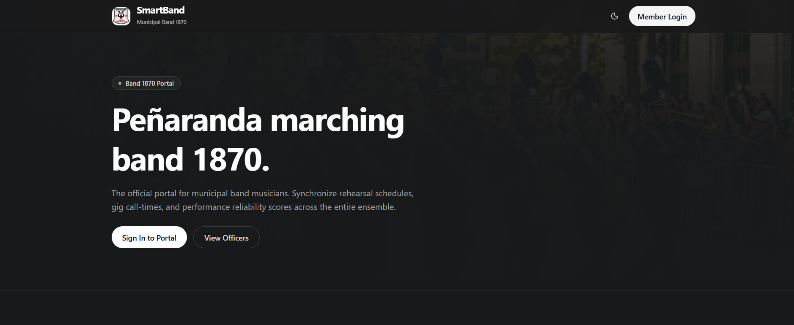
Numbered Callout Descriptions
No. | Field, Control, or Area — Description
1 | SmartBand Brand Logo & Identity Badge — Displays the official insignia and title "SmartBand - Municipal Band 1870", establishing institutional credibility and branding.
2 | Top Navigation Bar — Houses quick navigation anchor links including "Band 1870 Portal", "View Officers", and "Member Login" for rapid viewport jumping.
3 | Primary Hero Headline — Prominently declares "Peñaranda marching band 1870. The official portal for municipal band musicians." to immediately orient visitors.
4 | Operational Value Statement — Explains the automated capabilities of the platform in eliminating coordination breakdowns and establishing performance turnout tracking.
5 | "Sign In to Portal" Action Button — Primary styled call-to-action button launching the secure authentication modal dialog.
6 | "View Officers" Link — Secondary button smoothly scrolling the viewport directly to the Executive Leadership & Section Heads showcase.

1.2 Band Officers Showcase — Executive Leadership Council & Section Coordinators Carousel
The Officers Showcase is a directory of the band's leaders. Under Band President Hon. Roberto "Doc" Valmonte, the carousel shows the executive council members, conductors, and section coordinators for the Woodwinds, Brass, Percussion, and Colorguard. Municipal organizers, fiesta committees, and members can use it to confirm who the officers are and to get contact details for bookings. The carousel has previous and next buttons and an eight-dot page indicator, so users can browse all executive profiles on both mobile and desktop.
Figure C2
Peñaranda Band 1870 Executive Officers and Section Leaders Showcase
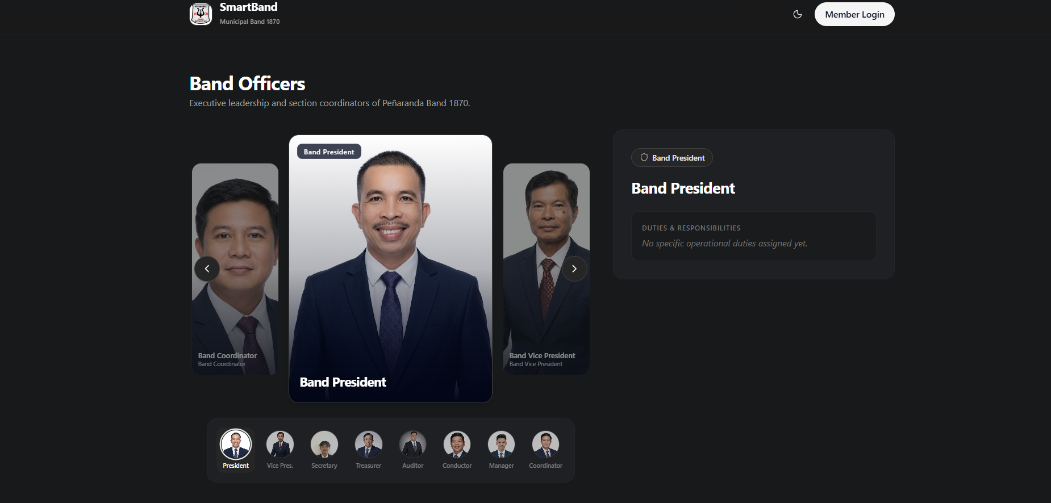
Numbered Callout Descriptions
No. | Field, Control, or Area — Description
1 | Section Title & Mission Subtitle — "Executive Leadership & Section Heads" header emphasizing organizational stewardship and municipal heritage.
2 | Featured Officer Card — Card container featuring high-resolution photography, executive designation, and organizational tenure of Band President Hon. Roberto "Doc" Valmonte.
3 | Direct Official Contact Badge — Official telephone hotline and institutional email facilitating municipal booking inquiries and event authorizations.
4 | Section Specialization Badge — Visual badge indicating the officer's musical discipline, executive rank, and oversight responsibilities.
5 | Carousel Navigation Chevrons — Interactive left and right arrow buttons allowing users to smoothly cycle through consecutive leadership profiles.
6 | Slide Pagination Indicators — Eight status dots at the base of the carousel indicating the active card position and total officer count.

1.3 Automated Band Operations, PWA Capabilities & Musician Authentication Portal (Sign-In Mode)
When a musician clicks Sign In on the landing page, the Authentication Modal opens, with the three main features of the platform shown in the background: Automated High-Priority Notifications, Turnout & Reliability Tracking, and Real-Time Ensemble Synchronization. Members, band secretaries, and administrators use this form to log in. The user enters the registered email address and password and clicks "Sign In". The app then authenticates with Supabase Auth, reads the user's role (Member, Secretary Admin, or Super Admin), and redirects to the dashboard for that role.
Figure C3
Musician Authentication Dialog Overlaid on Core Operational Value Pillars
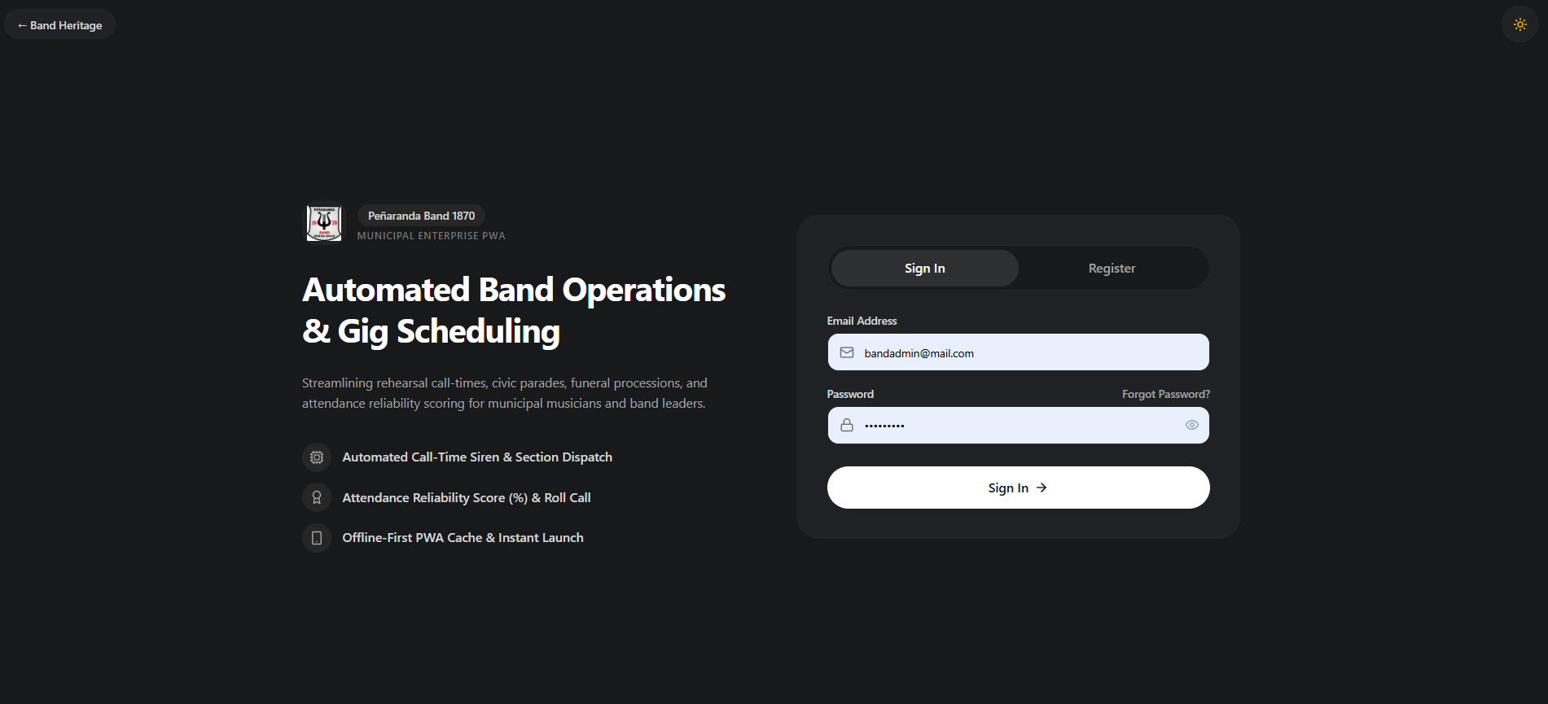
Numbered Callout Descriptions
No. | Field, Control, or Area — Description
1 | Core Value Pillars (Background) — Three feature columns detailing automated push alerts, reliability score tracking, and instant ensemble synchronization.
2 | Authentication Modal Backdrop — Semi-transparent backdrop darkening background elements to focus user interaction on authentication credentials.
3 | Modal Switcher Tabs — Segmented control toggling between "Sign In" and "Register" modes without reloading the webpage.
4 | Registered Email Input Field — Form control accepting registered musician email addresses (e.g., bandmem@mail.com, bandsec@mail.com).
5 | Secure Password Field — Input field masking alphanumeric characters to prevent visual eavesdropping during login.
6 | "Sign In" Submission Button — Action trigger executing Supabase JWT token generation, local session caching, and role routing.
7 | Roster Verification Note — Informational link advising unregistered band musicians to verify their inclusion on the master roster before registering.

MODULE 2: Musician Authentication & Master List Verification
2.1 Musician Registration Portal — Master List Verification & Instrument Assignment (Register Mode)
To prevent unauthorized sign-ups, registration includes a Master Roster Verification step. When a musician selects the "Register" tab, the form asks for the full legal name, an active Philippine mobile number (09xxxxxxxxx), the primary instrument, an email address, and a password. On submission, the backend checks the name and instrument against the pre-approved municipal master roster. If they match, the system creates the Supabase authentication account, assigns the default "Member" role, sets the reliability score to 100%, and creates the default weekly availability grid.
Figure C4
Musician Registration Interface with Instrument Assignment and Roster Verification
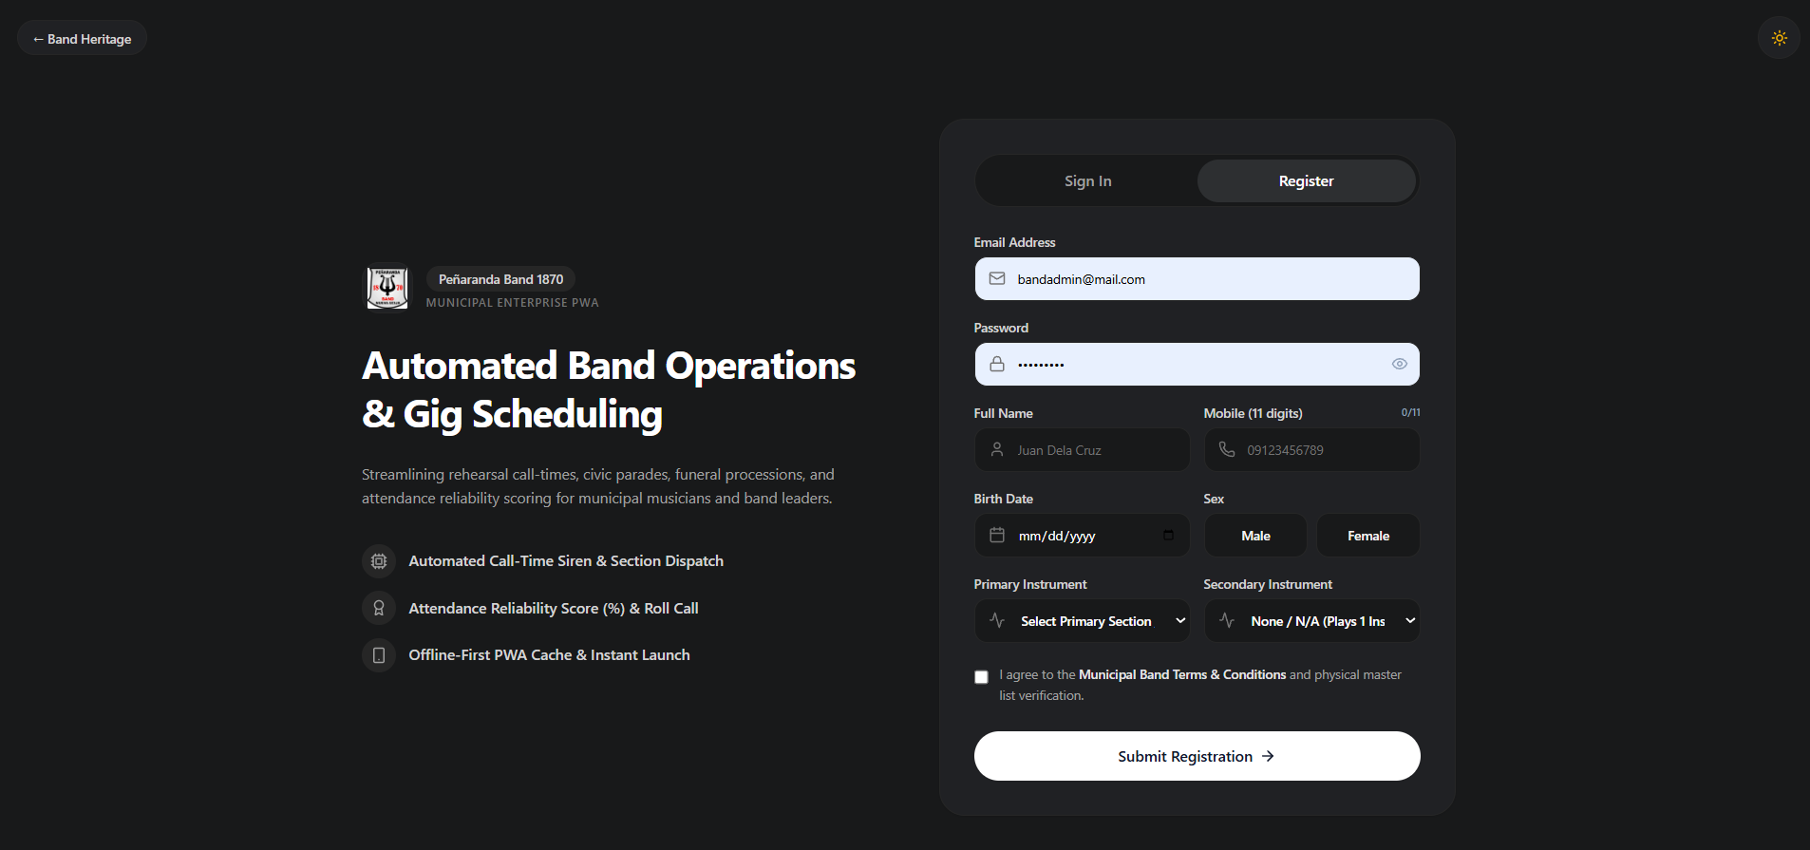
Numbered Callout Descriptions
No. | Field, Control, or Area — Description
1 | "Register" Mode Active Tab — Visual highlight indicating that account registration mode is selected and ready for input.
2 | Full Legal Name Input Field — Text field capturing the musician's legal name for exact matching against the municipal band archive.
3 | Contact Mobile Phone Field — Standard 11-digit mobile number input used for critical call-time push notifications and SMS fallbacks.
4 | Primary Instrument Dropdown — Categorized selector offering standard brass band instruments (Trumpet, Trombone, Clarinet, Snare Drum, Tuba, etc.).
5 | Account Email Address Field — User-specified email address serving as the unique credential identifier across the system.
6 | Secure Password & Confirmation Fields — Dual password inputs enforcing security standards and confirming typographical accuracy.
7 | "Create Account" Action Button — Primary submission button executing PostgreSQL validation, member record linking, and dashboard initialization.

MODULE 3: Musician / Member Portal
3.1 Musician Dashboard — Active Status, Upcoming Rehearsals & Attendance RSVP
The Musician Dashboard is the main screen for band members. The example account is "Larcade" (Junior Rank, Drums Section). The dashboard shows the member's status, assigned instrument, and upcoming rehearsals. In the highlighted card, a rehearsal (Ensayo) is scheduled for Friday, October 2, 2026, at 06:00 PM at the Peñaranda Gazebo. The musician can see the venue, call-time, and repertoire and confirm attendance with the green "Confirmed Attending" button. The response is saved to the database right away, so officers can follow section quorum in real time.
Figure C5
Musician Dashboard with Active Member Status, Upcoming Rehearsals, and RSVP Action
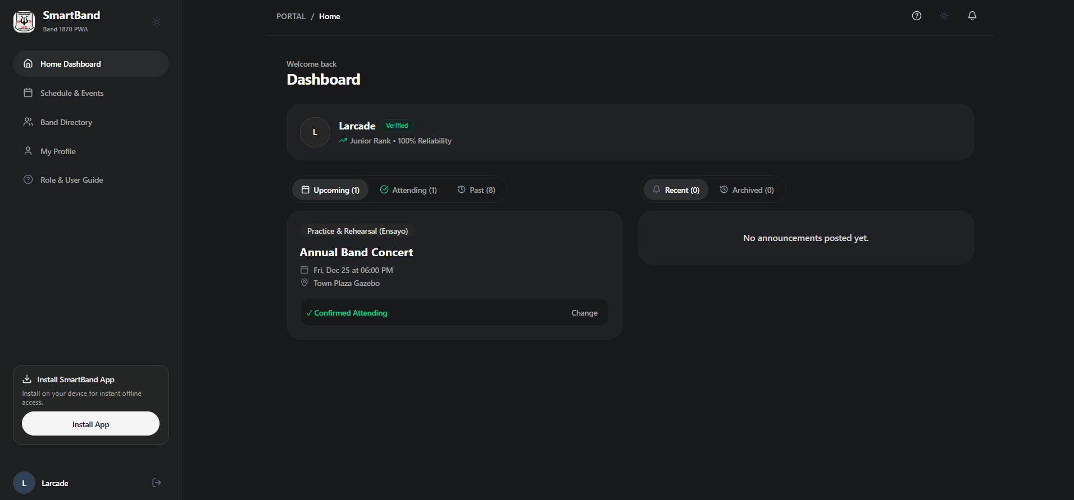
Numbered Callout Descriptions
No. | Field, Control, or Area — Description
1 | Musician Profile Summary Header — Displays musician name ("Larcade"), ensemble seniority rank ("Junior"), and instrument specialization ("Drums").
2 | Main Application Navigation Menu — Navigation links providing instant access to Home Dashboard, Schedule & Events, Band & Ranks, and My Profile.
3 | Active Standing Indicator — Visual badge confirming that the member is in good standing and cleared for performance engagements.
4 | Immediate Rehearsal Event Card — Highlighted engagement container detailing event type (Ensayo), reporting date, and scheduled time window (06:00 PM - 09:00 PM).
5 | Performance Venue Location — Geographic location pin identifying "Peñaranda Town Plaza Gazebo" as the physical assembly point.
6 | "Confirmed Attending" RSVP Toggle — Interactive status button allowing musicians to commit to the rehearsal, immediately updating the secretary's quorum roster.

3.2 Musician Dashboard — Event History & Gig Log Navigation
The dashboard has an event timeline with two tabs, "Upcoming" and "Past". Under "Upcoming", musicians check parade call-times and rehearsal venues. Under "Past", they can review the civic parades (Parada), religious feasts (Prusisyon), and funeral services (Libing / Lamay) they took part in. This history shows which events counted toward their attendance record and reliability score.
Figure C6
Musician Event History and Gig Log Navigation Tabs
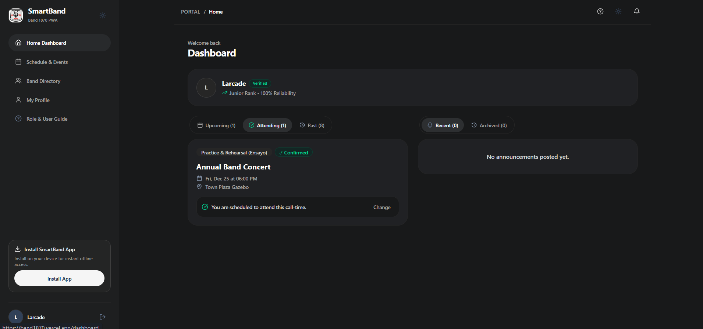
Numbered Callout Descriptions
No. | Field, Control, or Area — Description
1 | Event Timeline Segmented Switcher — Interactive toggle tabs allowing musicians to switch between "Upcoming (1)" and "Past (0)" event streams.
2 | Event Taxonomy Badge — Color-coded badge categorizing the engagement as Ensayo (Rehearsal), Parada (Parade), or Prusisyon (Procession).
3 | Scheduled Date & Duration — Formatted calendar date and duration badge indicating call-time and estimated finish time.
4 | Rehearsal Venue Details — Venue description informing musicians of assembly logistics and setup requirements.
5 | Individual Attendance Response Indicator — Real-time status display indicating whether the musician's RSVP has been recorded in the database.

3.3 Musician Dashboard — Announcements Stream & Broadcast Feed
The musician dashboard includes an Announcements Stream so that official notices are kept apart from other chat groups. Officers and section coordinators use it to post directives such as mandatory rehearsal notices, uniform rules (e.g., gala white uniform or casual band polo), sheet music updates, and urgent call-time changes. Each announcement card shows the subject, the date and time posted, the posting officer (such as Band Secretary Darius T. Macapagal Jr), the priority level, and the full message.
Figure C7
Real-Time Announcements Stream and High-Priority Broadcast Feed
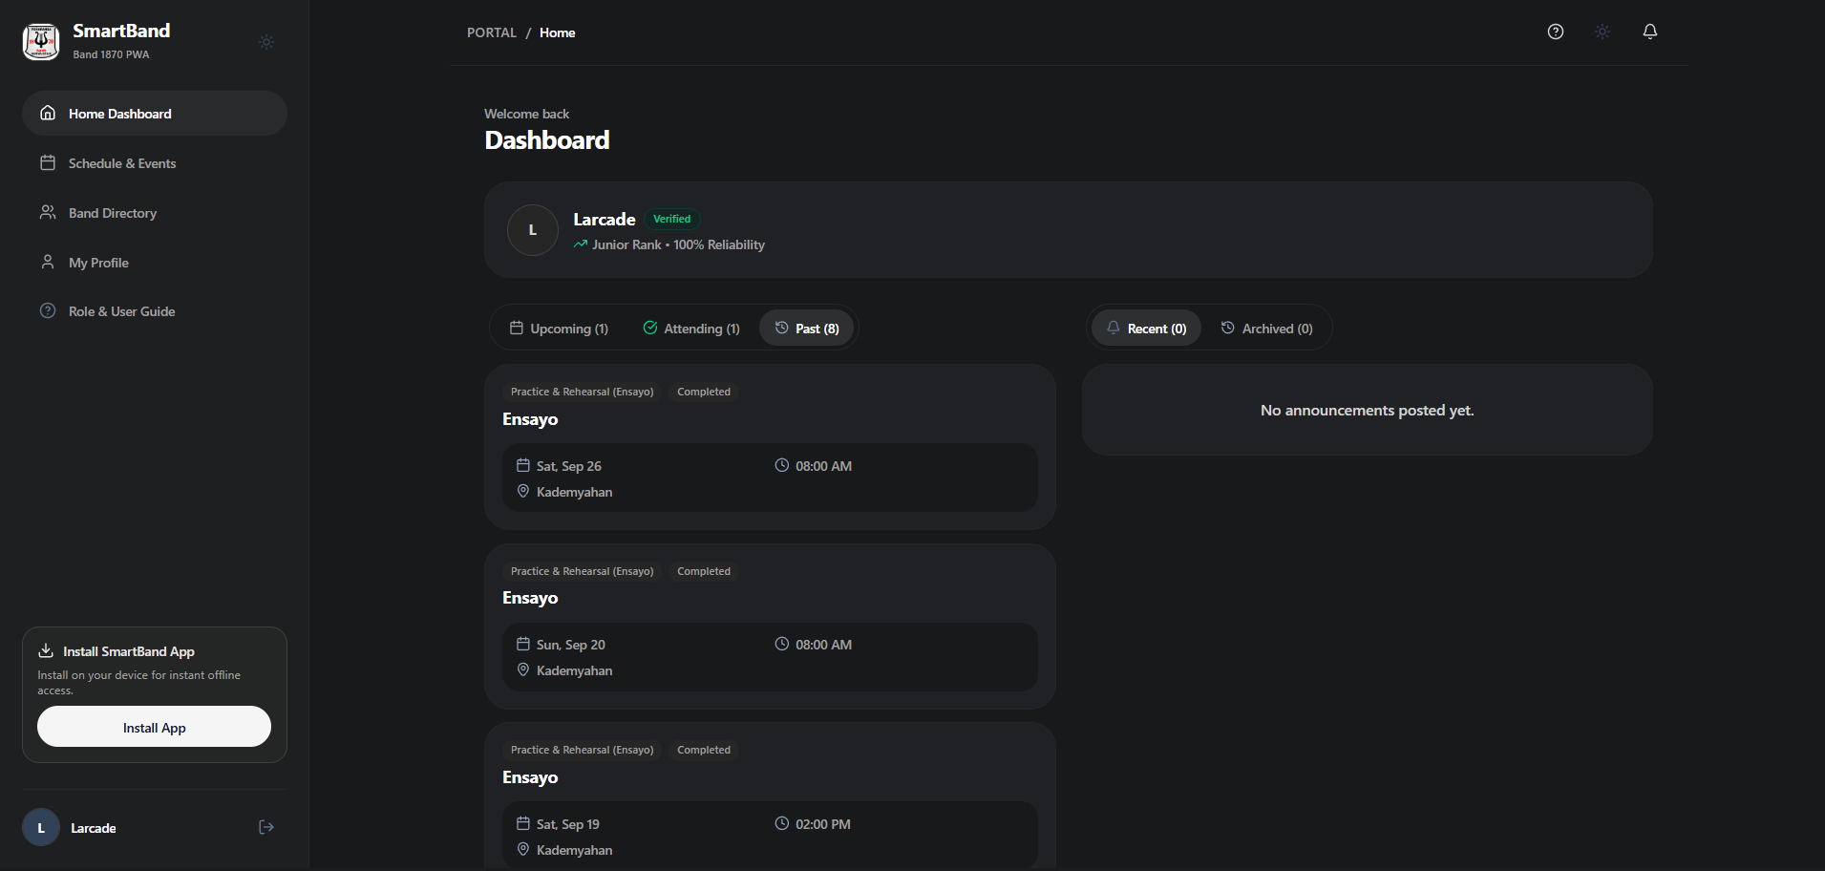
Numbered Callout Descriptions
No. | Field, Control, or Area — Description
1 | Announcements Feed Header — Prominent section banner organizing high-priority communications and administrative dispatches.
2 | Broadcast Notice Card — Individual message container formatting announcement header, author, timestamp, and body text.
3 | Urgency / Priority Badge — Visual indicator distinguishing normal informational notices from mandatory or urgent operational alerts.
4 | Author Signature & Executive Role — Verifies the posting official (e.g., Band Secretary Darius T. Macapagal Jr), confirming administrative authority.
5 | Message Narrative & Directives — Text block detailing specific operational requirements, uniform guidelines, repertoire selections, and logistics.

3.4 Musician Calendar & Logs — Master Schedule Overview
The "Schedule & Events" module is the calendar of all band engagements. It lists the scheduled engagements in chronological order so that musicians can avoid conflicts with work, school, or personal commitments. Musicians can view upcoming rehearsals and performances, the required instrument sections, and the call-times in advance. Search and event category filters help them find specific events without scrolling through the whole calendar.
Figure C8
Master Schedule Overview with Search and Category Filtering
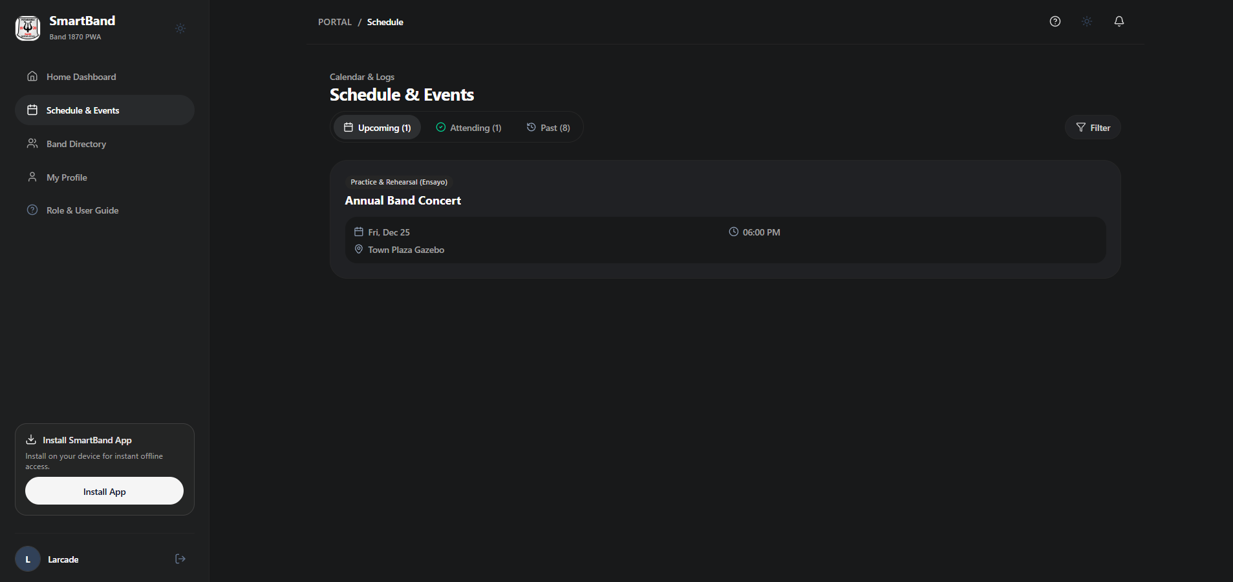
Numbered Callout Descriptions
No. | Field, Control, or Area — Description
1 | "Schedule & Events" Module Title — Header establishing the calendar and event ledger workspace.
2 | Event Search Filter Field — Search box allowing instant string matching across event titles, venue locations, and notes.
3 | Category Taxonomy Dropdown — Filter selector allowing musicians to isolate specific categories (Ensayo, Parada, Prusisyon, Libing, Pulong).
4 | Master Event Record Card — Structured card presenting event name ("General Rehearsal / Ensayo"), date, time, and assembly location.
5 | Section Quorum & Repertoire Overview — Summary indicating which instrument sections are required to attend and performance focus.
6 | Musician Participation Action — Fast-action button enabling musicians to submit or modify their attendance commitment.

3.5 Musician Calendar & Logs — Filtered Event Records Ledger
This screen shows the category filter in the Master Schedule. Using the Category Dropdown, musicians can display only one type of engagement, such as rehearsals (Ensayo), civic parades (Parada), or religious processions (Prusisyon). In this example, selecting "Ensayo" shows only the scheduled practice sessions. This helps musicians focus on their rehearsal obligations and helps section leaders check whether enough members of their section are expected before the group assembles at the Gazebo.
Figure C9
Filtered Event Ledger by Category and Search Parameters
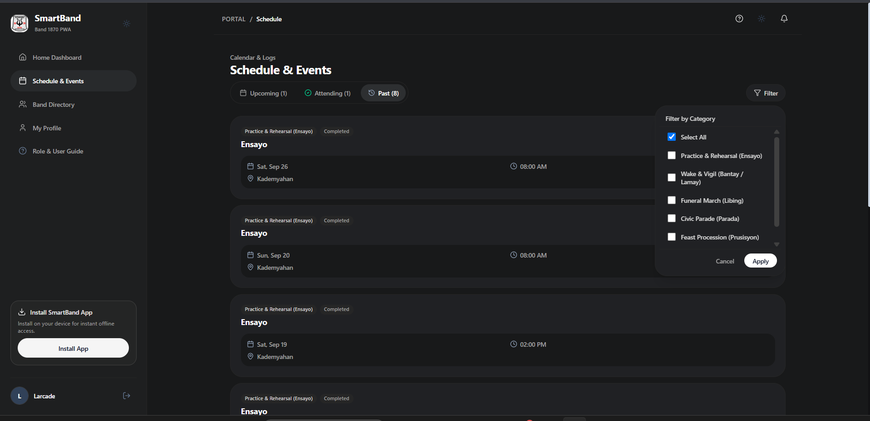
Numbered Callout Descriptions
No. | Field, Control, or Area — Description
1 | Expanded Category Selector — Dropdown menu showing the complete event taxonomy (All Types, Ensayo, Parada, Prusisyon, Libing, Lamay, Pulong).
2 | Active Filter Status & Match Counter — Readout reporting the active filter criterion and number of matching events found.
3 | Filtered Event Result Card — Card displaying matching rehearsal details, including call-time and venue address.
4 | Section Requirements Badge — Visual indicator designating required ensemble sections (e.g., Full Band, Brass Section, Rhythm Section).
5 | Real-Time Quorum Confirmation Bar — Progress bar showing the proportion of confirmed section members versus target quorum.

3.6 Band Directory — Musician Registry & Verified Section Roster (Member View)
The Band Directory shows musicians the verified roster of all 19 active members of Peñaranda Band 1870, grouped into the Woodwinds, Brass, Percussion, and Majorette & Guard sections. Musicians can search for section mates by name or instrument, view their ranks (Senior, Junior, Regular Musician), and identify the section coordinators. In the member view, the administrative controls are hidden.
Figure C10
Musician Directory and Verified Section Roster in Member View
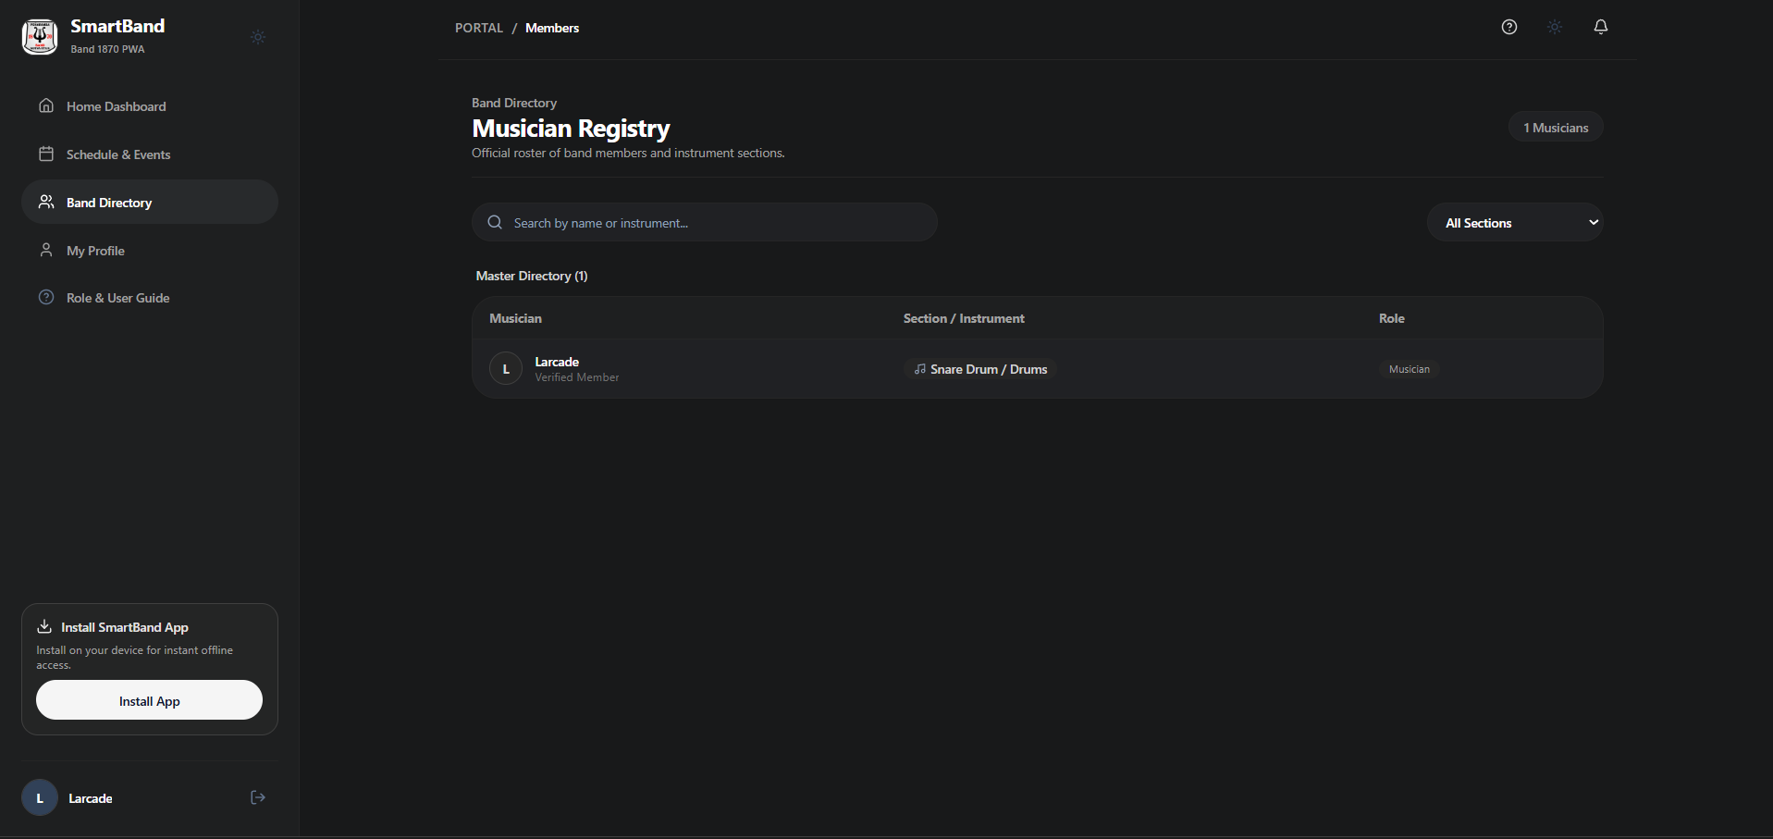
Numbered Callout Descriptions
No. | Field, Control, or Area — Description
1 | Directory Header & Total Count — "Band Directory & Roster" banner displaying total active ensemble membership (19 musicians).
2 | Musician Search Input Field — Real-time search box filtering members by first name, surname, or assigned instrument.
3 | Section Filter Tabs — Interactive filter pills segmenting the directory into All, Woodwinds, Brass, Percussion, and Officers.
4 | Member Profile Roster Cards — Cards presenting member avatar initials, legal name, primary instrument, and mobile contact number.
5 | Seniority Rank Badge — Visual badges indicating member experience and rank within the municipal band hierarchy.

3.7 Musician Profile & Account Management — 7-Day Weekly Availability Grid
A main feature of SmartBand is the 7-Day Weekly Recurring Availability Grid on the musician's profile page. Many band musicians also have school, farm, or work commitments. In the grid, the musician sets a baseline availability for each day from Monday to Sunday across three shifts: Morning (8:00 AM – 12:00 PM), Afternoon (1:00 PM – 5:00 PM), and Evening (6:00 PM – 10:00 PM). Clicking a shift button switches it between green "FREE" and gray "BUSY". When the Band Secretary prepares a contract, the system uses these grids to estimate how many musicians will be available.
Figure C11
Musician Profile and 7-Day Weekly Recurring Availability Matrix
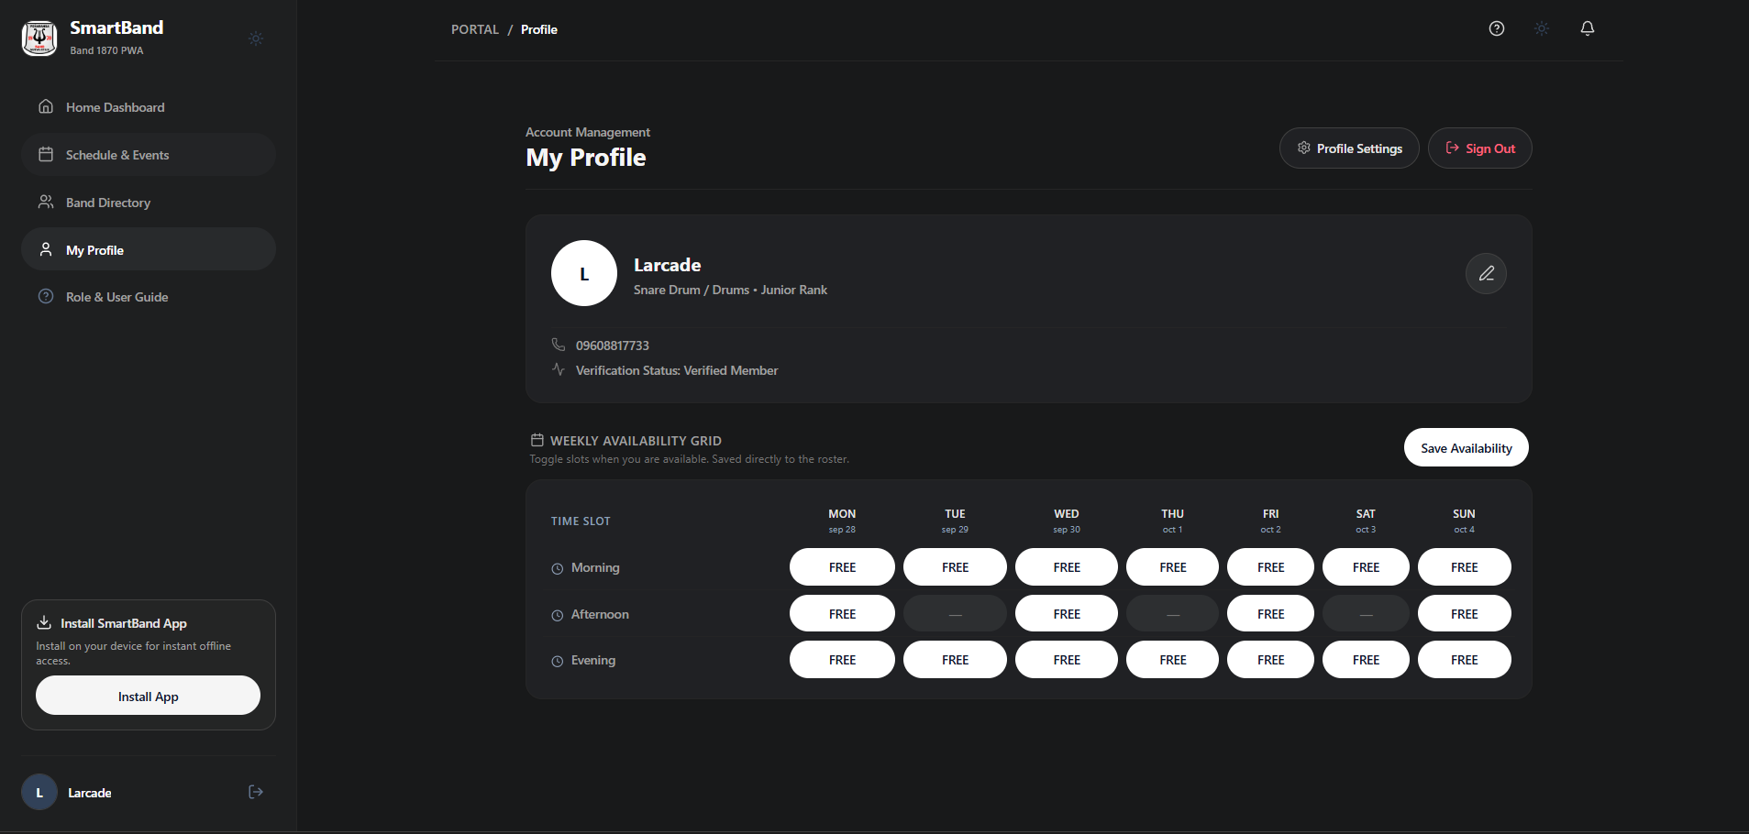
Numbered Callout Descriptions
No. | Field, Control, or Area — Description
1 | Musician Identity Summary — Profile header showing member name ("Larcade"), primary instrument ("Drums"), and seniority status.
2 | Weekly Availability Grid Container — 7-column matrix representing the weekly operational schedule of the municipal band.
3 | Morning Shift Controls (08:00 AM - 12:00 PM) — Shift toggles for morning parade readiness and early civic ceremonies across all seven days.
4 | Afternoon Shift Controls (01:00 PM - 05:00 PM) — Shift toggles for afternoon religious processions and fiesta serenades.
5 | Evening Shift Controls (06:00 PM - 10:00 PM) — Shift toggles for evening general rehearsals (Ensayo) and concert performances.
6 | Interactive State Toggles — Green buttons indicating "FREE" availability; gray buttons indicating "BUSY" conflict.
7 | "Save Availability" Action Button — Commits updated shift states to PostgreSQL, updating predictive scheduling queries instantly.

3.8 User & Role Guide Modal — Role Powers & Operational Governance Matrix
The User & Role Guide modal explains the system rules, user roles, and authority levels. The "Role Powers" tab shows a table that compares what Band Members, Secretary Admins, and Super Admins can do. Band Members can submit RSVPs and manage their availability grids, Secretary Admins can create events, post announcements, and log attendance, and Super Admins handle system administration and role management.
Figure C12
User and Role Guide Explaining System Governance and Permissions Matrix
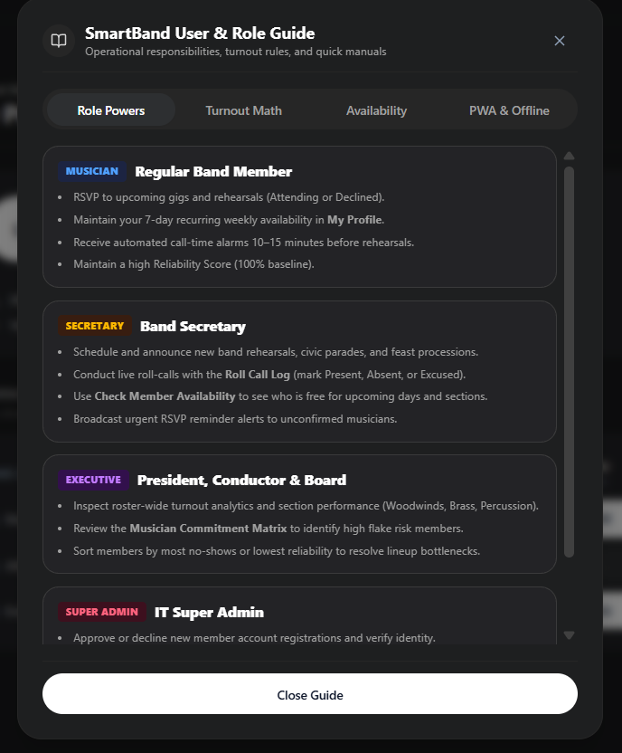
Numbered Callout Descriptions
No. | Field, Control, or Area — Description
1 | Role Guide Modal Navigation Tabs — Top tabs organizing the guide into "Role Powers", "Turnout Math", "Weekly Grid vs RSVP", and "Install PWA".
2 | Band Member Privileges Section — Outlines standard musician permissions including schedule browsing, RSVP toggling, and profile updates.
3 | Secretary Admin Authority Section — Details operational scheduling powers, announcement broadcasting, and attendance tracking.
4 | Super Admin Governance Section — Documents system-level oversight, role assignment, and security audit capabilities.
5 | Modal Dismissal Control — Close button returning the musician to their active dashboard workspace.

3.9 User & Role Guide Modal — Turnout Math & Reliability Scoring Algorithm
The "Turnout Math" tab of the guide explains how reliability scores are computed. Every verified musician starts with a 100% reliability score. If a musician confirms attendance ("Confirmed Attending") and attends, the score stays the same or improves. If a musician confirms but does not show up and has no excused absence, a penalty of -10% is applied. The guide shows this formula to all members so that they know how their score is computed.
Figure C13
Turnout Math and Reliability Scoring Formula Explained in Guide Modal
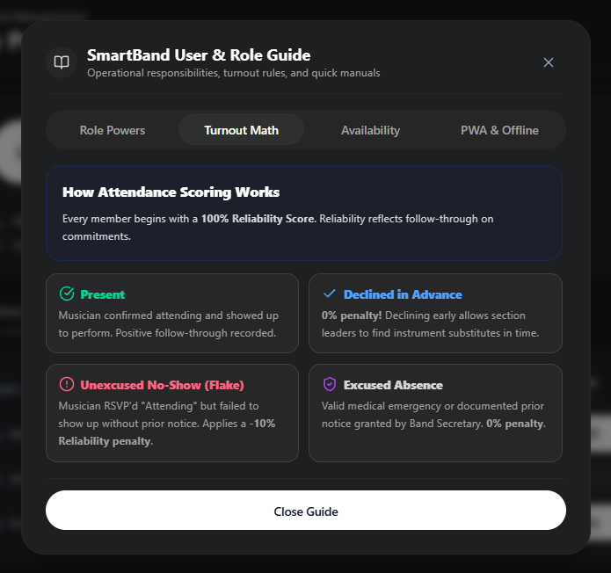
Numbered Callout Descriptions
No. | Field, Control, or Area — Description
1 | Turnout Math Title & Overview — Header explaining the purpose of objective, automated reliability tracking across the ensemble.
2 | 100% Baseline Score Definition — Explains that every active musician starts at an unpenalized 100% reliability benchmark.
3 | Attendance Honor Points — Positive weighting applied for prompt attendance, verified arrival, and fulfilled RSVP commitments.
4 | No-Show Penalty Formula — Details the specific -10% penalty deduction assessed for unexcused absences after confirming attendance.
5 | Sectional Health Aggregation — Explains how individual scores roll up into section performance health gauges (Woodwinds, Brass, Percussion).

3.10 User & Role Guide Modal — Weekly Recurring Grid vs. Event-Specific RSVP Rules
The "Weekly Grid vs RSVP" tab explains the difference between general availability and event commitments. The 7-day recurring grid shows a musician's usual availability, which the secretary uses to check whether an event is feasible. When a rehearsal or performance is created, members must submit an RSVP ("Confirmed Attending" or "Unavailable") for that specific event. The RSVP takes priority over the recurring grid because it gives officers confirmed quorum numbers.
Figure C14
Operational Rules Distinguishing Recurring Availability from Event-Specific RSVPs
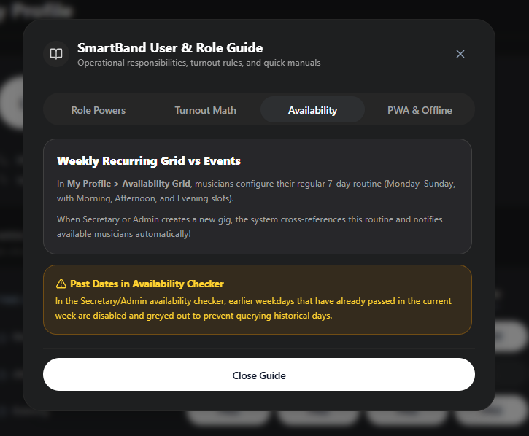
Numbered Callout Descriptions
No. | Field, Control, or Area — Description
1 | Rule Explanation Header — Clear banner framing the distinction between general availability and event commitments.
2 | Recurring Availability Purpose — Outlines how the 7-day grid serves as a predictive tool for prospective gig contracting.
3 | Event-Specific RSVP Mandate — Emphasizes that every scheduled event requires an explicit attendance commitment.
4 | Precedence & Hierarchy Rules — States clearly that explicit event RSVPs override weekly baseline availability.
5 | Quorum Impact Notice — Explains how RSVPs directly inform the Band Secretary whether sectional quorum is satisfied.

3.11 User & Role Guide Modal — Cross-Platform PWA Installation & Offline Guidelines
As a PWA, SmartBand can be installed from the browser like a native app. The "Install PWA" tab gives step-by-step instructions for Android, iOS, Windows, and macOS. Android users tap "Install App" or use the "Add to Home screen" option in Chrome. iOS users tap the Share icon in Safari and choose "Add to Home Screen". The tab also explains offline caching: the service worker saves schedule data on the device, so musicians can still view call-times and assembly points at remote venues without an internet connection.
Figure C15
Progressive Web Application (PWA) Installation and Offline Operation Guide
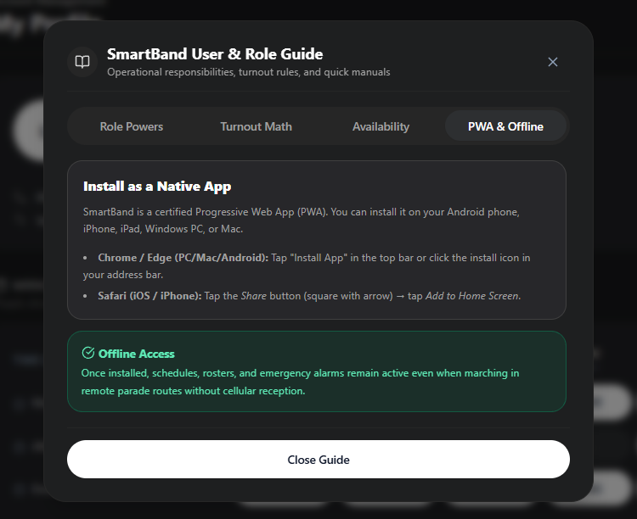
Numbered Callout Descriptions
No. | Field, Control, or Area — Description
1 | PWA Installation Overview — Explains the advantages of installing SmartBand as a standalone homescreen application.
2 | Android / Chrome Step Guide — Visual instructions on using the in-app install banner or browser menu prompt.
3 | iOS / Apple Safari Step Guide — Clear sequence showing the Share button and "Add to Home Screen" selection on iPhones and iPads.
4 | Desktop Chrome / Edge Guide — Instructions for installing SmartBand as a desktop app on Windows and macOS laptops.
5 | Offline Synchronization Protocol — Explains how cached data enables offline schedule access and syncs RSVPs when reconnected.

3.12 Musician Profile & Settings Modal — Personal Information & Instrument Configuration
In the Profile Settings Modal, musicians manage their personal and instrument details. The "Personal Info" tab shows the legal name, primary instrument (e.g., Snare Drum / Drums Section), secondary instruments, mobile number, and seniority rank. The contact number should be kept up to date so that officers can reach members during emergency schedule changes. After editing, the musician clicks "Save Profile" to update the record in the Supabase database.
Figure C16
Musician Profile Settings Modal for Personal Information and Instrument Configuration
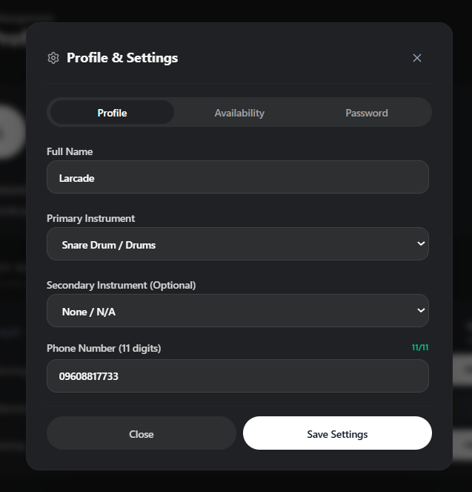
Numbered Callout Descriptions
No. | Field, Control, or Area — Description
1 | Settings Navigation Tabs — Tab switcher organizing settings into "Personal Info", "Weekly Schedule", and "Account & Security".
2 | Member Avatar & Legal Name Input — Display avatar and text input field for legal name verification.
3 | Primary Instrument Configuration Dropdown — Form control setting the musician's primary instrument section assignment.
4 | Active Contact Telephone Field — Mobile number input ensuring band officers can reach the musician during urgent parade deployments.
5 | Band Seniority Rank Badge — Read-only badge displaying assigned organizational standing (e.g., Junior Musician).
6 | "Save Profile" Action Button — Commits all modifications to the Supabase database.

3.13 Musician Profile & Settings Modal — Weekly Schedule Availability Matrix
The "Weekly Schedule" tab of the Settings Modal shows a compact version of the 7-day availability grid, so that musicians can update their schedule without going back to the main dashboard. They can check their availability for the Morning, Afternoon, and Evening shifts from Monday to Sunday, click a cell to switch between FREE and BUSY, and save the changes with one click.
Figure C17
Compact Weekly Schedule Matrix within the Settings Modal
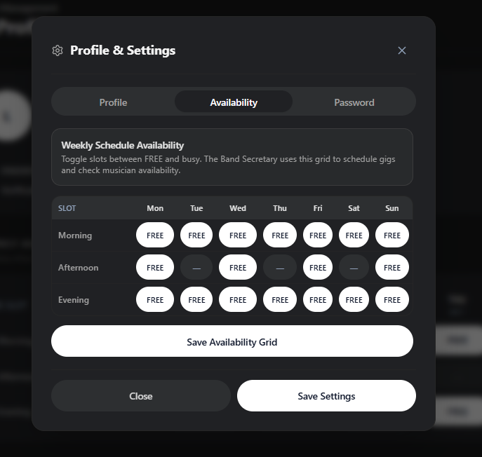
Numbered Callout Descriptions
No. | Field, Control, or Area — Description
1 | Weekly Schedule Modal Tab — Active tab highlighting the in-modal availability matrix editor.
2 | Seven-Day Column Layout — Columns representing Monday through Sunday in standard weekly sequence.
3 | Three Standard Shift Rows — Morning (08-12), Afternoon (01-05), and Evening (06-10) shift rows.
4 | Shift Cell Toggles — Green cells indicating free availability; gray cells indicating personal or academic commitments.
5 | "Update Schedule" Action Button — Submits updated weekly availability states to the backend database.

3.14 Musician Profile & Settings Modal — Password & Account Security
The "Account & Security" tab lets musicians change their password by entering the current password, the new password, and a confirmation. This protects accounts on shared family phones or on the community tablets at the band hall. The system checks the new password against the complexity requirements before sending the update through the Supabase Auth API.
Figure C18
Password and Account Security Management Modal
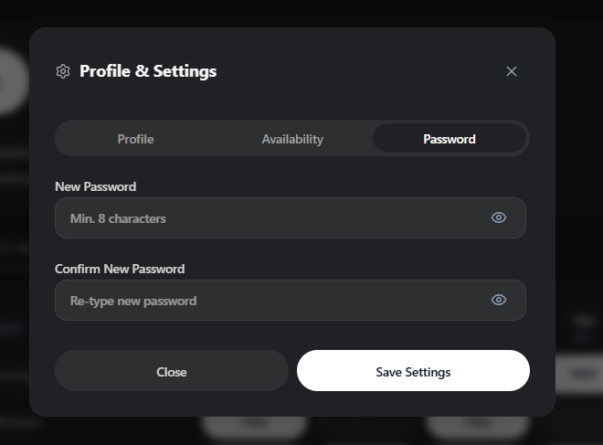
Numbered Callout Descriptions
No. | Field, Control, or Area — Description
1 | "Account & Security" Active Tab — Tab highlighting the credential and password management interface.
2 | Current Password Input Field — Verification field requiring existing credentials to prevent unauthorized modification.
3 | New Password Input Field — Field for the new password, enforcing alphanumeric security complexity.
4 | Confirm New Password Field — Verification field ensuring matching password inputs and preventing typographical lockouts.
5 | Password Complexity Advisory — Informational text detailing minimum character length and strength guidelines.
6 | "Change Password" Action Button — Triggers secure cryptographic password update through Supabase Auth.

3.15 Musician Session Management — Sign Out Confirmation Dialog
Signing out is important when musicians use SmartBand on shared devices, such as the tablets at the band rehearsal hall or the municipal band office. Clicking "Sign Out" in the navigation bar opens a confirmation dialog, which warns that unsaved inputs will be lost and that the cached session token will be cleared. After "Confirm Sign Out" is clicked, the system removes the JWT token stored in local storage and returns to the public landing page.
Figure C19
Session Sign Out Confirmation Dialog for Secure Session Termination
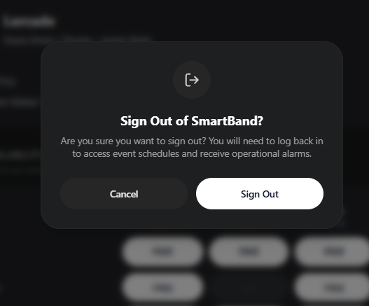
Numbered Callout Descriptions
No. | Field, Control, or Area — Description
1 | Sign Out Dialog Title & Icon — Warning header and security icon alerting the musician to session termination.
2 | Session Security Notice — Explanatory text advising the musician that active tokens will be invalidated on this device.
3 | "Cancel" Action Button — Dismisses the dialog and keeps the musician's session active.
4 | "Confirm Sign Out" Action Button — Primary red button clearing session authentication tokens and redirecting to the landing page.

MODULE 4: Band Secretary Portal (Operational Management)
4.1 Band Secretary Dashboard — Operational Headquarters & Quick Action Hub
The Band Secretary Dashboard is the main screen for managing band operations. The example account is "Darius T. Macapagal Jr" (Band Sec JJ). The secretary can schedule rehearsals, post urgent announcements, and monitor attendance. The header has quick-action buttons for creating events, writing announcements, and cross-referencing availability. The dashboard also shows active rehearsals, live RSVP counts, and section quorum gauges, so the secretary can see instrument shortages before call-time.
Figure C20
Band Secretary Dashboard with Administrative Quick Actions and Event Oversight
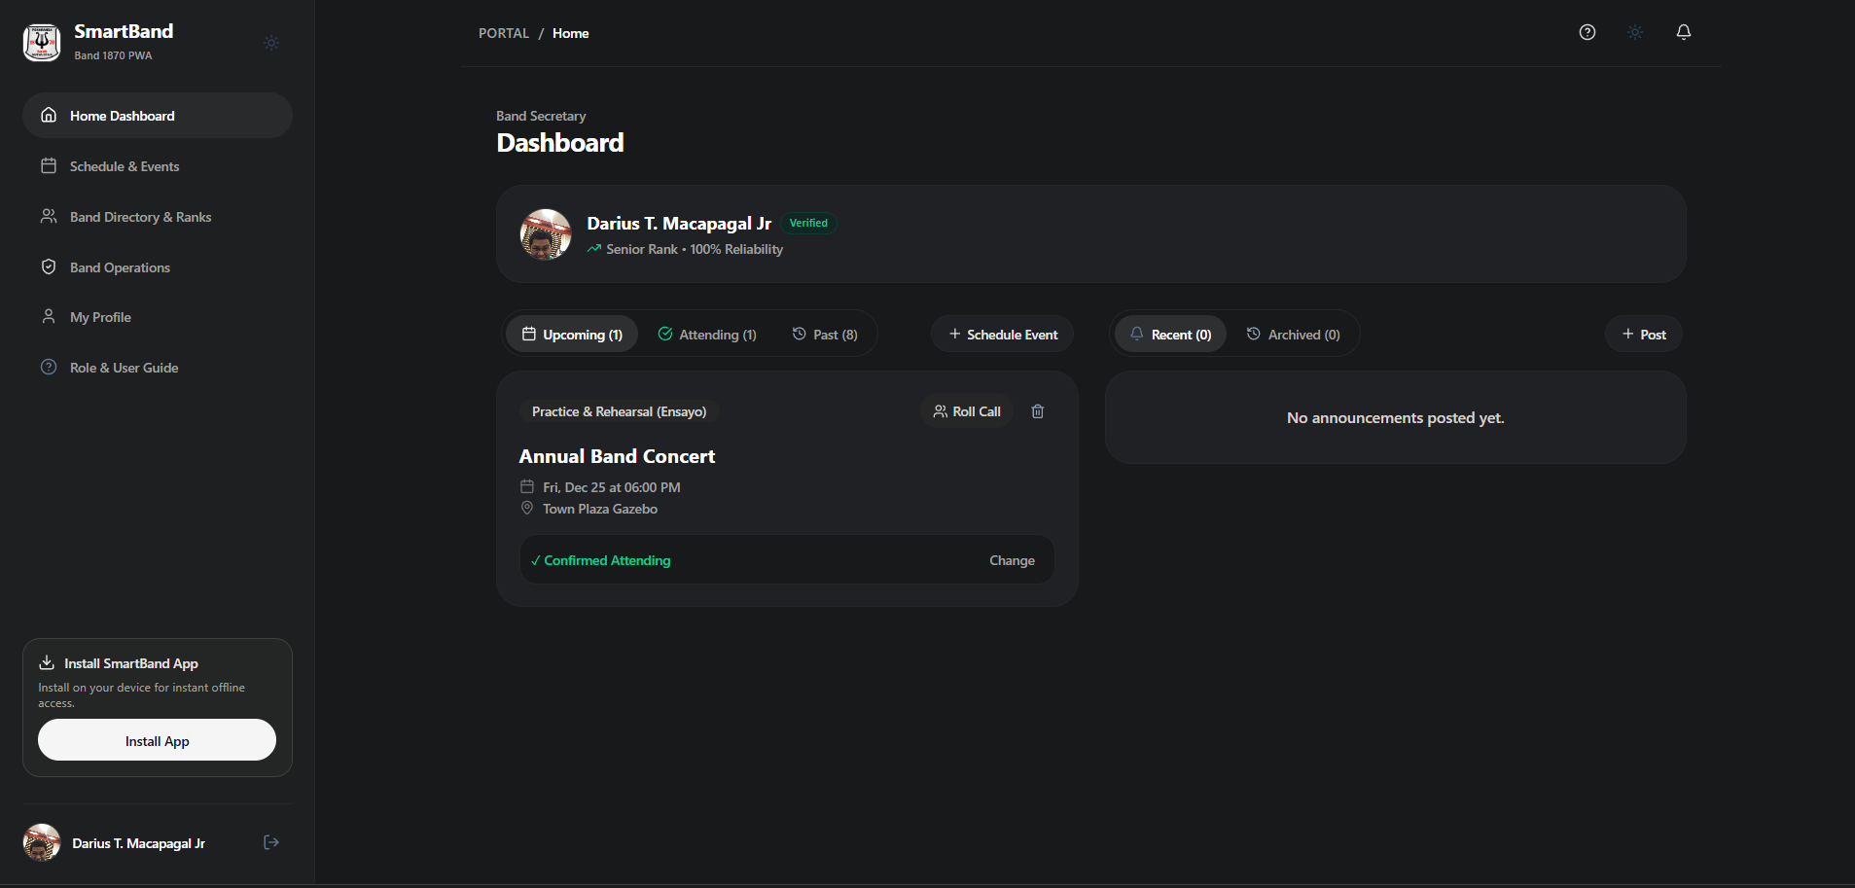
Numbered Callout Descriptions
No. | Field, Control, or Area — Description
1 | Secretary Identity & Administrative Banner — Header displaying officer name ("Darius T. Macapagal Jr"), executive title ("Band Secretary"), and elevated privileges.
2 | Operational Quick-Action Header — Fast-action button cluster including "+ Create Event", "+ Announcement", and "Check Availability".
3 | Active Event Roster Card — Live summary of upcoming rehearsals (Ensayo) and contracted performances with real-time RSVP counts.
4 | Section Quorum Progress Gauge — Visual progress bar tracking ensemble attendance confirmations against required instrument quotas.
5 | Broadcast Bulletin Preview — Summary feed showing current high-priority announcements issued to ensemble members.

4.2 Quick Event Scheduling Modal — Fast Rehearsal & Gig Creation
Short-notice rehearsals and performance bookings are common in municipal band work. The Quick Event Scheduling Modal lets the Band Secretary create an event from the dashboard without opening another page. The secretary enters the event title, selects the category (Ensayo, Parada, Prusisyon, Libing, Lamay, Pulong), sets the date and call-time, enters the venue, and selects the participating sections. Clicking "Publish Event" saves the event to the database and sends high-priority push notifications to the assigned musicians.
Figure C21
Quick Event Scheduling Modal for Rapid Rehearsal and Performance Creation
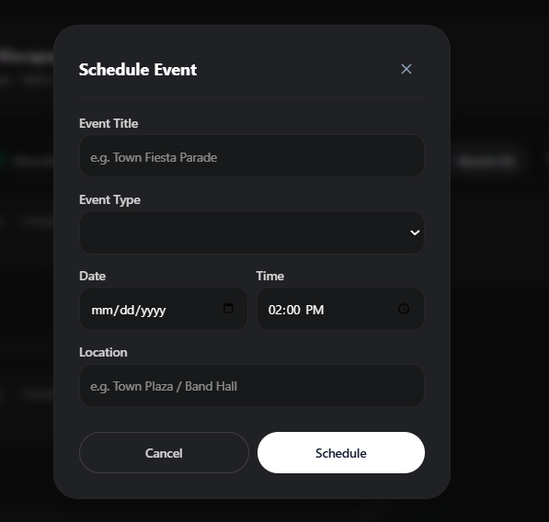
Numbered Callout Descriptions
No. | Field, Control, or Area — Description
1 | Quick Scheduling Modal Header — "Schedule New Event" title and descriptive subtext.
2 | Event Title Input Field — Form control accepting engagement title (e.g., "Emergency Ensayo for Town Fiesta").
3 | Event Category Taxonomy Dropdown — Category selector supporting standard municipal band engagement classifications.
4 | Date & Time Pickers — Date selection, start call-time, and estimated conclusion time controls.
5 | Performance Venue Input Field — Address field capturing assembly location (e.g., Peñaranda Town Plaza Gazebo).
6 | Section Quorum Checkboxes — Toggles allowing the secretary to designate required instrument sections (Full Band, Brass, Rhythm).
7 | "Publish Event" Action Button — Primary button saving the event and dispatching notifications to all assigned musicians.

4.3 Post Announcement Modal — Broadcast Dispatcher & Urgent Alerts
The Post Announcement Modal lets the Band Secretary send announcements to the whole band. The secretary enters the subject, selects the priority level (Normal, High, Urgent/Emergency), and types the message. Announcements may cover uniform rules (e.g., gala white uniform with black dress shoes), sheet music, assembly points for transportation, or emergency call-time changes. When submitted, the announcement appears in the dashboard stream and triggers device notifications.
Figure C22
Announcement Broadcast Dispatcher Modal for High-Priority Alerts
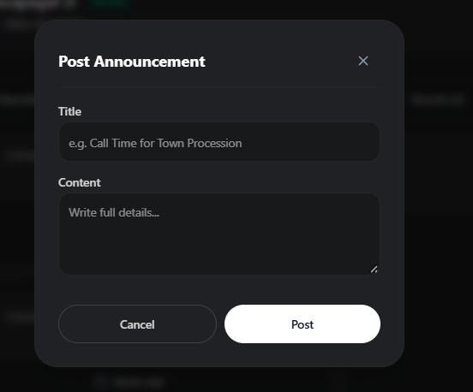
Numbered Callout Descriptions
No. | Field, Control, or Area — Description
1 | Broadcast Modal Header — "Broadcast New Announcement" title establishing communication authority.
2 | Announcement Subject Headline — Title input capturing the primary focus of the notification.
3 | Priority Severity Selector — Radio/dropdown selector designating urgency level (Normal, High, Urgent/Emergency).
4 | Detailed Message Textarea — Multi-line rich text field detailing uniform codes, call-times, and repertoire instructions.
5 | Target Audience Filter — Selector allowing broadcasts to target All Members, Officers Only, or Specific Sections.
6 | "Post Announcement" Action Button — Triggers immediate database broadcast insert and fires mobile push alerts.

4.4 Comprehensive Event Scheduling Form — Venue, Quorum & Availability Cross-Referencing
For major contracts such as town fiesta parades or multi-day religious processions, the Band Secretary uses the Comprehensive Event Scheduling Form. This full-page form groups the event details into sections: sponsor details, assembly points, parking instructions, instrument van loading times, and minimum section quorum. The secretary sets the minimum number of musicians needed for Trumpet, Trombone, Clarinet, Tuba, and Percussion. Before confirming the booking, the secretary can check the proposed date against the members' recurring availability grids.
Figure C23
Comprehensive Event Scheduling Form with Section Quorums and Logistics Details
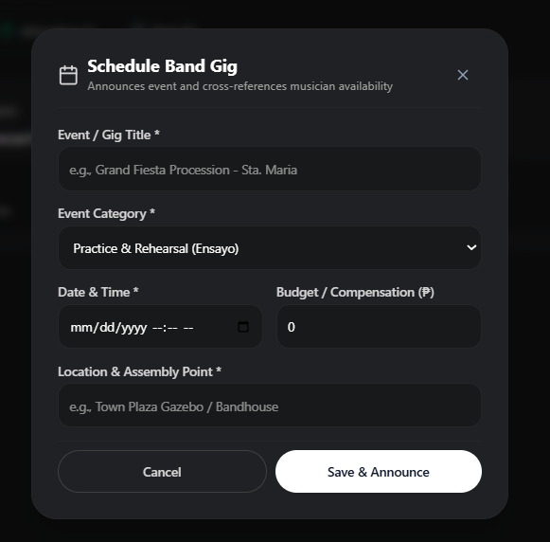
Numbered Callout Descriptions
No. | Field, Control, or Area — Description
1 | Comprehensive Form Header — Multi-section form organizing contract logistics, venue details, and sectional quorums.
2 | Contract Sponsor & Title Details — Form inputs capturing sponsoring municipal LGU or church committee and event designation.
3 | Venue Logistics & Assembly Point — Instructions specifying instrument van loading, musician call-time, and parking arrangements.
4 | Section Quorum Threshold Inputs — Numerical inputs specifying required minimum counts for Trumpets, Trombones, Clarinets, and Drums.
5 | Uniform & Repertoire Notes — Controls specifying uniform dress code (Gala Formal, Polo Band) and musical marching pieces.
6 | Availability Cross-Reference Button — Interactive button testing prospective event timing against musician availability before publishing.
7 | "Save & Publish Event" Button — Publishes the event to the master schedule and issues official member invitations.

4.5 Secretary Musician Directory & Executive Council Highlights
In the administrative directory view, the Band Secretary can see more organizational data. The top section shows the Executive Council with profile cards for Band Secretary Darius T. Macapagal Jr and the other officers, including verified phone numbers and roles. Below it, the directory lists the 19 verified musicians by instrument section. This helps the secretary identify section leaders and contact members during parade formations.
Figure C24
Administrative Directory with Executive Council Highlights and Roster Breakdown
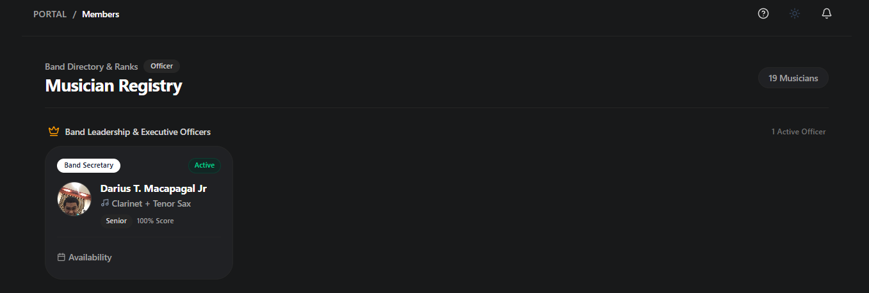
Numbered Callout Descriptions
No. | Field, Control, or Area — Description
1 | Executive Council Showcase — Highlighted leadership section displaying executive officers and operational coordinators.
2 | Officer Title & Contact Badge — Explicit operational designations and direct phone hotlines for municipal dispatch.
3 | Total Verified Roster Metric — Statistical counter reporting 19 total ensemble musicians in the system database.
4 | Section Breakdown Filter Tabs — Interactive filter tabs segmenting musicians into Woodwinds, Brass, Percussion, and Majorettes.
5 | Administrative Search Field — Real-time search filter querying musician records across all metadata fields.

4.6 Master Musician Registry Ledger — 19 Verified Ensemble Members
The Master Musician Registry Ledger shows all 19 verified members of Peñaranda Band 1870 in a table. The secretary can view each musician's assigned instrument (Clarinet, Trombone, Saxophone, Trumpet, Bass/Tuba), seniority rank (Senior, Junior, Regular Musician), mobile number, and current reliability score. The ledger helps the secretary check that each section has enough experienced members and contact musicians directly when needed.
Figure C25
Master Musician Registry Ledger with Seniority Ranks and Contact Numbers
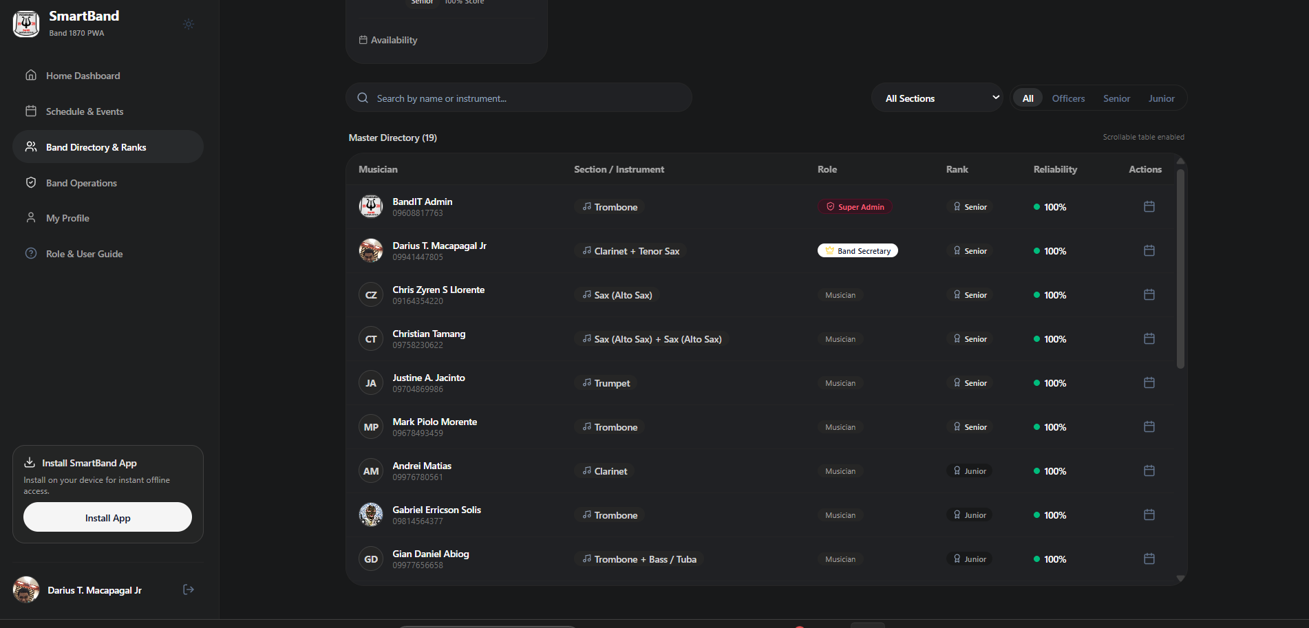
Numbered Callout Descriptions
No. | Field, Control, or Area — Description
1 | Registry Ledger Header — Columns for Musician, Section / Instrument, Role & Rank, Contact Number, and Reliability Score.
2 | Musician Record Rows — Granular records displaying musician legal name, initials, and assigned section icon.
3 | Instrument Taxonomy Badges — Specific instrument tags including Alto Sax, Tenor Sax, Clarinet, Trombone, Trumpet, and Tuba.
4 | Seniority Rank Classifications — Visual badges indicating Senior Musician, Junior Musician, and Regular Musician status.
5 | Click-to-Call Phone Numbers — Direct mobile phone links enabling immediate voice coordination during parade formations.
6 | Real-Time Reliability Indicators — Percentage badges reflecting cumulative attendance reliability records.

4.7 Band Operations Hub — Member Availability Cross-Referencing Tool Setup
The Member Availability Cross-Referencing Tool helps the officers decide whether the band can accept an engagement. Before the band accepts a paid municipal parade contract or schedules a mandatory rehearsal, the Band Secretary sets up a query. The secretary selects the date (e.g., Friday, October 2, 2026) and the shift (Morning 8–12, Afternoon 1–5, Evening 6–10), and may limit the query to specific sections (e.g., Brass Section only). The tool then checks the recurring availability grids of all 19 musicians to see whether enough are available.
Figure C26
Member Availability Cross-Referencing Tool Setup for Predictive Scheduling
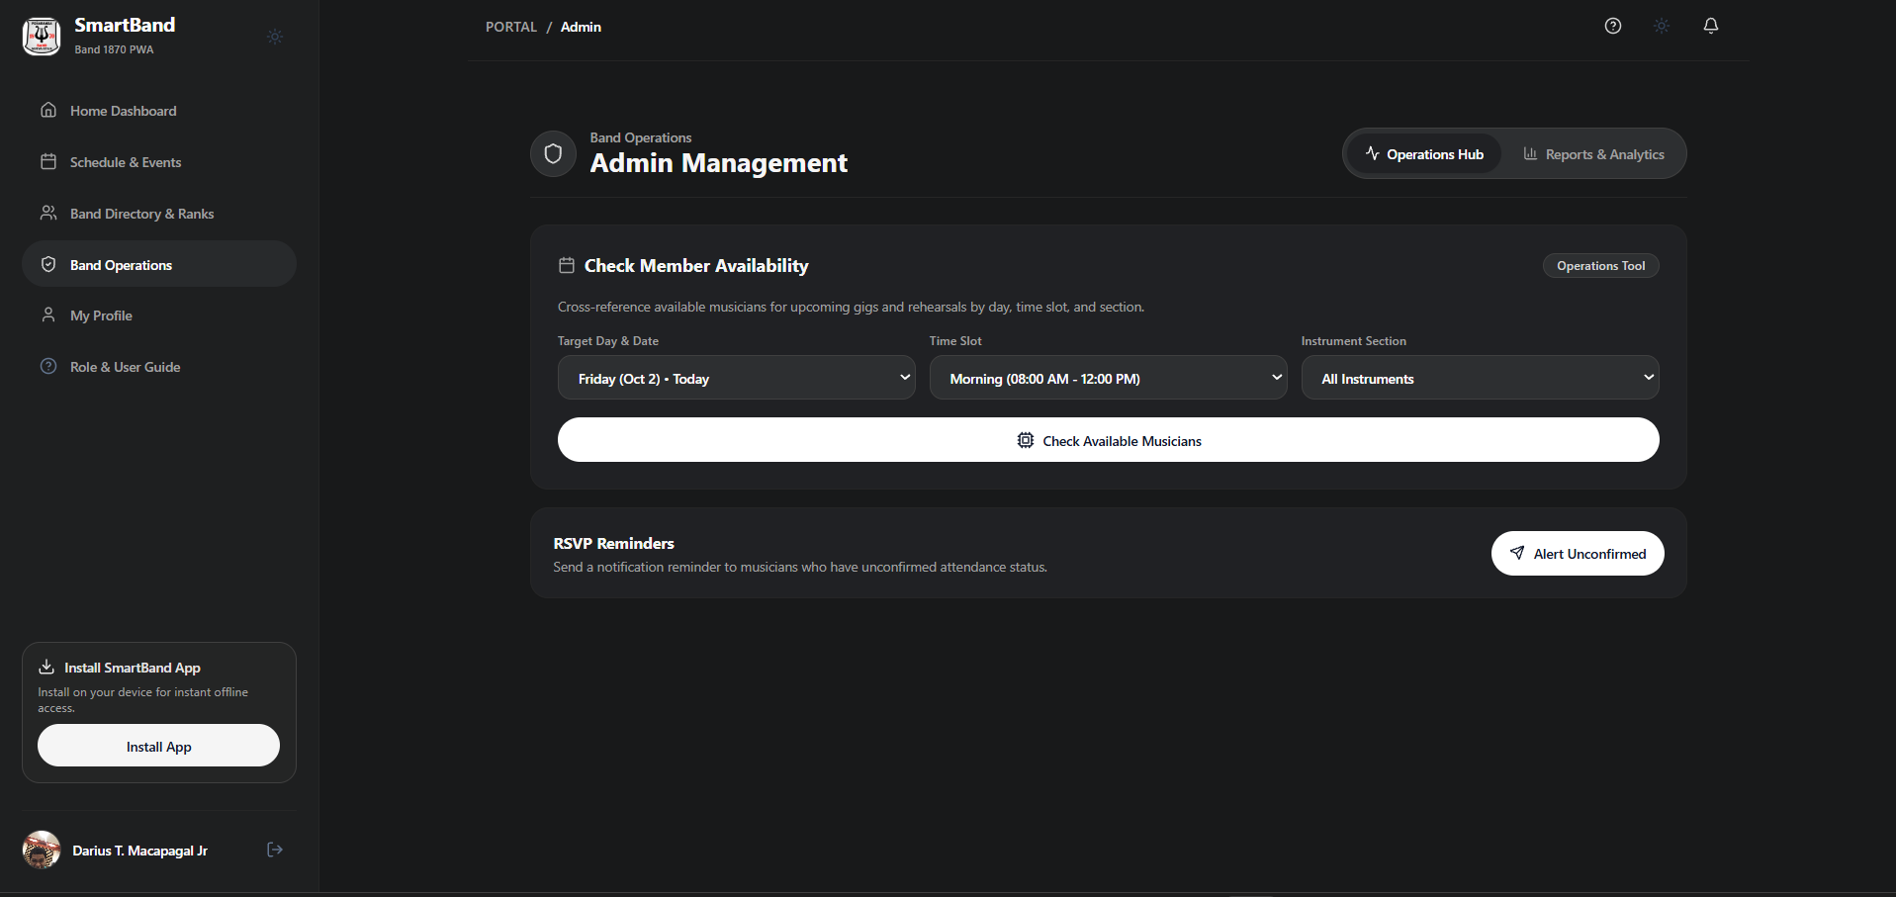
Numbered Callout Descriptions
No. | Field, Control, or Area — Description
1 | Cross-Referencing Tool Title — "Check Member Availability" header explaining predictive scheduling cross-referencing.
2 | Target Date Selector — Date picker set to proposed performance or rehearsal date (e.g., Friday, October 2, 2026).
3 | Shift Time Selector — Radio controls selecting Morning (8-12), Afternoon (1-5), or Evening (6-10) shift windows.
4 | Optional Section Filter — Dropdown allowing availability checks for specific sections (e.g., Brass Section only).
5 | "Run Cross-Reference Query" Action Button — Executes predictive query against all 19 musicians' recurring availability grids.

4.8 Operations Hub — Section Availability Results Roster
After the query for Friday, October 2 (Evening Shift) is run, the tool shows the Section Availability Results Roster, which is split into two panels: "Available (5)" and "Unavailable (2)". The secretary checks the available musicians, confirms that the key instruments (Trumpet, Trombone, Clarinet, Drums) are covered, and verifies the instrumentation balance. If quorum is met, the secretary clicks "Proceed to Schedule Event" to create the event with the available musicians already selected.
Figure C27
Cross-Referenced Availability Results Showing Available and Unavailable Rosters
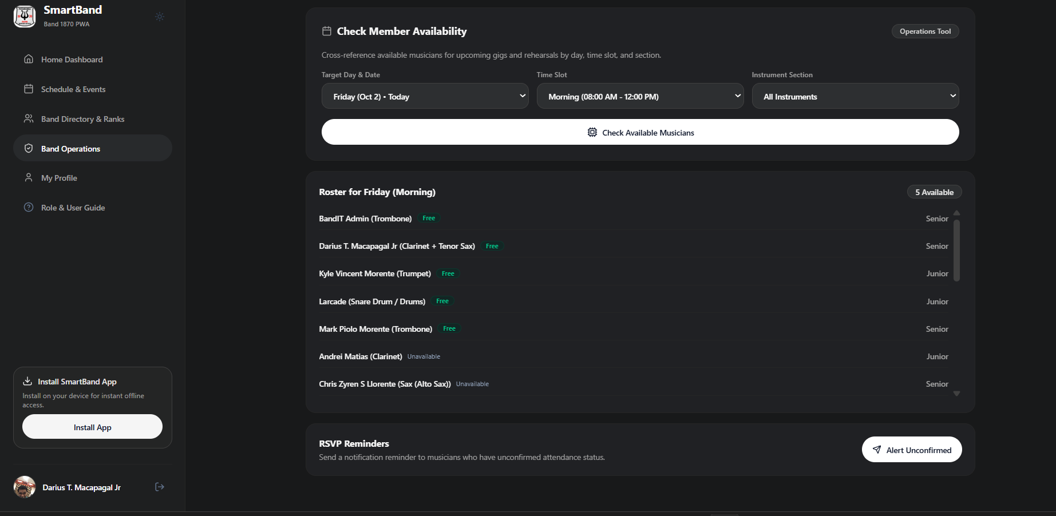
Numbered Callout Descriptions
No. | Field, Control, or Area — Description
1 | Query Result Summary Header — Confirms evaluated date and shift window ("Friday, Oct 2 • Evening Shift").
2 | "Available" Roster Panel — Green-accented panel listing musicians confirmed "FREE" for the selected shift window.
3 | Available Musician Profile Cards — Individual cards showing member name, assigned instrument, and reliability score.
4 | "Unavailable" Roster Panel — Gray/red-accented panel identifying musicians who have logged "BUSY" conflicts for that shift.
5 | Section Balance Evaluation — Instant visual breakdown showing whether all required instrument voices are present.
6 | "Proceed to Schedule Event" Action Button — Direct link pre-populating the event creation form with available musicians.

4.9 Attendance & Reliability Analytics — Executive Turnout Metrics & Sectional Gauge
The Attendance & Reliability Analytics dashboard shows attendance statistics for the whole ensemble. The Band Secretary and Executive Committee use it to monitor attendance, review turnout trends over the season, and compare sections. It shows an overall turnout gauge (e.g., 95.8% aggregate turnout), the total number of rehearsals and gigs evaluated, and progress meters for Woodwinds, Brass, Percussion, and Majorettes. Leadership can use these figures to find sections that may need recruitment or attendance follow-up.
Figure C28
Executive Attendance Analytics with Overall Turnout Rate and Sectional Gauges
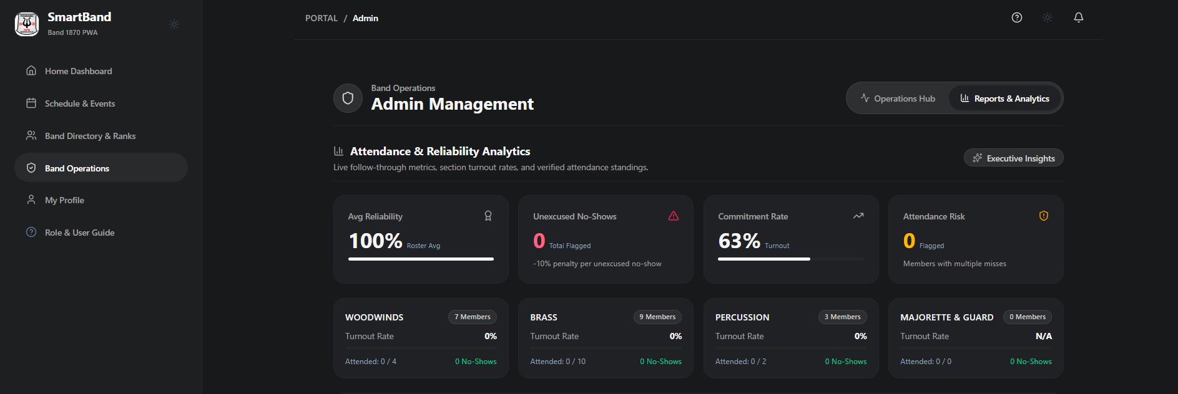
Numbered Callout Descriptions
No. | Field, Control, or Area — Description
1 | Analytics Dashboard Header — "Attendance & Reliability Analytics" header establishing executive reporting.
2 | Overall Band Turnout Gauge — Prominent numerical gauge displaying aggregate ensemble attendance percentage.
3 | Total Engagements Evaluated — Cumulative counter of evaluated rehearsals and performances during the season.
4 | Sectional Performance Gauges — Dedicated progress meters benchmarking turnout rates for Woodwinds, Brass, and Percussion.
5 | Reliability Distribution Curve — Summary showing distribution of members maintaining 100%, 90-99%, and sub-90% ratings.
6 | "Export Report" Action Button — Generates official PDF/Excel attendance summaries for municipal LGU reporting.

4.10 Musician Attendance & Commitment Matrix — Individual Turnout Standings
The Musician Attendance & Commitment Matrix lists the performance of each member. For each musician, it shows the legal name, total RSVPs, confirmed appearances, unexcused no-shows, and follow-through percentage. Members with 100% follow-through receive a high-reliability badge, which gives them priority for high-honorarium civic gigs. If a member misses an event because of a verified emergency, the secretary can use the adjustment controls to record an excused absence so that the reliability score remains fair.
Figure C29
Musician Individual Attendance and Commitment Matrix with Follow-Through Rates
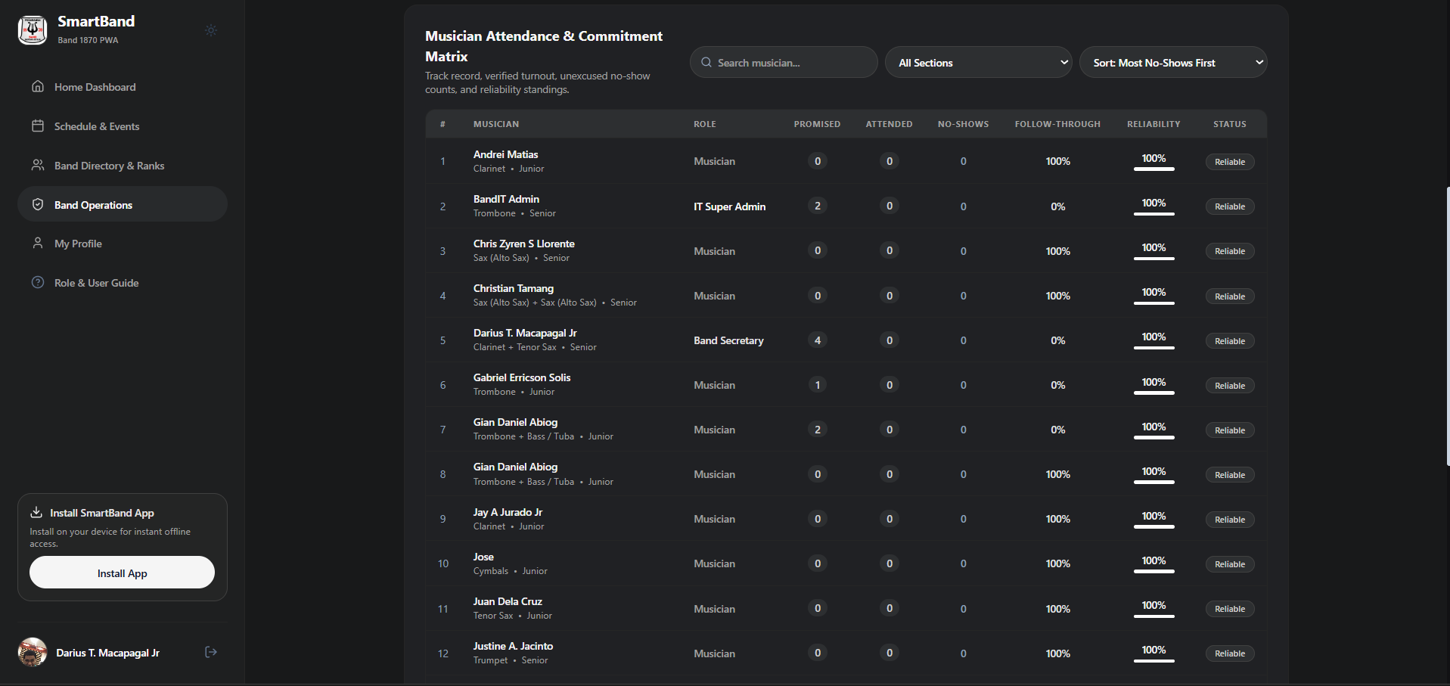
Numbered Callout Descriptions
No. | Field, Control, or Area — Description
1 | Individual Standings Ledger Header — Column headings for Musician Name, Promised RSVPs, Attended Events, No-Shows, and Follow-Through %.
2 | Musician Attendance Records — Granular data rows showing active members maintaining 100% follow-through ratings.
3 | Commitment Rating Badges — Visual badges highlighting top-tier performers versus members requiring attendance counseling.
4 | Administrative Adjustment Controls — Secretary override buttons allowing manual correction of attendance records with documented excuses.
5 | Section Filter Dropdown — Selector isolating specific sections to evaluate localized attendance trends.

MODULE 5: Band Administrator & IT Super Admin Portal
5.1 IT Super Admin Home Dashboard — Master Controls & System Governance
The IT Super Admin Dashboard gives administrators control of the platform. The example account is "BandIT Admin" (Super Admin, Senior Rank). The Super Admin manages user accounts, role changes, database integrity, and maintenance. The dashboard has controls for account management, security audits, database backups, and PWA deployment monitoring, and it has cards that show the Supabase connection status, active user sessions, and API latency.
Figure C30
IT Super Admin Master Dashboard with System Governance Controls
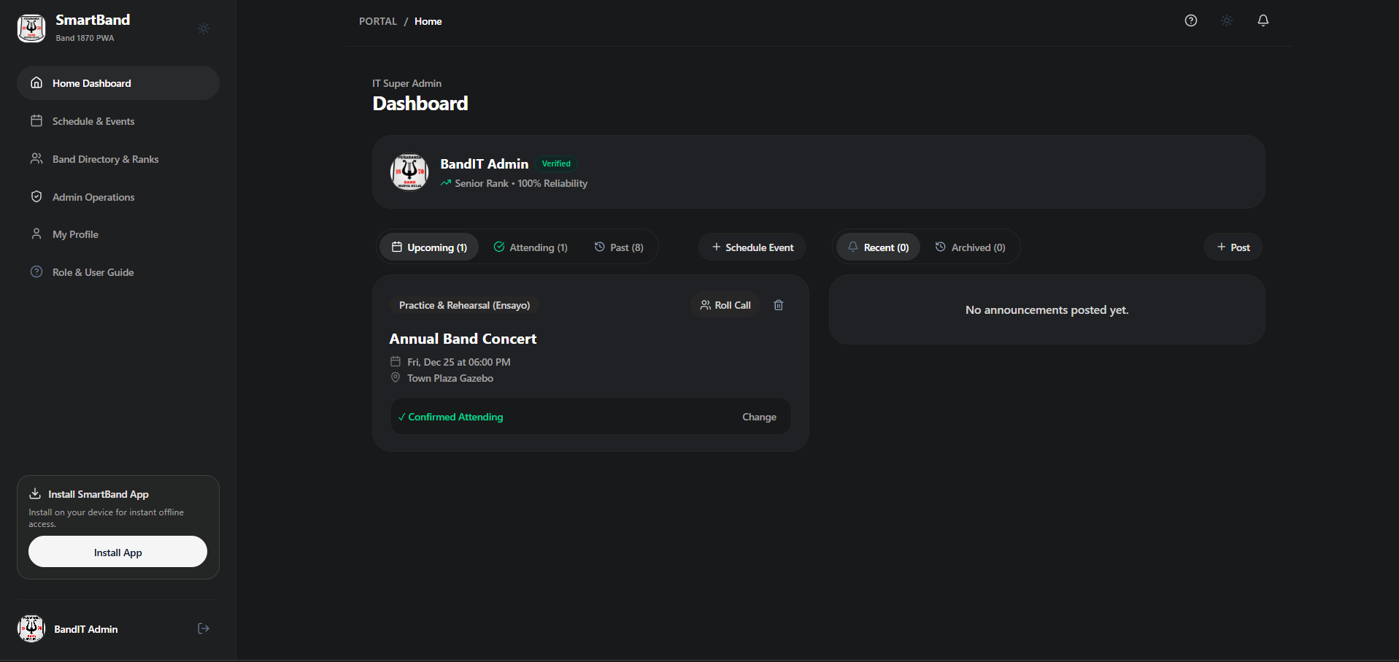
Numbered Callout Descriptions
No. | Field, Control, or Area — Description
1 | Super Admin Identity & Clearance Banner — Profile card displaying "BandIT Admin", "Super Admin" clearance, and Senior rank.
2 | Master Navigation Menu — Comprehensive menu providing access to Admin Operations, Band & Ranks, System Schedules, and Security Profiles.
3 | System Health & Database Telemetry — Real-time indicators monitoring Supabase connectivity, session counts, and database health.
4 | Governance Quick-Action Controls — High-level administration buttons including "Manage Accounts", "Audit Logs", and "Backup Roster".
5 | PWA Deployment & Cache Status — Controls monitoring service worker status and client application build versions.

5.2 Admin Musician Registry & Role Management Controls
In the Administrator Musician Registry, the Super Admin manages account permissions, role changes, and instrument assignments for all 19 registered members. The registry lists each member's legal name, phone number, section, current role, and seniority rank. Each record has an "@ Manage" button that opens a role management menu, where the administrator can promote a member to Band Secretary, update the seniority rank, or change the instrument assignments when a musician learns a secondary instrument.
Figure C31
Administrator Master Directory with Role Management and Seniority Ranks
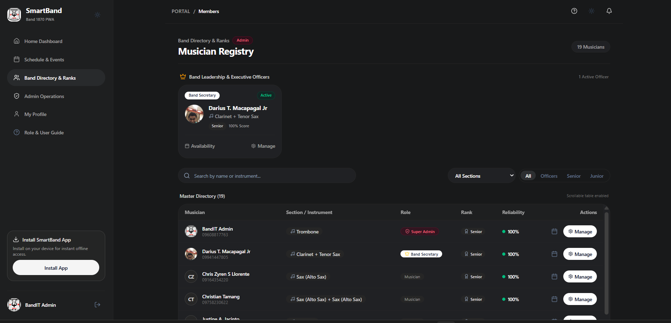
Numbered Callout Descriptions
No. | Field, Control, or Area — Description
1 | Administrator Master Directory Header — Displaying all 19 registered municipal band musicians.
2 | Section / Instrument Filter Tabs — Filter pills allowing administrators to inspect specific instrument sections.
3 | Comprehensive Musician Data Rows — Rows detailing legal names, phone numbers, instruments, roles, and ranks.
4 | Role Designation Badges — Visual tags identifying Super Admin, Band Secretary, and Musician roles.
5 | Seniority Rank Classifications — Badges displaying Senior, Junior, and Regular musician classifications.
6 | Administrative Action Triggers (@ Manage) — Action buttons opening role and profile management controls for each musician.

5.3 Admin Master Roster Management & Governance Post Assignment
The Administrative Post Assignment panel is used to change user roles and official positions. When an officer is elected or reappointed during a municipal reorganization, the Super Admin changes the member's system role (Member, Secretary Admin, or Super Admin) here. The administrator can also move musicians between sections (for example, from Clarinet to Saxophone) and update seniority classifications (Senior, Junior, Regular Musician). Saved changes take effect immediately across all modules, which keeps role-based access control up to date.
Figure C32
Role Governance and Administrative Post Assignment Interface
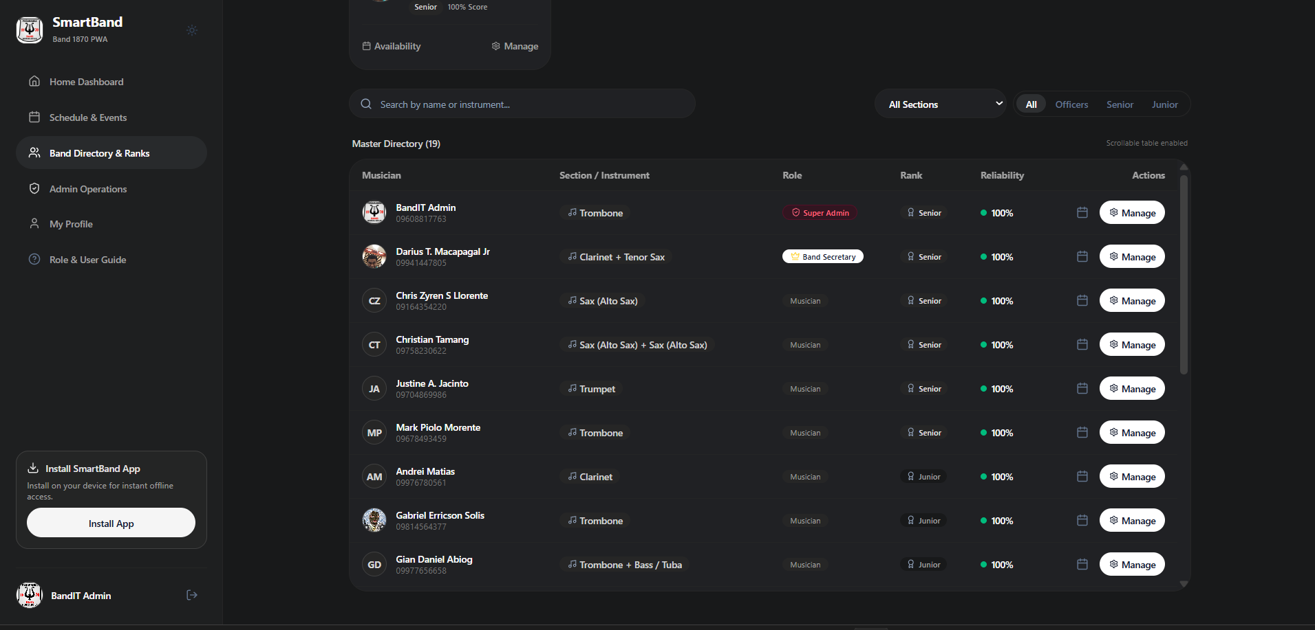
Numbered Callout Descriptions
No. | Field, Control, or Area — Description
1 | Role Governance Panel — Dedicated interface for modifying role permissions and executive appointments.
2 | Selected Musician Profile Target — Active member record undergoing administrative modification.
3 | System Role Dropdown Selector — Selector offering Member, Secretary Admin, and Super Admin privilege levels.
4 | Seniority Classification Selector — Rank assignment control (Senior, Junior, Regular Musician, Trainee).
5 | Instrument Section Reassignment — Selector to reassign musicians across sections as performance needs dictate.
6 | Scrollable Table Navigation — Responsive table controls enabling smooth navigation across the full membership ledger.
7 | "Commit Administrative Changes" Button — Persists governance adjustments directly to PostgreSQL user metadata in Supabase.

